**CONTENTS**

|  |  |  |
| --- | --- | --- |
| **CHAPTER 1 – INTRODUCTION** | | 1 |
|  |  |  |
|  | 1.1 Research rationale | 1 |
|  | 1.2 Scope, objectives and research question | 3 |
|  | 1.3 Research contribution | 4 |
|  | 1.4 Research structure | 5 |
|  | 1.5 Chapter summary | 5 |
|  |  |  |
| **CHAPTER 2 – LITERATURE REVIEW** | | 7 |
|  |  |  |
|  | 2.1 Introduction | 7 |
|  | 2.2. Governance at corporate level | 8 |
|  | 2.2.1. Corporate governance | 8 |
|  | 2.2.2. Contrasting governance models | 13 |
|  | 2.2.2.1 The shareholding paradigm | 14 |
|  | 2.2.2.2 The stakeholding paradigm | 16 |
|  | 2.3 The board of directors research | 20 |
|  | 2.3.1. Board purpose | 21 |
|  | 2.3.1.1. Board role | 23 |
|  | 2.3.1.2 Board contribution | 28 |
|  | 2.3.1.2.1 Board composition and organisational outcomes | 29 |
|  | 2.3.1.2.2 Board structure and organisational outcomes | 31 |
|  | 2.3.2 Board performance | 36 |
|  | 2.3.2.1 The need for contextualise | 36 |
|  | 2.3.2.2 Board dynamics and board "inner workings" | 38 |
|  | 2.4 Literature review summary | 43 |
|  | 2.5 Conclusions and identification of gap | 43 |
|  | 2.5.1 The research question | 45 |
|  | 2.6 Chapter summary | 45 |
|  |  |  |
| **CHAPTER 3 – RESEARCH METHODOLOGY** | | 47 |
|  |  |  |
|  | 3.1 Research philosophy | 47 |
|  | 3.2 Methodology and research design | 50 |
|  | 3.3 Sample | 55 |
|  | 3.4 Questionnaire | 57 |
|  | 3.5 The data collection process | 59 |
|  | 3.6 Chapter summary | 60 |
|  |  |  |
| **CHAPTER 4 – ANALYSIS AND DISCUSSION OF RESULTS** | | 61 |
|  |  |  |
|  | 4.1 The context of the Portuguese board of directors | 61 |
|  | 4.2 Board demographics | 65 |
|  | 4.3 Views on the chairman, the board, the SID and the CEO | 68 |
|  | 4.3.1 Views on the chairman | 72 |
|  | 4.3.2 Views on the board | 81 |
|  | 4.3.3 Views on the SID | 83 |
|  | 4.3.4 Views on the CEO | 87 |
|  | 4.4 Typology of board members | 91 |
|  | 4.4.1 Clusters' profile | 93 |
|  | 4.4.2 Clusters' (dis)similarity | 95 |
|  | 4.4.3 Clusters' demographics | 97 |
|  | 4.5 Chapter summary | 99 |
|  |  |  |
| **CHAPTER 5 – CONCLUSION** | | 101 |
|  |  |  |
|  | 5.1 Revisiting the research question and survey's conclusions | 101 |
|  | 5.2 Implications of the research | 103 |
|  | 5.3 Contributions of the research | 104 |
|  | 5.4 Limitations of the research | 105 |
|  | 5.5 Areas of further investigation | 106 |
|  | 5.6 Chapter summary | 106 |
|  |  |  |
| **BIBLIOGRAPHY** | | 107 |
|  |  |  |
| **ANNEXES** | | 119 |
|  |  |  |
|  | Annex A – Questionnaire in English | 119 |
|  | Annex B – Questionnaire in Portuguese | 124 |
|  | Annex C – Chairman scores | 131 |
|  | Annex D – Fusion coefficients, Ward method | 132 |
|  | Annex E – Cluster means | 133 |
|  |  |  |
| **TABLES** | |  |
|  |  |  |
|  | Table 1 – Key distinctions between the Anglo-American and European Continental governance models | 15 |
|  | Table 2 – Empirical studies on the effects of independent directors on corporate social responsibility | 31 |
|  | Table 3 – Demographic profile of the population and the sample | 57 |
|  | Table 4 – Structure of the questionnaire | 58 |
|  | Table 5 – Cronbach’s alpha coefficient results per dimension | 58 |
|  | Table 6 – Current position held | 66 |
|  | Table 7 – Age group by position held | 66 |
|  | Table 8 – Committees of the Board | 67 |
|  | Table 9 – Type of corporate governance model | 68 |
|  | Table 10 – Dimensions measures | 68 |
|  | Table 11 – Correlations between age and board views | 69 |
|  | Table 12 – Correlations between level of education and board views | 70 |
|  | Table 13 – Board scores | 82 |
|  | Table 14 – The Senior Independent Director scores | 84 |
|  | Table 15 – The CEO scores | 88 |
|  | Table 16 – Number of cases in each cluster | 93 |
|  | Table 17 – Clusters’ demographics | 98 |
|  |  |  |
| **GRAPHS** | |  |
|  |  |  |
|  | Graph 1 – Views by age | 70 |
|  | Graph 2 – Views by level of education | 71 |
|  | Graph 3 – Mean's comparison per dimension according to chairmen, CEO/GM and other directors | 72 |
|  | Graph 4 – Views on chairman strategic decisions according executive and non-executive directors | 73 |
|  | Graph 5 – Views on chair strategic decisions according the chairman executive and non-executive directors | 74 |
|  | Graph 6 – Views on chairman on risk according to executive and non-executive directors | 74 |
|  | Graph 7 – Views on chairman on risk according to chairman, executive and non-executive directors | 75 |
|  | Graph 8 – Views on chairman governance according to executive and non-executive directors | 76 |
|  | Graph 9 – Views on chairman governance according to the chairman, executive and non-executive directors | 77 |
|  | Graph 10 – Views on chairman style according to the chairman, the CEO/GM and others | 78 |
|  | Graph 11 – Views on chairman qualities according to the chairman, the CEO/GM and others | 79 |
|  | Graph 12 – Views on chairman performance according to executive and non-executive directors | 79 |
|  | Graph 13 – Views on chairman Performance according to the chairmen and the other directors | 81 |
|  | Graph 14 – Views on board performance according to the chairmen, the CEO/GM and the other directors | 83 |
|  | Graph 15 – Views on SID performance according to executive and non-executive directors | 85 |
|  | Graph 16 – Views on SID performance according to the SID and the others directors | 86 |
|  | Graph 17 – Views on SID performance according to the chairmen, CEO/GM and others | 87 |
|  | Graph 18 – Views on CEO performance according to the CEO and the other directors | 89 |
|  | Graph 19 – CEO and chairman relationship according to the chairmen, CEO/GM and the others directors | 90 |
|  | Graph 20 – CEO and chairman personal relation according to the chairmen, CEO/GM and the other directors | 91 |
|  | Graph 21 – Cluster means | 93 |
|  |  |  |
|  |  |  |

**CHAPTER 1 - INTRODUCTION**

1. **Introduction**
   1. **Research Rationale**

In an age of deeper government scrutiny of business operations, increased civil and criminal penalties for compliance failure, and heightened consumer awareness and sophistication, organisations are beginning to understand that their survival is closely related to the way that they deal with their environment, and that it goes beyond the simple link between ethics and profits.

From a practitioner’s perspective, companies today face increasing demands for corporate responsibility. However, they have new opportunities to build business value through judicious choices and actions to improve social and environmental conditions in which they do business (Porterand Kramer, 2006). Whereas firms previously concerned themselves almost exclusively with financial results, now many are finding it directly valuable to manage a wider array of the impacts that they generate (or can influence), from environmental conditions to employee health and safety to social conditions like the quality of public education.

From a scholarly perspective, one cannot write about corporate governance and corporate responsibility without raising the issue of the stakeholders for whom the company is responsible, or simply put, “Whose company is it?” Is the company simply a pass-through mechanism to process incoming revenue for return to the owners in share appreciation and dividends or is the company a citizen of the society in which it does business, with a responsibility to its various stakeholders beyond the core owner constituency? As a result of this reflection, scholars widely accept that the primacy of the shareholder model created a gap between business and society (Davis, 2005, Kemper and Martin, 2010). Therefore corporate governance and corporate responsibility have climbed the corporate agenda in recent years. The UK Company Law Reform White Paper (2005) links corporate responsibility to the duties of directors. It suggests that directors should take an “enlightened” approach to value creation by taking into account, where relevant, other stakeholders’ interests, the company’s social impacts and its reputation for integrity. For the board of directors, most relevant when considering corporate governance is the extent of the board’s contribution to corporate responsibility. If corporate responsibility is a precondition for sustainable long-term creation then boards may have a unique and decisive role to ensure that companies behave responsibly. However, are the boards of directors contributing to companies behaving responsibly? Do their actual actions lead to effective and more responsible company behaviour? Corporate responsibility sets the terms of an implicit contract between business and society, establishing the shared expectations between both. The responsibility pervades applying business life to all levels of the company and concerning all business functions. Therefore, maybe more than ever, the role and contribution of the ultimate corporate decision-making group (the board of directors) is, as a leader, at the centre stage of operations and requires re-evaluation in order to assess its effectiveness.

Corporate governance in general and boards of directors in particular, became the object of most business writings after the 2008 financial crisis (Wong 2012). It is also at the centre of policy makers’ and reformers’ interests in an attempt to explain the failings and understand the connection between business and society, and particularly to whom the firms are responsible to regain visibility and relevance. Expressions such as “sustainable growth” and “harmful short-termism” entered every business and institutional agenda. The European Commission in its 2010 communication *Towards a Single Market Act – for a highly competitive social market economy* stated “*it is of paramount importance that European businesses demonstrate the utmost responsibility not only towards their employees and shareholders but also towards society at large.”* The tone was set to re-connect business and society linking corporate governance and corporate responsibility, considering them as two key elements in building people’s trust and increasing the competitiveness of the European firms through well managed and well governed and so, sustainable businesses. Thus, and considering that corporate governance is one of the possible ways to coerce the excess of short-termism and risk-taking, the European Commission held a public consultation in 2010 for financial institutions and, in 2011 for all European listed companies, as green papers (EC Green Paper Corporate Governance in Financial Institutions and Remuneration Policies, 2010 and EC Green Paper, Corporate Governance Framework, 2011) to gather stakeholders’ views and assess the effectiveness of the current corporate governance framework in Europe. The ECGI (European Corporate Governance Institute), answering the call of the European Commission, stressed, among others, the importance of the board behaviour on the quality of decision-making. Whilst contending the pivotal role of the chairman to ensure substantive decision-making and procedural effectiveness, the ECGI claimed the need for research to observe boards in action to analyse whether “rules” make any difference to the way boards behave (European Commission Green Papers on Corporate Governance and the EGCI Research Agenda, 2011). EABIS (The Academy of Business in Society) responded to the Green Paper calling for the need to rethink the purpose of corporate governance, broadening its context. Since nowadays the economy is highly integrated, interdependent and global, this institution highlighted the need to deepen the reflection following three different levels: the societal, the behavioural and the strategic dimensions of corporate governance. In all dimensions the board of directors is paramount either by playing a relevant role in addressing corporate responsibility and public policy engagement or ensuring governance quality through enhancing its own processes of leadership, culture, competence and interactions with firm’s stakeholders and in defining 1) the terms of the firm’s long-term value creation; 2) its appropriate measurement; and 3) how governance and management processes can be value-based (EABIS’ position paper and response to the European Commission’s Green Paper on the EU Framework for Corporate Governance, 2011). Finally, ecoDa (European Confederation of Directors’ Associations) yet agreeing with the Commission that corporate governance and corporate responsibility are key elements to build people´s trust and to improve sustainable competitiveness, claimed the need to treat both subjects jointly, embedding the corporate responsibility agenda into the governance framework. For that purpose, ecoDa states that in order to enhance the ultimate purpose of a company which is to sustainably generate profits for its shareholders, the board of directors will need to obtain deep understanding of all stakeholders’ interests and in so doing consider corporate responsibility a key aspect of its fiduciary duty towards the firm (ecoDA’s response to the EU Green Paper on CG for listed companies, 2011).

Corporate governance continues to undergo substantive changes (mostly increasing regulation), which are impacting and redefining board activities. Therefore, more than ever, it is of capital relevance to understand the role and contribution of the board of directors. If the role of the boards is to govern then effective governance from the board is essential for companies to reap the long-term rewards for responsible behaviour towards its stakeholders and society in general.

* 1. **Scope, objectives and research question**

Probably mostly driven by external events such as corporate scandals (Enron, Tyco, WordlCom), climate change and globalisation, scholars expect corporate responsibility aspects of governance to grow in future. Not only, most large global companies are held by the public (through pension funds) who have an interest in long term corporate performance, but also scholars are now claiming that the boards are in charge of managing for the long-term good of all its stakeholders (Kakabadse, 2007). Therefore, the relevance of corporate responsibility has led its integration into the boardroom, as a direct formal duty of the board of directors. However, are the board members really playing on their daily activities and as their standard tasks to ensure a responsible behaviour from the company that they are representing? It is then critical to analyse and research Portuguese Boards’ role and contribution departing from board members’ own perception.

Through the analysis of the board members’ perceptions, we intend to understand the role and contribution of the boards, the boundaries between key functions at the board level, and explore what boards are, in fact, doing to help firms build the public confidence and trust and ultimately increase the firm’s value in the long run. Up until recently global empirical research into board dynamics has been limited and as far as we know non-existent among the Portuguese listed firms. Therefore, this project aims to explore the dynamics and performance at the boardroom in a non-Anglo-American context in order to understand the contributions and the roles which Portuguese boards play.

As a result of the literature review, the author developed the following research question:

**‘What is the perceived role and contribution of the board of directors?’**

The author based the empirical study on a quantitative survey completed by board members of Portuguese listed companies at Euronext Lisbon in 2011. Thus this survey explored a set of quantitative data generated from a sample of directors, who express their views on the Chairman, the Board, the Senior Independent Director and the CEO performance, based on their own (board) experience.

Bearing in mind the nature and purpose of this research, the listed companies, although not representative of the Portuguese firms, are the most appropriate since ownership and control are separate and corporate governance codes exist to enforce them on a “comply or explain” basis.

* 1. **Research Contribution**

The major business and organisational challenge to the Portuguese companies is the one related to the post-recession economy. In spite of major business trends such as higher volatile capital movements, and an increasingly competitive business environment both in goods and services and labour markets, it seems that after the global recession started in 2008 the globalization process accelerated. Highly uncertain and disruptive business environments, sustainability of actual business models and global competition are among the major challenges that companies face. The global consequences of the Western financial market’s crisis has forced companies to question, whether for the short or long term, their role as a responsible business in our society. We are facing huge changing times. As stated above, the civil society is asking business to clarify its purpose and to set a clear definition of its responsibilities towards stakeholders and society in general. Additionally, there is a claim for further academic research to understand the role and contribution of the boards in the new global economic context and beyond the shareholder maximisation model.

Much of board research is data based, examining boardroom dynamics from a distance (Dalton and Dalton, 2011). In contrast, this survey contributes to a relatively small but growing stream of research which draws on the growing recognition that the board is a living social system that operates as a ‘team’ and having a human dimension, whose behavioural aspects have a deep impact on board contribution to the performance of the firm.

Whilst adding value to the literature on board of directors’ dynamics, we can summarise the contributions of this research as follows:

*Theoretical contribution*

* To bridge the existing gap between corporate governance and corporate responsibility literature with an empirical study;
* To contribute to reinforce the need of understanding boards’ dynamics and their impact on firms’ outputs; and
* To help clarify the role of the board of directors.

*Managerial contribution*

* To help Portuguese boards of directors respond to the challenges of our rapidly and disruptive changing business world through the clarification of its role;
* To accelerate the integration of corporate responsibility into the Portuguese boardroom and thus raise the awareness of reconciling the long-term structural issues with the short term need for results; and
* To raise the awareness of the need to include the governance of business and society relationship as a direct formal responsibility of boards.
  1. **Research Structure**

This research is presented in five chapters. Chapter One, the current chapter, presents the research rationale, the scope, objectives and research question. A summary of the research contribution to both theory and practice precedes a review of the study structure, which concludes the chapter.

Chapter Two reviews the literature as it relates to the research topic. This chapter will examine the existing and relevant literature in relation with the boards of directors within the context of the corporate governance theory and the main theories, concepts and empirical research to date informing the board of directors’ role and contribution.

Chapter Three describes the methodological and theoretical choices that serve as a guide for the empirical study. It provides a detailed description of the empirical research framework.

Chapter Four presents the analysis and discusses the results of this research relating specifically to the research question. It provides a discussion of the implications of the study findings.

Chapter Five completes the research by presenting the main conclusions. It also includes the limitations of the study and provides suggestions for areas of further study.

* 1. **Chapter summary**

This chapter has introduced the research topic along with the rationale that underlies the research. The project’s objectives have been identified along together with a summary of the contribution this survey makes to both theory and practice. The next chapter will present the literature review.

**CHAPTER 2 – LITERATURE REVIEW**

1. **Literature review chapter**
   1. **Introduction**

Humans and consequently, social institutions have a purpose. It may be hidden or clearly stated, manifested or latent, formal or informal, but human actions are purposeful. Also managers’ actions are purposeful, as per Bruch and Ghoshal (2004) study. Bearing this in mind, this survey intends to explore and understand the board of directors’ purpose, role and contribution through board members’ perceptions.

This chapter aims to examine the existing literature in relation to the area of inquiry, specifically the roleof the board of directors within the realm of corporate governance. The chapter will begin to show the key issues surrounding the concept of corporate governance, namely describing two contrasting governance models - the Anglo-American and the Continental European - and highlighting the two most influential perspectives of corporate governance and how it affects the way scholars look, understand and explore the firms and ultimately the boards of directors. Underlining the mentioned models are two contrasting philosophies: one based on the traditional dominant wisdom of ‘individualism’– private property and individual liberty – thus framing and consequently justifying the maximisation of the shareholders’ value as the sole purpose of the firm and on the other side the ‘communitarian’ view of property and the social conception of the firm as the primal legitimisation of including all stakeholders interests’ in the corporate objectives (Letza et al., 2004). These different theoretical and philosophical perspectives emphasise different roles of the board of directors, influence corporate governance mechanisms and practices and affect the way social actors perceive their role.

Additionally, the chapter will examine the board of directors’ research tradition, focusing on the boards’ role and contribution followed by the recent board research stream to assess board effectiveness. This framework helps us to better understand the issues surrounding the contribution, the purpose, the functioning and performance of the board of directors according to various theoretical perspectives. The literature review identifies a gap in the empirical academic research and, as a consequence, the chapter concludes with a presentation of the research question and the conceptual framework for this study.

The following outline summarises the chapter:

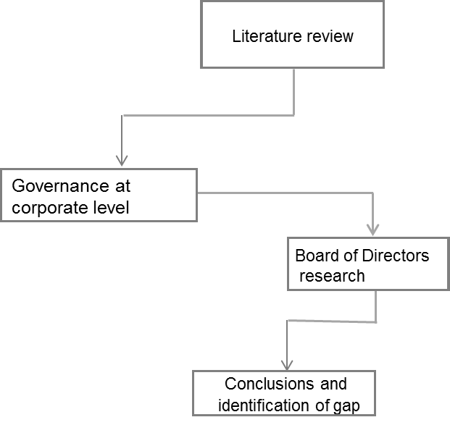

### Governance at corporate level

### Corporate Governance

### Before entering the realm of corporate governance, it makes sense to answer the age-old question: what is a firm? The literature provides two essential definitions of the firm. Alchian and Demsetz (1972) define the firm as a nexus of contracts, individuals freely contracting with one another so that the fiduciary duty of directors to maximise shareholder value becomes a contractual matter, which depends on shareholders bearing the residual risks of the firm. The latter is the reason why shareholders are the most privileged group with interests in the company (Gamble and Kelly, 2001). Maximising shareholder value serves then the dual purpose of accountability and efficiency, determining the way one conceives the firm. This perspective, known as the contractual view of the firm, draws on the principal-agent model which allows agents to write elaborate contracts characterised by ex-ante incentive alignment under the constraints imposed by the presence of asymmetric information (Foss et al., 1999). The conflict of interest between owners and managers is but one example of an incentive or principal-agent conflict which arises in the context of firms and which may explain important aspects of a firm’s corporate governance. In this context Zingales (1998) indicates that corporate governance is nothing more than a more complex version of standard contractual governance.

### Bearing in mind another perspective, Grossman and Hart (1986) and Hart and Moore (1990) define the firm as a collection of jointly owned physical assets. This theory draws on the traditional property rights view (Gamble and Kelly, 2001). In this second case, ownership matters since it confers the owners the right to make decisions related to all contingencies that are not ruled by the initial contract. It is precisely here where the difference between governance and corporate governance begin to make sense because it rules in the latter the non-contractual elements. Rajan and Zingales (1998) provide a broader view of the firm and define it as a nexus of specific investments, a combination of mutually specialised assets and people, be they workers, suppliers and customers. This way the firm allows other constituents than just the owners or shareholders.

### From a historical and legal perspective, corporations today resemble those from the Middle Ages (Carroll, 1989), in the sense that the social structure and other collectivities existed independently of any particular membership. Their assets belonged to the collective itself and rose as a protection against the royal domination (Monks and Minow, 1996). Hence, the firm emerged for the sake of separating a person’s life from his/her business, having life beyond its owner’s existence and within a social environment of collective ownership (Clancy, 1989). Later, in the early seventeenth century, the first joint stock companies were formed, answering the growing markets of the East and West Indies (Kakabadse, 2001). However, it was during the nineteenth century that a major political and legal event occurred that influenced the structure of companies as they are today – the establishment of public companies with limited liability (Hunt, 1936). The 1844 Joint Stock Companies Act in the United Kingdom gave general permission for the formation of companies (Hannah, 2006). For Gamble and Kelly (2001), the arguments in favour of the limited liability were connected 1) to grant small investors the possibility of mobilising their capital and so participating in the success of new industries and 2) to allow free contracting among individuals without the state’s intervention. Whilst the first principle allows the company to be a small set of its own right, *‘a miniature political system’*, where its members, the shareholders, had rights to representation, information, and decision-making and thus to whom directors had to be accountable, the latter gave rise to the emergency of sets of economic power independent of the state (Gamble and Kelly, 2001). According to Allen (1992), during the seventeenth and eighteenth centuries, business people developed the perspective that the right to incorporate is inherent in the right to own property and write contracts, and we should regard corporations as legal extensions of their owners. The new form of corporate property is the aggregation of individual property rights under a collective name, united by contract and protected by company law (Letza et al., 2004). Hannah (2006) defines this legal and political revolution as the origin of the corporate economy.

### Apart from the well-known transaction costs theory of the firm, first presented by Coase (1960), where the firm arises as a consequence of market inefficiency, or in response to resolving growing transaction costs, there are other complementary explanations such as that offered by the strategy theory or as a response to geographically large markets (Kakabadse, 2001). Yet, in both cases, the key issue for organising is motivated by the reduction of transaction costs, through economies of scale in the latter and, for instance, passing over barriers to enter the market in the former (Kakabadse, 2001).

### The definition of corporate governance depends on the firm’s purpose and the lens which it uses to analyse it (Huse 2009) or, as Clarke and Chanlat (2009) put it, competing definitions of corporate governance go from the very narrow, only concerned with the relationships between shareholders and managers, as in agency theory, to very extensive definitions involving all the possible relations in which a firm is involved. Adopting an uncommon lens, Kakabadse and Kakabadse (2001) differentiate the two most known corporate governance perspectives from a micro versus a macro view of control. Asserting that both shareholder and stakeholder views address the issues of checks and balances, those authors conclude that their fundamental difference lay on the greater account of the wide stakeholder community for the macro perspective, whilst the micro perspective emphasises the meeting of shareholders’ needs. In so doing, the stakeholder theory focuses primarily on the actors in the environment so that scholars define the firm as a system (Clarkson, 1995) or a collection of resources embedded in a network (Porter, 1990) therefore allowing the context to be an active player in the governance game.

### Padilla (2000) popularly defines corporate governance, consistent with the traditional view of the firm, as a “nexus of contracts” that guide the firm’s policies and strategies to maximise shareholders’ value. Therefore, the main function of a corporate governance system is to improve ex ante efficiency by providing adequate incentives for value-enhancing investments. Zingales (1998) challenged this view since corporate governance is only meaningful in the presence of contractual incompleteness. Hence, a corporate governance system for this author is the complex set of constraints that shape the ex post bargaining over the quasi-rents generated by the firm. Under Zingales, the definition ex ante efficiency is no longer the only efficiency object of a corporate governance system – it must also aim to minimise inefficiency in ex post bargaining. Interestingly, the need for governance is non-existent in the absence of the quasi-rents since in that case the market’s competitive nature would eliminate any scope for bargaining. So, still according to Zingales, in a world of incomplete contracts it is necessary that someone (the principal) allocates the right (to the agents) to make adjustment decisions to unspecified events.

### John and Senbet (1998) gave a broader definition of corporate governance stating that corporate governance concerns the mechanisms by which the firm’s stakeholders exercise control over corporate insiders and management so that their interests are protected. Thus, one of the fundamental questions that immediately rises when considering the expression corporate governance is “who should control the firm”? Berle and Means (1932) first realised the growing separation of power between management and the shareholders. This led to the well-established shareholder-focused model in the corporate governance research field. When Brealey and Meyers (1988:22) stated that ‘*managers of the firms could all be given one simple instruction: maximising net present value*’, they were also stating that was the corporate objective and they framed the separate thesis of ownership versus control of the firm. When developing a theory of the firm’s ownership structure and using the view of the firm as a nexus of contracting relationships, Jensen and Meckling (1976) raise the question of the major conflict between shareholders and managers that discusses the classical issue of corporate governance literature – the conflicts arising from the division between the ownership and control of the firm. The objective in agency theory is to decrease the agency costs incurred by the principals (shareholders) by implementing internal mechanisms of control to monitor the agent’s (manager’s) self-serving behaviour (Jensen and Meckling, 1976).

### The key issue in the agency framework is how to align the agent’s interests with those of the principal using specific instruments, including monitoring, performance bonuses, equity shares, promotion and dismissal (Oliver Marnet, 2004). Sundaram and Inkpen (2004) asserted that in the realm of finance, the obvious corporate objective is the shareholder maximisation. Revisiting and debating other views, these authors argue that to ‘maximise shareholder value’ should be the corporate goal simply because it is the best among all available alternatives, therefore the preferred goal for managers who are formulating and implementing strategy. Adopting a contrarian position, Jordi (2010) asserts that we can use the profit-maximisation hypothesis to describe a model that makes complex, real-world situations more manageable, but by giving exclusive importance to profit maximisation excludes other important factors that contribute to long-term value creation.

### Other than the shareholder-focused model, the stewardship theory brings a completely different view of corporate governance issues and consequently, its institutions, namely the boards of directors. Based on the traditional legal view of the corporation as a legal entity in which directors have a fiduciary duty to the shareholders (Letza et al., 2004) and drawing on criticism about the individualistic utility motivations which result in principal-agent interest divergence and on the complexity of organisations, stewardship theory (Donaldson and Davis 1991, Davis et al. 1997) defines situations in which managers are not motivated by individual goals, but are stewards whose motives are aligned with the objectives of the firm’s shareholders. Other than agency theory, the model of man in stewardship theory is based on a person whose behaviour dwells on the higher utility of pro-organisational and collectivist behaviours rather than individualistic and self-serving ones. So, the emphasis is on cooperation rather than confrontational behaviour between principals and agents. For Burton (2000), stewardship theory emphasises involvement rather than control, trust rather than monitoring, and performance enhancement rather than cost control. So, whenever conflicts may arise, stewards would choose in the best interest of the firm (Davis et al. 1997). Unlike agency theory, stewardship theory does not enter the economics realm, as its origins come from the social-psychology and the sociology fields. In accordance with Donaldson and Davis (1991), underlying the stewardship theory is the ‘model of the man’ who is motivated by a need to achieve, for intrinsic satisfaction as per Herzberg’s (1968) classification and the achievement and affiliation needs of McClelland’s (1962) typology. This said, it is clear that the mechanisms of corporate governance adopted and prescribed by the stewardship theory are different. In fact, Davis et al. (1997), when defining their choice model, state that if a mutual stewardship relationship (principal-steward) exists the potential performance of the firm is maximised. Similarly, Donaldson and Davis (1991:52) wrote that ‘*stewardship theory focuses not on motivation of the CEO, but rather facilitative, empowering structures, and holds that fusion of the incumbency of the roles of chair and CEO will enhance effectiveness and produce, as a result, superior returns to shareholders than separation of the roles of chair and CEO.*’

### Economic theory considers the existence of external mechanisms as corporate regulators. As outside mechanisms for regulation, Roe (1994) considers that “governance can be seen as competition’s assistant; good governance speeds along competitive adaptation; bad governance slows it down” (Roe 1994:223). Shleifer and Vishny (1997), commenting on the role of competition, stated that we could not worry about the governance reform as in the long run the market would force firms to minimise costs and as part of this process adopt rules and corporate governance mechanisms. Nevertheless, in their opinion, market competition is one of the most powerful forces to enhance economic efficiency, but they are sceptical about its sole ability to solve the problem of corporate governance.

### According to the agency theorists and after years of intense debate and research, corporate boards continue to stay in the central stage of scholarly discussion as the most established governance mechanism to protect principals’ interests. In fact, triggered by the blame game which started after the colossal global financial meltdown in 2008, the boards of directors became the most researched corporate governance mechanism ever and are the focus of this survey. For a while the scholarly literature about corporate governance examined the links between board functions and company outcomes. Yet, consistent and widely accepted results were not achieved probably because scholars use different points of view and do not allow contrarian and multi factorial lenses. Meanwhile, Fama and Jensen (1983) posit that shareholders consider boards as an inside mechanism for controlling management Pfeffer (1972) highlights the service role of the boards. Yet recently, agency theorists began to incorporate directors’ service roles, namely, stating that expert directors might facilitate effective evaluation of management proposals through valuable advice as strategies are formulated (Fama and Jensen, 1983).

### Pettigrew (2009), referring to the governance of the modern corporation and more precisely to the board (as an instrument of both control and strategic leadership), argues that the modern corporation needs now to go beyond the established agenda. He calls for the discussion of the purpose, conduct and effectiveness of boards, which is the objective of this survey. Daily et al. (2003), in the seminal article revising the status of the corporate governance field, began asserting that it was ‘at a crossroads’. Curiously and after decades of debate, those authors realised that non-knowledge overshadowed actual knowledge. In the same manner, Huse (2005), trying to assess what is board accountability and how it is created, concludes that to open the ‘black box’ of the boardroom, one would need to explore actual board behaviour. Moreover, considering Huse’s (2009) recent calls for non-mainstream contributions of board research, this study intends to explore the inner workings of the boards of directors to get a broader understanding of the boards’ purpose, role and contribution.

### For the purpose of this study we use the OECD’s 1999 definition of corporate governance: ‘*Corporate governance is the system by which business corporations are directed and controlled. The corporate governance structure specifies the distribution of rights and responsibilities among different participants in the corporation, such as, the board, managers, shareholders and other stakeholders, and spells out the rules and procedures for making decisions on corporate affairs. By doing this, it also provides the structure through which the company objectives are set and the means of attaining those objectives and monitoring performance’*. This definition, consistent with the one in the Cadbury report (1992), does not appoint the most relevant role of the boards of directors, the one of monitoring, the one that guarantees to shareholders that an appropriate governance structure is in place, as the one prescribed by the Cadbury report. The OECD definition enlarges the concept since it allows different constituents to be part of the equation. In a word, corporate governance relates to the institutional arrangements for relationships among the several constituents who may have direct or indirect interests in a firm such as shareholders, directors/managers, employees, creditors, customers, suppliers, local communities, government and the general public (Letza et al, 2004). Throughout the key point is that firms have to account for governance considerations and ever-increased set of interests which exposes them to the context and consequently, a much more complex reality. Moreover, the definition of corporate governance is more important than its effective application. For Monks and Minow (1996), effective corporate governance implies a system of controls and balances in place for defining the boundaries of power and consequently, limits its abuse through accountability, whilst ensuring the correct answering of questions.

### However, the importance of the company’s constituents diverging among scholarship and geographies has given rise to the most mentioned governance models in the literature. Aguilera and Jackson (2003) comment that the diversity of corporate governance practices around the world nearly denies the existence of a common definition. The following section will examine the main differences between the two contrasting models.

### Contrasting governance models

### Allen (1992), in his reflection about the effectiveness of corporate governance mechanisms when compared with the role of the market and the competition, stated that firms in the USA and in the UK focus on creating wealth for shareholders; whereas, in Japan and to some extent in Germany and France, the firm is a group of people working together. The focus is on benefiting those within the firm, thus adopting the communitarian view in the legal literature. Furthering his position raises the question of whether the firm’s traditional agency view is the correct way to think about companies. In fact, scholars commonly used to mention two dichotomous models of corporate governance – the Anglo-American and the Continental European (La Porta et al., 1999). According to Aguilera and Jackson (2003), we can describe the Anglo-American model in terms of financing through equity, dispersed ownership, active markets for corporate control and flexible labour markets, whilst the Continental model embraces terms of long-term debt finance, ownership by large block-holders, weak markets for corporate control, and rigid labour markets. Likewise, Clarke and Chanlat (2009) describe two parallel universes of corporate governance: a market-based, Anglo-American one as a dispersed ownership model relying on strong and liquid markets, high disclosure standards, high market transparency, and where the market for corporate control is the ultimate disciplined mechanism and a concentrated ownership model, and the European and Asian relationship-based corporate governance model characterised by controlling shareholders, weak securities markets, low transparency and disclosure standards and often a central monitoring role for large banks who have a stake in the company. Adding on, Kakabadse et al. (2004) posit that within the Anglo-American model or shareholder model the locus of control is external in the sense that the executive management is monitored by independent agents and institutions in their key task of enhancing the wealth of a firm’s investors, whilst in an contrasting way, the Continental or stakeholder model is driven by an internal locus of control based on the premise that a shared and committed relationship amongst several firms’ constituents will improve their performance thus providing higher returns for shareholders. An additional consideration is that in different regions of the world there are deeply embedded contrasts regarding business values and ways of doing things and profoundly divergent beliefs in the role of the market, which influence the way one considers a firm (Clarke and Chanlat, 2009), so that the diversity of corporate models is valuable and rooted in societal characteristics that together shape the competitiveness of the different models. A key issue between the two models is the conception of the firm in terms of private versus public rights. Meanwhile, the Anglo-American model regards the firm as a private association united by individual property rights the Continental European model considers it as a public association constituted through political and legal processes and as a social entity for pursuing collective goals with public obligations (Letza et al., 2004). Therefore, academicians assert that the stakeholder approach is closer to the reality of the Continental European model – the biggest difference between the market-based systems of the US and UK, and the relationship-based systems predominating in many European countries is that Europeans emphasise co-operative relationships and reaching consensus; whereas, the Anglo-American tradition emphasises competition and market processes (Nestor and Thompson, 2000). However, the two models share the aspiration of generating shareholder wealth. Yet more relevant than their different characteristics (which Table 1 depicts) is the philosophy behind the two different systems (see Table 1), following the notion that corporate governance practices are socially constructed and, consequently, context driven (Aguilera and Jackson, 2003). Through the recognition that multiple stakeholders are involved in the corporate dialectic and thus adopting a macro and wide perspective, the stakeholder philosophy and, consequently, the European Continental governance model, provide a way to consider the environment and its effects on the firm and on all involved actors through the complexity of their networks whilst looking for wealth creation and more socially driven wealth distribution. At odds, management and profit generation in the Anglo-American world have been connected to the enhancement of the individual, namely due to the need to keep individuals motivated to generate further profit or to reduce the transaction costs (Kakabadse and Kakabadse, 2001). Hence, individuality and the understanding of social redistribution are the social outcomes of different economic philosophies, which we can often observe in the shareholder versus stakeholder views (Nesbitt, 1994).

**Table 1 Key distinctions between the Anglo-American and European Continental governance models**

|  |  |  |
| --- | --- | --- |
| Key characteristics and meanings | Anglo-American (shareholder or external model) | Continental European (stakeholder or internal model) |
| Firm's goals | Maximise shareholder wealth | Pursue multiple objectives of parties with different interests |
| Firm's concept | Instrumental | Institutional |
| Governance structure and key processes | Principal-Agent Model: Managers are agents of shareholders. Monitoring is the key task | Team production model: Coordination, cooperation, and conflict resolution are the key tasks |
| Residual Risk Holders | Shareholders | All stakeholders |
| Board structure | Unitary board, with predominately external directors, "one tier" | Mostly "two tier" board (i.e., supervisory and management) |
| Ownership concentration | Weak and relatively small number of intercorporate shareholdings | High and substantially intercorporate shareholdings |
| Locus of control | External: Capital market and large shareholders | Internal |
| Timeframe of operation | Short run | Long run |
| Loyalty | Oneself, profession | Organisation |
| Identity | Own initiatives; self developed | Community or organisational; broader based initiatives |
| Conduct | Self-disciplined; codes of conduct as models | Legislation |
| Values | Self-generated wealth | Public good |
| Source: Compiled from Kochan and Rubinstein (2000); Kakabadse et al. (2004); Kakabadse et al. (2009) | | |

In fact, whilst the Anglo-American system is based and focuses its attention on shareholder value creation, the Continental European model (also present in Japan and some other Asian countries) centres its attention on embodying all players involved who affect the firm’s value creation, decision-making and strategic choices (O’ Sullivan, 2000; Kakabadse and Kakabadse, 2001). Ayuso and Argandona, (2007) view the consideration of firm’s stakeholders groups as a possible ethical demand therefore going beyond the thinking that the difference between these two models lays on the mere difference of wealth distribution. Also going beyond the obvious and adopting a broader societal view of corporate governance, Kakabadse and Kakabadse (2001) contend that the stakeholder philosophy governance models are better able to integrate wealth creation with equity of wealth distribution.

### The shareholding paradigm

### One of the most established ways of thinking about the firm’s property, corporate governance and objectives is anchored in Friedman (1970) and the Chicago school of economics’ well-known description of the firm’s core responsibility*: ‘there is one and only one social responsibility of business – to use its resources and engage in activities designed to increase its profits so long as it stays within the rules of the game, which is to say, engages in open and free competition without deception or fraud.’* This perspective became known as the shareholder primacy model which, in short, argues that the managers of a firm should pursue the single objective of maximising the wealth of current shareholders (Becker-Blease 2009). Therefore, under the shareholder model one of the basic issues in corporate governance is whether or not shareholders’ interest can be effectively protected under the current institutional arrangements and at what cost. As previously stated in this literature review, the agency problem arises from the potential risk incurred by the shareholders (principals) when delegating control to managers (agents) to run the firm on their behalf, serving their own interests instead of those of shareholders.. For Jensen and Meckling (1976), the agency problem is a universal one since it can occurs in all cooperative efforts where there exist principal-agent relations, therefore in all types of organisations and at every level of management. This means that management, as agents, can use delegated power to serve its own interests, thus the agency theory and consequently the shareholder model is based on the assumption of the nature of self-interest human behaviour which props individualism and classical and neoclassical economics (Letza et al. 2004).

### Adopting this governance and societal perspective leads to interpreting the board of directors as a mechanism to protect shareholders from the managers’ self-interest (Daily et al., 2003). Analogously, Kakabadse and Kakabadse (2007), referring to the non-central and universal concept concerning the role and purpose of the boards, present three interrelated interpretations attributable to this perspective: guardian (safeguarding owners’ interests and overseeing management), compliance (monitoring compliance and conformance) and control and conformance.

### Despite some academic arguments about the contrarian views of shareholder versus stakeholder theories, some authors posit, as Sundaram and Inkpen (2004), that both theories are not opposite since both advocate a decision-making rule of enlarging the pie for everyone, that is, maximising value for shareholders in the long run would benefit all stakeholders (Kakabadse et al. 2005). Jensen (2002) named it the ‘enlightened value maximisation concept’. Regardless some scholarship attempts to reconcile these two perspectives Letza et al. (2004) establish that in the agency theory all social relations in an economic realm are reduced to a set of contracts between principals and agents. In the same vein, Aguilera and Jackson (2003) name the agency theory as *undersocialised* and call for the need of conceptualise the corporate governance realm considering the social relations as the fundamental unit of analysis, located in a specific social and cultural context.

### Although it played a pivotal role for decades and produced valuable insights into many aspects of the manager-shareholder conflict, the agency approach overlooked relevant interrelations among other stakeholders of the firm (Aguilera and Jackson 2003; Ricart et al. 2004).

### The stakeholding paradigm

### Using a managerial lens and coming from a normative perspective (driven to reflect and direct how managers operate) the stakeholder theory of the firm focuses its attention to the understanding of how the firm creates and trades value (Freeman et al. 2004). Drawing on the communitarian view of the firm, Freeman et al. (2004) state that at the core of stakeholder theory is the fundamental reality that: ‘economic value is created by people who voluntarily come together and cooperate to improve everyone’s circumstance.’ At odds with the individual private property mentality, this perspective regards the firm as a public association constituted through political and legal processes and as a social entity for pursuing collective goals with public obligations (Gamble and Kelly, 2001). As Bonnafous-Boucher and Porcher (2010) put it, stakeholder theory, since it covers all parties who influence or who are influenced by the firm, encourages a dynamic vision of business strategy making it an alternative to the financial approach to business governance. Stakeholders are persons or groups identified by their interests in the corporation (Donaldson and Preston 1995, Freeman 1984) as the critical challenge for the firm’s management to reconcile the mutual interests among the firm and its stakeholders (Ricart et al. 2004). It was precisely in that point that Jensen (2002), trying to clarify the relation of value maximisation and stakeholder theory, criticises the stakeholder theory since he argues that their multiple-valued firm’s objective makes it almost impossible for managers to assess corporate performance, besides increasing the agency costs.

### For Jordi (2010), the stakeholder’s concept was a very relevant step in the management literature to overcome the practical pre-eminence of shareholders above any other stakeholder. That is why scholarship situates the paradigmatic shift from the shareholder to the stakeholder model in the late 20th century. This shift was triggered by institutional changes, the emergence of context contingent factors so that materials and power interests changed to both stakeholders and organisations (Letza et al. 2004). As a result of these unbalanced forces, Ricart et al. (2004) assert that for the stakeholder theorists, the firm’s ability to generate sustainable wealth in the long-run is determined by its relationship with critical stakeholders and no longer is only dependent and determined by the stockholders’ interests and wealth. However, in the stakeholder theory the firm’s objective is not clear (Bonnafous-Boucher and Porcher, 2010). Assuming managers to be rational in order to be efficient should focus exclusively on a single objective: maximising the firm’s value (Bonnafous-Boucher and Porcher 2010), which is to say maximising the aggregate value of all implicit and explicit contracts among stakeholders (Becker-Blease, 2009). Jensen (2002) offers a similar approach when describing the enlightened value maximisation concept – specifying the long-term value maximisation as the firm’s objective and managing the interests among the firm’s stakeholders in order to enhance corporate profitability. Apparently those who advocate both theories are trying to realign their arguments to avoid polarisation. It is important to evolve with the organisations and leverage the most controversial stakeholder assumptions, which is denying the axiom of maximisation of the shareholders’ value as the firm’s sole purpose. Recently, Clarke and Chanlat (2009), discussing the state of art of corporate governance in Europe, characterised this rapprochement as follows: ‘*European perceptions of the role of governance have changed in recent years towards the Anglo-American view, but often the change has proved partial with political leaders, regulators and business executives advocating the salience of shareholder value, while acknowledging the continuing legitimacy of stakeholder values.’*

### Hill and Jones (1992), looking for the causes behind the conflict between managers and shareholders, propose a paradigm, built on the agency and stakeholder theory- the *´stakeholder agency theory’*. This paradigm integrates the long-run market efficiency and the short-run market disequilibria. The latter gives rise to temporary power differentials between managers and shareholders who would be overcome by the evolving of new incentive structures and institutional mechanisms for controlling and framing the contractual relations between managers and stakeholders (Hill and Jones, 1992).

### Rethinking the firm’s purpose and positing the need for change, Zollo and Freeman (2010) state that the global community of management scholars is still looking for a new compelling narrative about the role of business firms within the broader economic, social and environmental context. In the same vein and trying to frame the need for change, Huse (2003, 2005) posits that firms should emphasise corporate citizenship and they should be held accountable for creating sustainable value for other stakeholders such as employees, customers and communities.

### Talking about stakeholder’s theory is also talking about corporate social responsibility since CSR literature is partly drawn on the stakeholder literature (Kakabadse et al. 2005). In the words of Ayuso and Argandona (2007), the stakeholder theory is connected to the literature of corporate sustainability and CSR, as long as it provides a convincing theoretical framework for analysing the relationship between company and society through the firm’s constituents. Also, Carroll (1991:43) refers to this link stating that there is a ‘natural fit between the idea of corporate social responsibility and an organisation’s stakeholders’. Several others researchers refer to the appearance of stakeholder theory among the contrarian theoretical perspectives as a reaction to the ascendance and successful implementation of the Chicago school theories of the firm and the agency theory (Hambrick and Chen 2008, Kemper and Martin 2010). In fact, Kemper and Martin (2010) commented that one of the most impactful consequences of Friedman’s economic theories was the shift in the basic conception of a firm’s role in society so that business and society conversation become a discussion of the individual firm’s social performance. Thus, scholarship legitimised the primacy of business over society. In the same article, the authors stated that scholars have defined both social contract theory and stakeholder theories in juxtaposition to Friedman and the Chicago school of economics. Curiously, Freeman and Liedtka (1991) asserted that considering the existence of the stakeholders as legitimate business and society partners, the notion of corporate social responsibility disappears as an issue simply because business and society are inseparable. However, stakeholder theory does accept profitability as a corporate objective which widens the shareholder model by addressing and defining to *whom* the business is accountable (Kakabadse et al. 2005). It reintegrates the business into the society and does not consider it as a separate entity.

### Post et al. (2002:9) conceptualising the New Stakeholder theory and empirically drawing on the maxim ‘*corporations are what they do’,* define *‘stakeholder management*’ as the ‘*development and implementation of organisational policies and practices that take into account the goals and concerns of all relevant stakeholders*’, thus managing the relationships with critical stakeholders, the firms will generate sustainable wealth over time and hence add value in the long-term. This study suggests that one of the crucial roles of the boards of directors is to deal with business and society relationships, thus going far beyond the simple role of monitoring and supervising the management team, as prescribed by the agency theorists and the shareholder model. Similarly, Kakabadse et al. (2005) conclude that research tends to show that leaders contribute significantly to enhance the social and environmental performance of their firms, thus contributing to the conversation between business and society, yet influenced by societal structures and governance philosophies, at least at board level (Kakabadse and Kakabadse, 2007). Researching CSR at the boardroom Kakabadse and Kakabadse (2007) conclude that whilst for French and German board directors (adopters of the European Continental model) CSR as a strategy for stakeholder engagement was considered crucial, UK and US board directors’ held that it had no place in boardroom discussions. The literature suggests that as long as the goals and concerns of both business and society are aligned, firms will generate sustainable wealth in the long run. Notwithstanding it seems that the mainstream literature is now asserting the closed connection of the firm, its stakeholders and society in general as a significant factor to determine sustainable wealth in the long-run. Therefore, it makes sense to question how firms will govern this closed connection and what role and contribution can boards of directors play to enhance it. Ayuso and Argandona (2007) propose a stakeholder board of directors. The authors assert that under the team production perspective (Blair, 1995), the governance structure shifts from a principal-agent to a team production problem. Therefore, the critical governance tasks, usually performed by a board of directors, are to ensure effective negotiations, coordination, cooperation and conflict resolution to maximise and distribute the joint gains among multiple stakeholders. There is no longer the fundamental task to protect the shareholders’ interests over management. Therefore, a board that seeks to address the needs of multiple stakeholders may have to adapt its composition and functioning to this new role and consequently, its behaviour and actions would reflect the new practices and views (Ayuso and Argandona 2007). In the same vein, several authors stress the need to include the stakeholder director in the boardroom (Hillman et al., 2001; Hillman and Dalziel, 2003; Ayuso and Argandona, 2007) among others to ensure that the interest of other constituents are legitimately entering in board decision-making (Luoma and Goodstein, 1999). They consider this the firm’s highest decision-making body. Maybe triggered by the corporate scandals, shareholder activists and consequent governance reforms, stakeholders are demanding that corporate boards more accurately reflect a broad range of constituents, thus aligning more with large society interests. However, the prominence of stakeholder theory after 1995 (Laplume et al., 2008) has already developed its own detractors. Although still in its infancy in terms of empirical research, apparently the majority of criticism questions shareholders’ wealth maximisation as the most fundamental business objective.

### Concerned with the dualistic, static and entitative view of both shareholding and stakeholding perspectives, Letza et al. (2004) propose a process approach for a better understanding of the corporate governance practices, a consequence of its context-driven inherent instability and heterogeneity. In fact, those scholars posit that as long as corporate governance is located in the social world, we cannot consider it as a representation of a fixed, external reality such as an efficient and optimal mechanism of organisation or some universal principles, but as a ‘*temporary product of social construction’*. Hence, the most appropriate approach to corporate governance practices is to investigate it bearing in mind that particular and context-driven social perceptions and conceptions are shaped by a range of differing ideologies and paradigms, placing it into wider social, economic and political systems and its historical and societal contexts, which is the perspective this survey will use.

### So far the literature review has highlighted the two most influential models of corporate governance and how it affects the way scholars look, understand and explore the firms and ultimately the boards of directors. Underlining both theoretical positions are two contrasting philosophies: one based on the traditional dominant wisdom of ‘individualism’– private property and individual liberty – thus framing and consequently justifying the maximisation of the shareholders’ value as the sole purpose of the firm and on the other side, the ‘communitarian’ view of property and the social conception of the firm as the primal legitimisation of including all stakeholders interests’ in the corporate objectives (Letza et al., 2004). For decades the shareholder maximisation paradigm dominated the ‘theory of the firm’. However, organizations as social constructs are not immutable in time nor space and so the shareholder-maximising perspective is not an immutable law of economics (Kochan and Rubinstein, 2000). The current modern business environment development where, among others, the firm’s boundaries become diffuse in terms of global markets and where physical assets are far less relevant than human resources, knowledge and information (Letza et al., 2004) creates the seeds to question corporate pluralism in the ‘*stakeholding’* debate. It proposes a pluralistic structure of the modern firm, which we need to seriously consider, regardless of the normative appeal of the stakeholder perspective (LaPlume et al., 2008). Notwithstanding, different theoretical perspectives emphasise different roles of the board of directors. Whereas in agency theory, drawing on the shareholder model focuses on the board’s monitoring or control function (Hillman and Dalziel, 2003) and the stewardship theory on the board’s mentoring role, other perspectives integrate corporate pluralism to introduce a new board role: balancing stakeholder interests (Kakabadse and Kakabadse, 2007).

### Since the social reality is never static nor ideal, this survey will use multiple lenses to explore the boards’ roles believing that as social entities they are cultural and context influenced and above all fluid and constantly in motion. The following part of the literature review will examine in more detail the board of directors.

### The Board of Directors Research

### Due to failures of diligence, ethics and controls on the part of directors and senior managers, today boards are facing pressures that their predecessors did not suffer which result in a new way of behaving. Charan (1998) states: ‘*Once a sleeping giant, the corporate board is waking up, and flexing its intellectual muscle*’. More than ever, it is of absolute relevance to explore the inner workings at the boardroom and understand board activity and what they *really* practice.

### Most recent work on boards of directors has focused on best practices for effective governance (Ricart et al. 1998). It is split into two different research areas: the role and contribution of the board as a governance body; elements of the board’s composition and board structure and the connection with firm performance and board functioning. This chapter provides an overview of these research streams.

### Board Purpose

### The corporate governance literature usually distinguishes between internal and external corporate governance mechanisms. Internal mechanisms include the ownership structure and the board of directors; whereas, external mechanisms correspond to the market control and the regulatory system. In this study the emphasis is on one of the internal mechanisms - the board of directors – since, among others, they are the highest decision-making group in an organisation and, both in theory and practice, have always been treated slightly differently than other areas and levels of group decision-making in organisations (Pye 2004, Nicholson and Kiel 2004a, Zahra and Pierce 1989, Forbes and Milliken 1999, Johnson et al. 1996). Whilst attributing different roles, scholars broadly and widely accept that boards of directors are an internal mechanism for the corporate governance realm, thus its purpose is intrinsically connected with governance issues. Huse (2007) contends that ‘*the board of directors is just one several governance mechanisms.’*

### Shareholder activism and the involvement of professional and regulatory bodies in corporate governance led to the development of codes of practice for listed companies, compulsory almost everywhere. Even if not backed by formal legislation, companies are compelled to apply it otherwise they need to publicly explain their reasons for non-compliance (Burton 2000). In so doing, these prescriptions frame the boards’ purpose and, at least formally, also the boardroom dynamics. This movement began in the USA and the UK, but globalisation has spread this almost everywhere, at least in the world dominated by western philosophy. Most of these guidelines are directed at increasing board accountability to shareholders and improving board effectiveness (Ayusa and Argandona, 2007). Dalton et al. (1998:270) also note the intrusion of this informal regulation ‘*It is notable that board reform activists has strongly argued for boards comprised predominantly, if not exclusively, of independent directors and the formal separation of the CEO and board chairperson position.’* This said the main recommendations of the Cadbury report (1992) are as follows:

### The majority of non-executive directors should be independent of management and free from any business or other relationship;

### Non-executive directors should be appointed for specified terms;

### Service contracts should not exceed three years;

### Executive remuneration should be subject to the recommendations of a Remunerations Committee made up entirely or mainly of non-executive directors;

### An Audit Committee, comprising of at least three non-executives, should be established.

### In the USA, the Sarbanes-Oxley Act of 2002 decrees that all listed companies must have an audit committee. All members of each must be independent and they must meet other various conditions relating to the independence. The Act also declares that the companies must prohibit or forfeit other agency costs like loans, bonuses and profits in some circumstances. The UK Revised Combined Code (issued in 2003), besides incorporating the Higgs report recommendations issued in the same year, maintained the requirement for the *comply-or-explain* procedure for reporting*.* This called for the separation of the roles of the chairman and the chief executive and incorporated recommendations on the role of non-executive directors and the role of the audit committee. The 2010 UK Corporate Governance Code incorporates limited, but significant changes to signal the importance of the general principles which should guide the board behaviours. One of the changes is the recommendation that all FTSE 350 company directors should be subject to annual re-election. To reduce the risk of ‘group-thinking’, the Code contains a specific reference to board diversity and, in particular, gender diversity. The Code creates a specific obligation on boards to identify and monitor risk and add additional responsibility and emphasis on the role of the chairman: he is responsible for leadership of the board and ensuring its effectiveness; for achieving the requisite culture of constructive challenge by non-executives to the executives; and has a particular responsibility for training, evaluation and board composition.

### Rather than embracing and reflecting recent academic advances, these normative and legal perspectives (Nicholson and Kiel 2004) try to format the role and contribution of corporate boards as a New York Stock Exchange report (2002) enacted a series of new rules for listed companies requiring, among other things, boards to have a majority of outside directors. The rules also required strengthening the independence of the audit and compensation committees. Despite a multi-perspective approach to the academic literature on corporate governance (Zahra and Pierce 1989, Judge and Zeithaml 1992, Boyd 1995, Stiles, 2001, Hillman and Dalziel 2003), a 2010 New York Stock Exchange report prescribes the agency rule-making as important to establish the basic tenets of corporate governance as per the role of the board as accountable to shareholders for achieving the long-term sustainable growth in shareholder wealth. Lastly, the 1999 OECD Principles of Corporate Governance clearly stated that the principles should focus on governance issues that result from the separation of ownership and control and that the board of directors’ prescribed responsibilities are almost related within the monitoring role which agency theory recommends. The prescriptions called by these reformers are substantially formatted by the agency theory. Additionally its basic assumptions are poorly or unsatisfactory supported by both academic wisdom and empirical results (Burton 2000, Gabrielsson and Huse 2004, Huse 2005, Dalton et al. 1998, Daily et al. 2003). Most companies had already absorbed the conventional policy recommendations. Recent history has shown that both the scholarly and regulatory focus on board composition and structure is a dangerously incomplete solution since they have not and likely will not lead to better board effectiveness and firm performance, namely because as Burton (2000:195) rightly points out, ‘*codes have been introduced without any significant research into how the behaviour and effectiveness of the organisations might be affected in an operational sense’.* These reforms and other recommendations are contributing to increase the gap between what companies expect boards of directors to do and what they actually do. This research intends to bridge the gap between board role expectations and actual board role reality and consequently, board performance. Going far beyond, Kaufman and Englander (2005) state that the premise (shareholder model claiming for board independency) underlying the post-Enron corporate governance reforms is unfortunate since it encouraged the managerial misbehaviour of the nineties.

### However, Zahra and Pierce (1989) presented a slightly different approach. They believe that board reform should entail broadening the representation of different stakeholders on boards. This then raises, in particular, large corporations’ social roles, but it depends on the lenses that they use, so the boards’ purpose and role might change, as this chapter will show.

### Board role

### Scholars interchangeably use the terms ‘role’ and ‘contribution’ (Katz and Kahn, 1978; Roberts et al., 2005). For the sake of this survey, the author uses the terms differently because this research intends to really understand what the board of directors really practice, regardless of recommendations and board reforms. Drawing on the findings (Petrovic et al., 2009) the author will use role as the pre-determined tasks and goals and refers to contribution as the extent that board members perform or fulfil tasks and goals to assess board contribution to a firm’s performance (Zahra and Pearce, 1989).

### Turning from a broader and prescriptive governance perspective to the contribution of boards of directors, in spite of recent attention, there is no all-accepted theme concerning the purpose, the role and functioning of boards. Consequently, scholars have used different lenses when analysing the apex of corporate leadership. We now turn to a brief description of the most relevant theories and positions over the board of directors’ role.

### Adopting the agency view of the firm implies to look at the board of directors as the body designated to discipline the firm’s top management (Fama and Jensen, 1983). Concerned with representing shareholders controlling stakes, Berle and Means (1932) stated that the contribution of each board member is to represent shareholders by holding accountable the management of the enterprise.

### Daily et al. (2003:379) summarise this view as follows: ‘*Agency theorists present the board of directors as a mechanism to protect shareholders from managerial self-interest.’* Thus, the main emphasis of the board’s role is on the way principals could monitor or control managerial (the agents) misbehaviour. Suggestions following this perspective would enhance control over the management team as separating the chairperson and the CEO positions in order to have a majority of independent directors, thus raising the number of board committees (Huse 2005). However, Padilla (2000) believes that the role of the board is not to detect and punish opportunistic behaviour from the manager, but to ensure that his investment decisions are not corrupted by his misperceptions. Namely, when looking at a board’s behaviour, it seems relevant to control for other determinants as the liability protection awarded to directors. In both cases, the controlling function is there and is crucial to ensure the shareholders’ interests and protect their wealth.

### Departing from the agency theory, Blair and Stout (1999:255) provide an alternative answer for the board’s main function by addressing a different problem. For them, the ‘*team production’* problem arises when the team members find difficult or impossible to write explicit contracts to distribute the results/output of the team’s joint work. The authors argue *‘that the essential economic function of the public corporation is not to address principal-agent problems, but to provide a vehicle through which shareholders, creditors, executives, rank-and-file employees, and other potential corporate ‘stakeholders’ who may invest firm-specific resources can, for their own benefit, jointly relinquish control over those resources to a board of directors.’* Dwelling in the ‘nexus of contracts’ view of the firm, the team production model considers that the essential function of the boards is to protect the firm-specific investments of all the members of the corporate ‘team’, including shareholders, managers, employees, creditors and other ‘team’ members. Highlighting the need for the incorporation of alternative theoretical perspectives into the corporate governance research, Daily et al. (2003) refers to Blair and Stout’s view as a reconceptualisation of the board’s role. Gabrielsson et al. (2007) mention that for the team production approach, corporate boards are knowledgeable and cooperative teams with the purpose of leading the firm and coordinating activities. Yet, for this school of thought, the major function of the board of directors still continues to be monitoring and controlling, but for a different reason and for an enlarged set of constituents.

### Meanwhile, the agency theory builds on the managerial opportunism the stewardship theory views managers as a firm’s stewards; therefore, the board’s main role would be active collaboration and mentoring in the firm’s strategy formation and implementation phases (Davis et al. 1997; Hillman and Dalziel 2003). As Huse (2009) puts it, the stewardship theory has a focus on collaboration and mentoring board tasks and also involving them in the firm’s strategic realm. Therefore, boards adopting a stewardship approach are more likely to strategise beyond short-term profitability since all conspire towards the interests of all stakeholders and not only the shareholders. Concomitantly, a collaborative approach leads managers to be collectively oriented and intrinsically motivated (Sundaramurthy and Lewis, 2003). They are prone to internalise the firm’s mission and act accordingly. Sundaramurthy and Lewis (2003), when presenting the board roles and structures which the stewardship and agency theories prescribe, posit that the stewardship theory’s collaborative approach would stress service calling for boards to advise and enhance strategy. Similarly, Westphal (1999) contends that the social ties connecting the board of directors and the management team foster trust between these two groups, leading the executives truly to seek greater input from the directors’ experience and knowledge, and the directors offering feed-back, believing that executives are considering their views. Within this scenario, Finkelstein and D’Aveni (1994) envisage the CEO-chairman relationship to provide unity of command, thus reducing role conflict, reassuring shareholders and giving clear instructions about the decision-making process. However, are they, *in fact*, playing this role? Despite insufficient empirical results, several research findings appoint to the pivotal influence of a concerted relationship. Roberts and Stiles (1999) report that there are no clear lines separating board member roles and responsibilities. However, other studies have acknowledged that the relationship between the Chairman and CEO has a major influence on board interactions and processes (Forbes and Milliken, 1999, Pye, 2000; Knight and Kakabadse, forthcoming). Forbes and Milliken (1999) emphasised the actions and attitude of the chairman and especially the chairman/CEO dyad and how it affects the board’s culture and dynamics. Pye (2000) saw the relationship between the chairman and the CEO as a major factor to the emergent culture within the boardroom, namely to the degree of openness which both leaders expressed in discussion during board meetings. Van den Berghe and Levrau (2004) also posited that, in practice, board members put great emphasis on the quality of board meetings as appropriate and enough information. They want open and critical debates and recognise the chairman as the ‘*driving force*’. Kakabadse et al. (2010) showed that among all the boardroom inter-relationships, the chairman/CEO is the most critical and sensitive, hence the most challenging to manage. Previously, Kakabadse and Kakabadse (2008) had already stressed the relevance of existing togetherness between these two corporate leaders and above all, the need to delineate clear boundaries to their roles.

### Another important role whose empirical evidence has been very limited (Zahra and Pierce 1989) is the one related to corporate strategy. However, there is a growing consensus in the literature about the importance of the board’s role in strategic management which draws on the perception that they are ultimately responsible for effective organisational functioning (Blair and Stout 2001, Johnson et al. 1996, Pearce and Zahra 1991). For instance, defining the ‘participating board’, Andrews (1982), does not deny that the major function of the board is monitoring the performance of the senior executives, but also asserts that their strategic participation in policy decision-making affects the future development of the company stating that ‘*the board’s participation in strategic planning can enhance the quality of strategic decisions and empower the board better to understand and evaluate management performance*’. Similarly, Bainbridge (2008) defines today’s board as a production team whose product remains a unique combination of advice giving, on-going supervision, and crisis management, in order to play a key role on strategic issues. Bringing together the subjects of boards and strategy, McNulty and Pettigrew (1999) show that what they called ‘part-time board members’ (chairmen and non-executive directors) are able of exercising control over management and simultaneously influencing processes of strategic choice and change. These findings configure not only the involvement of board members in setting and influencing corporate strategy, but also the relevance of studying board’s behaviour to fully understand what board members do. This is exactly what this research intends to do. For Pearce and Zahra (1991), ‘powerful’ boards give competent counsel and advice regarding the firm’s strategic options. Agency theorists also emphasise the strategic role of the board not only as makers, but above all, as controllers of the strategic decisions (Zahra and Pierce 1989). For instance, when discussing the advantages of the outside directors, they emphasise their potential to appraise alternative strategies more effectively than inside directors (Fama and Jensen 1983). In spite of directors’ strategic involvement through advising and counseling the CEO, contributing with their own analyses or suggestions, they may not develop or execute strategies since these tasks are consigned to the CEO (Zahra and Pierce 1989). Yet later studies conclude that not all non-executive directors are simply ‘rubber-stampers’ of their executives counter-part (McNulty and Pettigrew, 1999). These contradictory studies show that the real practice of the board of directors and consequently, their role and contribution, is not yet thoroughly explored- something that this research intends to address.

### Judge and Zeithaml (1992) integrate the institutional and the strategic choice perspectives to assess the antecedents and effects of a board’s involvement in a firm’s strategic decision-making process. They state that researchers did not know exactly the board’s role in the strategy realm nor the influence of their involvement in the strategic decision-making process. Those authors, after finding that board involvement was positively related with financial performance, assert the positive contributions of the adopted perspectives and conclude that the board of directors is simultaneously *‘institutionally responsive and strategically adaptive*’. Forbes and Milliken (1999) established an important difference between the management team and the boards by stating that whilst the top team management is accountable for implementing the strategic decisions, the boards are responsible for monitoring and influencing strategy. This confirms the agency theorists’ position. Similarly, Cadbury (1992) urges that the board should be responsible for setting the company’s strategic goals. It should lead and monitor the management team for its implementation and reporting to the shareholders. Who, however, in the real world is setting the strategy? Is it the management team or the board or both or does it depends on the firm’s context, industry, or country? Has the firm clearly defined those roles and does management understand them?

Returning to the theory classification of the boards’ role, resource dependence theory views the board as an administrative body linking the firm with its environment – the boards of directors are vehicles through which they manage the connection with other external organisations (Pfeffer, 1972). Studying the board size and composition and its connection with organisational performance, Pfeiffer concludes that both are not random or independent factors, but rather rational corporate answers to the conditions of their environment. For Hillman and Dalziel (2003), the resource dependent theorists study how board capital (experience, expertise and reputation of board members as human capital and the social ties to the externalities of the firm as relational capital) conducts the firm’s provision of resources. Daily et al. (2003) assert that, providing the resources needed by the firm, directors will ensure organisational functioning, firm performance and survival. Drawing on the resource dependence theory and on the network social theory, the board acts as a boundary spanner (Zahra and Pierce 1989) assuming the role of networking, door-opening, legitimacy and also playing an internal role as a facilitator in inter-organisational coordination and exchange (Carpenter and Westphal 2001, Huse, 1998). According to Aldrich and Herker (1977), we may characterise organisations by their boundaries, as boundary roles are the link between the organisation and its environment. As stated, the literature has long identified this board role, so that when the resource dependent theorists emphasise the institutional role of boards in linking the organisation to its environment, they are describing the board’s boundary spanning role (Zahra and Pierce 1989, Daily et al. 2003, Hillman and Dalziel, 2003). Reframing it in another way, other scholars have addressed and highlighted the mediation role of directors between business and society (Pava and Krausz 1997, Pettigrew and McNulty 1995,1998, Wood 1994). Reformists and practitioners have emphasised the directors’ role of accountability for the shareholders and/or stakeholders, namely in accordance with the OECD Principles of Corporate Governance (1999) and the European Union through the Action Plan ‘Corporate Governance and Corporate Law’ (Aguilera 2005). Academics and scholars have stressed the role of building links with investors and other constituents (Zahra and Pearce 1989) or their co-optive role to match the firm with the environmental demands (resource-dependent theorists) or naming directors as gatekeepers (Wood 1994). De Wit, Wade and Schouten (2006), when studying sustainable development at Shell, suggest that the process of linking the firm and its environment requires both ‘hardwiring’ and ‘softwiring’. Hardwiring is the integration of corporate social responsibility into the organisational systems, processes and structures and the softwiring is about integrating in the organisational culture the skills and competencies that require equal attention in organisational transformation (Lessen et al., 2007). This learning journey is based and driven by the firm’s strategic leadership. Assessing what factors determine the corporate values, Thomsen (2006) argues that it boils down to corporate governance. He emphasises three governance mechanisms: ownership structure, board composition and stakeholder influence. For this author, managers and boards play a powerful role since by repeating interaction with customers, employees and other stakeholders, they shape corporate values through corporate reputation and culture, thus fulfilling their role as boundary spanners. Pettigrew and McNulty (1998) conclude that one of the power sources of the NED (non-executive directors) was characterised by their access to people, relationships and information inside and outside the firm. Earlier research (Pettigrew and McNulty, 1995) compared the relative power and influence of the ‘part time board members’ with the ‘full time board members’. This finding suggests that non-executive directors may play a relevant role as boundary spanners. Wood (1994) took the position of looking in and out of the organisation and compared it with the Roman god Janus. The god of beginnings and transitions, Janus is usually a two-faced god as looks to the future and the past. So, non-executive boundary spanners are helpful to gather information, uncover new and emerging issues and provide feedback. In short, they serve as ‘gatekeepers’. For Pava and Krausz (1997), boundary spanners are paramount to the organization and fulfill its social responsibility mandate as a consequence of their key position to understand and actively seek out the knowledge of social problems and their solutions.The literature highlights in several ways the relevance of the connection of the firm with its environment. Huse (1998) argues that the relative strength and importance of the relationships and the trust between internal and external stakeholders influence the board’s power and authority as well as its performance and effectiveness. Johnson and Greening (1999) contend that the primary task of non-executive directors is to deal with outside constituencies. Others call it the boards’ alignment role between the internal and external environment (Nicholson and Kiel 2004a). Theorists (Wood 1994, Pava and Krausz 1997) recognise that organisations need boundary spanners to fulfill their social responsibility mandate. As we already stated, boards of directors act as boundary spanner performers (Zahra and Pierce 1989, Daily et al. 2003, Hillman and Dalziel, 2003). This is a less controversial identified role along all schools of thought and with theorists. So far literature clearly showed the existence and the relevance of the board’s boundary spanner role. However, scholars have done little to explore to what extent this role is complementary or in conflict with the one of the management team. Despite the relevance of the board’s mediating role between the firm and its environment, their specific role and above all to what extent they *in fact* contribute in terms of what they do, might influence corporate responsibility. This research intends to address this gap of knowledge. The next section will explore this in the context of board contribution.

### Board contribution

### In the last section we saw how scholars have condensed the three main critical board roles into the categories of control, service and strategy (Zahra and Pearce, 1989; Johnson et al., 1996; Kakabadse and Kakabadse, 2001; Huse, 2007) reflecting different theoretical perspectives and being exposed as board task expectations (Huse 2005, 2007). Yet, to understand what exactly boards contribute, scholars need to go beyond conceptual and theoretical prescriptions about boards’ role/task expectations and explore the way boards are actually functioning. That was the reason behind Roberts et al. (2005:S18) research when they decided to focus on the conditions and consequences of ‘*processes of board accountability*’. They concluded that ‘*the practical challenges associated with creating and sustaining accountability within the board are not well served by conceptual distinctions between the ‘control’, ’service’ and ‘resourcing’ roles of the board’*. Huse (2005), referring to the same article, summarises their purpose as bridging the gap between board role expectations and board contribution. Also for Pye (2004), the realm of the debate is corporate govern*ing* and strategis*ing* and not only governance and strategy, i.e., what directors *do* in performing their functions as a board/decision-making body. Continuing with this reasoning and giving the example of Enron, what mattered was not what they *have* as governance mechanisms or strategy or leadership systems in place, but how people in charge *do* or enact governing, strategising and leading that makes the difference. So the way people perceive their own role and act accordingly do influence. As Kakabadse and Kakabadse (2004) remark, in firms people pursue their own objectives which they, in turn, embed their personal values, their vision and aspirations to turn the organisational change into a unique dance. When Kakabadse et al. (2006) posit that each board determines its own practice despite guidelines and voluntary best practice codes, the authors were not only calling for the need to be context driven when researching, but also stressing that there might be a gap between boards’ expected roles and actual practice. Therefore, this research envisages, by analysing the board dynamics, exploring the way boards of directors are contributing to the firms in which they act because, among others and per the words of Forbes and Milliken (1999), when talking about the role of directors, it is very important to understand and improve the way they perform their task since as stewards of their organisations, their actions impact the whole society.

### This said, it is worth mentioning Mace’s pioneering work (1972) which belongs to the managerial hegemony perspective. Measuring the gap between the ‘*myths of business literature*’ and the ‘*realities of business practices*’, Mace argues that boards give counsel to CEOs, offer ‘*discipline value*’ and act in crisis. They do not set the strategies for firms, ask questions, hire, fire and compensate the CEO, as one would generally expect. Mace gives managerial hegemony as the reason for this gap arguing that managers draw on information asymmetry and the existence of elite networks to overpass the board’s control. These findings suggest that there is a power imbalance between the board of directors and the executive/management team. Mace’s earlier pioneering work already recommended that researchers should direct attention to understanding the gap between boards’ role expectations and actual boards’ practice. As per Mace’ words (Mace, 1972:37), ‘*there is a disparity in the literature. Much of it describes the roles that boards should play, not those that they really do*.’ In this respect, his words still remain accurate and valid since the gap still exists. To assess the contribution of the board of directors implies the deep knowledge of what boards actually do through a board’s behaviour analysis and what they perceive as their contribution, which is what this study intends to explore.

### This research considers board contribution as the result of board actions so that to evaluate a board’s contribution implies assessment. One of the most developed board research streams is what Finkelstein and Mooney (2003) called the input-output studies. These studies try to assess the board contribution through its direct connection to the firm’s output following two commonly accepted board roles (controlling and servicing) that usually focus on the board’s research relating to the ‘*usual suspects*’ (board size, CEO duality, insider/outside ratio and the stock holding by board members) with corporate performance. The next two sections will discuss board composition and organisational outcomes and board structure and organisational outcomes.

### Board composition and organisational outcomes

### According to legalistic and agency theory approaches, one solution to improve board performance is to create independence in the board-management relations by board compositional means (Huse, 1993). In fact, according to the agency theory, a majority of outside directors would comprise effective boards. Empirical studies found support to highlight this position. Baysinger and Butler (1985) showed a positive relation between outside directors’ representation and the return on equity. Also Pierce and Zahra (1992) found a positive relationship between outside directors and firm performance. Quite opposite to agency theory, researchers sustaining the stewardship position found empirical support to their contrary assumption that inside directors were associated with higher firm performance (Dalton et al. 1998). Finkelstein and Mooney (2003), stating that the independence of the board of directors is a centerpiece to make effective corporate governance issues, made a study on the S&P 500 (Standard and Poor’s 500 Index) and showed that there was no measured relation between board independence using the ‘usual suspects’ and firm performance. Consequently, they proposed using the analysis of board process instead of the ‘usual suspects’ (number of board members, CEO duality, insider/outside ratio and board member stock holding).

### A balance of inside and outside directors is supposed to ensure that the board is at the same time knowledgeable about the company and independent from management. However, according to Allen and Gale (1998), scholars widely debate the extent to which this theory works in practice. Kaufman and Englander (2005), adopting the team production approach, assert that independent directors may risk damaging the long term creation of value in the sense that they may reduce their contribution to the board to a minimum as independence would imply an almost complete distance and detachment from any relations with the firm. This rationale lead to the costs of too much independence that reduces involvement and lack of firm-specific knowledge and understanding (Huse et al., 2009). Bhagat and Black (2002), for instance, after surveying large American public companies to observe the correlation between board independence and long-term performance, found no empirical evidence of the conventional wisdom that greater board independence improves firm performance. In spite of how critical for effective governance the balance between inside and outside directors may be, we cannot assess the relationships and interactions by using proxies and optimum ratios (Gabrielsson and Huse 2004). The ratio will influence the type of interactions and thus would shape the board decision-making processes however mediated by the role that the board perceives as performing. Their perception of the role performed will also influence board actions and consequently firm-level outcomes. After the meltdowns of corporations like Enron, Tyco and WorldCom Sonnenfeld (2002) assert that it is necessary to try to understand what really happened, not just within the board structure, but how the firms manage their boards as a social system. Thus, board independence is more a function of how directors interact as a group to play their roles rather than as a corporate governance objective based on composition and structure (Finkelstein and Mooney 2003). At this stage it worth querying if the so-called independence of board members is not more related to each directors’ independence of character. Each director acting according to how he or she thinks he or she should act in front of peers and not as an outsider as prescribed in the best practices codes. . Roberts et al. (2005) aptly note that when talking about the non-executive directors, ‘*independence is only significant within a board in the form of a willingness to exercise independence of mind in relation to executive strategy and performance.’* So far scholars have developed little work that follows this stream of research since it implies looking at the behavioral aspects of the board, thus the need to have access to the boardroom, which scholars commonly accept is not easy (Pettigrew, 1992).

### Also, in what concerns corporate social responsibility, and regardless of most recommendations that favour the role of independent directors (Ayusa and Argandona, 2007; Ibrahim et al. 2003), the empirical support comprises of mixed results (see Table 2).

### Table 2 Empirical studies on the effects of independent directors on corporate social responsibility

|  |  |  |
| --- | --- | --- |
|  | Positive findings | Neutral or negative findings |
| CSR | Ibrahim and Angelidis (1995), Ibrahim et al. (2003): Outside directors exhibit greater concern about the philanthropic component of corporate responsibility than inside directors. | Chapple and Ucbasaran (2007): The ratio of outsiders/insiders on the board is not related to CSR activity. |
| Johnson and Greening (1999): Outside director representation is positively related to corporate social performance. | McKendall et al. (1999): The proportion of inside directors to outside directors is not related to environmental law violations. |
| Webb (2004): Socially responsible firms tend to have boards with more outsiders. | Wang and Dewhirst (1992): Inside and outside directors do not differ in their stakeholder orientation. |
| Zahra et al. (1993): The percentage of outside directors is positively associated with corporate social responsibility. |  |
| Source: Compiled from Ayuso and Argandona (2007) | | |

### Although utilising a contrasting rationale, agency theorists also agree that independent directors should dominate boards since those would be more effective in monitoring and limiting managerial opportunism linked to corporate social responsibility activities, as those activities offer no visible direct financial benefit to shareholders (Ayusa and Argandona, 2007).

### In a recent state-of-the-art article, Daily et al. (2003) posit that extant empirical research provides virtually no support to the relationship between board independence and firm financial performance. Those authors grounded their explanations in too much emphasis placed on directors’ monitoring roles and the possible existence of ‘*intervening processes’* between board independence and firm financial performance.

### Board structure and organisational outcomes

The work of corporate leaders always attracted considerable attention among researchers and business practitioners. Lately, in many parts of the western world, it is also becoming highly regulated following an increased number of corporate governance recommendations (Gabrielsson et al. 2007). The European Commission, following its tradition of consulting the civil society, recently issued a green paper about the European corporate governance framework (2011). Here the role of the chairperson deserves attention as the paper calls for the need to clearly defining the position and responsibilities of the board’s chairperson as a consequence of the considerable impact his or her performance has on the board’s functioning. This indicates that the boardroom role requires additional clearance.

### Also scholars have always stressed the importance of following corporate leadership. Pettigrew (1992:163) posits clearly in his research and writing about boards of directors that *‘the study of managerial elites is one of the most important, yet neglected areas of social science research*’. Again on this subject, different perspectives arise and determine the course of research.

### Arguing that organisational structures affect the steward’s performance, Donaldson and Davis (1991) challenged the conventional wisdom. They state that CEOs who are stewards best attain their pro-organisational actions when the corporate governance structures give them high authority and discretion to facilitate effective action. This occurs when the CEO chairs the board of directors. Donaldson and Davis focus their stewardship theory not on the CEO’s motivation, but on facilitative and empowering organisational structures. They argue that the fusion of the incumbency of the roles of chairs and CEO (CEO duality – combining the roles of CEO and chairman) will enhance effectiveness, therefore producing superior returns to shareholders. Aligning with this position, Davis et al. (1997) stated that stewardships theorists focus on structures that facilitate and empower rather than monitor and control. On the contrary, applying the agency theory to leadership structure, the call is to pull for a board chair independent of the CEO and use incentives to bind CEO interests to those of shareholders for the sake of controlling the managerial ‘opportunism’ (Donaldson and Davis 1991, Donaldson and Davis 1994). The preference for the separate board leadership structure is grounded in agency theorists’ concerns for the management domination through the CEO entrenchment and consequent reduced board monitoring effectiveness (Dalton et al. 2004).

### Regardless, of what perspective is adopted the relationship between the chairperson and the CEO exists and it is paramount to the firm’s functioning and effectiveness as long as it affects the dynamics of the board of directors and the management team. We can only achieve the extent to which relationships affect the board’s nature, how it evolves and affects the directors’ behaviours and actions through studying board dynamics, in a word the behavioural aspects of the board. This implies entering the inside world of the boardroom to fully explore the board of directors’ contribution, which is what this research intends to address.

### An alternative research perspective on boards and governance research is the team production approach (Blair and Stout, 1999). Drawing on this perspective, Gabrielsson et al. (2007) conclude, from their empirical study, that effective board performance depends on the relevant knowledge which corporate directors bring into the boardroom. However, this knowledge serves nothing if the chairperson does not share this information. Therefore, competencies and behaviour as a leader are critical in the chairperson. From this review so far, it is clear that a chairman’s leadership role is paramount for the effectiveness of the board, but scholars have not extensively researched how this role interacts in the real world with a CEO.

### The issue of CEO duality opened another stream of research linking board leadership structure and company performance. However, here the empirical results are not consistent nor conclusive (Pettigrew, 1992; Boyd, 1995, Dalton et al., 1998).

### Drawing on the contingency, agency and stewardship theories, Boyd (1995) created a framework to understand and explain the relationship between leadership duality and corporate performance hypothesising that both theoretical perspectives are correct under different environmental circumstances, so that the environment is a moderator variable to reconcile the disparate approaches. This author concludes that, under certain circumstances, leadership duality can help firm performance despite the separation of CEO and chairman, which may prove dysfunctional in the long run. This study intends to shed light on the importance of context and on the use of a non-universalistic approach to reality, thus questioning the corporate governance practices standardisation.

### For Kakabadse et al. (2010), the relationship of the chairman/CEO is so critical that it determines boardroom and organisational effectiveness. Likewise, Kakabadse and Kakabadse (2007) assert that the chairman role is now the ‘*keeper of the board’* and also the ‘*minder of the CEO’* as a consequence of endlessly raising the power of the CEO. Thus, irrelevant of the diversity and magnitude of challenges that the organisation and the chairman face, and the empirical and direct connections to the firm’s performance, that relationship is critical to the sustainable future of the firm. The chairman’s skill in managing often complex and sensitive relationships, with board directors expressing differences of view on strategy whilst striving to attain meaningful consensus on board and enterprise wide issues, is fundamental to the long-term future of the firm (Cadbury, 1992; Taylor, 2001).

### There has been extensive debate in both prescriptive and descriptive writing and researching around the right leadership structure. Clear direction, faster response, greater firm and industry knowledge and greater commitment to the firm were some of the advantages that researchers highlighted when discussing the CEO duality structure (Boyd, 1995). On the other hand, a dual leadership structure would help firms avoid some crises and facilitate more objective assessment of the firm and the executive management team (Dalton et al., 1998). What seems to be critical for board effectiveness is how corporate leaders enhance the board’s ability to work together, as a team, not isolated from the outside work environment and not being accountable to a specific constituent, but for the firm as a whole. The goal is to manage conflicts in order to build consensus that brings added value at a firm and society level. However, we cannot observe the so-called board’s ability to work together without looking at the board from inside the board’s inner workings. This study intends to do so in an attempt to understand if there is a gap between boards of directors expected role and actual board role reality.

### One of the reasons given by Zahra and Pierce (1989) for the empirical shortcomings of past research when crossing board attributes and firm performance is ignoring the indirect paths through roles and strategic initiatives. Figure 2.1 shows the integrative model proposed by Zahra and Pierce (1989) where the links of board attributes and roles explain the impact of boards on corporate financial performance.

### Figure 1 Model of board attributes and roles

### 

### Source: Compiled from Zahra and Pierce (1989:305)

### Zahra and Pierce (1989) build their model integrating the board of directors roles, including control, service and strategy functions, the board attributes, including board composition, board characteristics, board structures and board processes, strategic outcomes, external contingencies and firm performance described by the legalistic, resource dependence, class hegemony and agency theoretical approaches. Another major contribution of this seminal article is showing that whilst board roles mediate the relationship between board composition and corporate financial outputs, the internal and external contingencies would moderate the referred relationships since they would have a direct effect on the board tasks (Huse 2009). In so doing, they size the relevance of context as a key factor for which to account when researching boards, therefore moving from the ‘one size fits all’ approach to corporate governance.

### Following the call to use a multi-theoretical approach and drawing on the statistical inconclusive findings between board composition, leadership structure and financial performance depicted by Dalton et al. (1998), Hillman and Dalziel (2003), using an integrative approach of the agency and resource dependence perspectives, linked the board of directors with firm performance and concluded that board capital affects not only the board’s monitoring role, but also the firm’s provision of resources and that board incentives (using board dependence and equity compensation) to moderate the referred relationships. Not relying on the usual conventional approach on assessing direct relations between the board structures and firm performance, but allowing indirect and moderating effects, those authors shed light on the current mixed empirical results so far prescribing a multi-dimension approach to the study of the boards. Whilst important, these studies do not bridge the gap between what academicians and reformers think boards do and what they actually do since they do not look at the boardroom departing from its ‘inner workings’.

### It has not been an easy task for researchers to pinpoint board characteristics and attributes that accurately reflect board behaviour (Ricart et al., 1998), consequence of the dearth of widely accepted results.

### Despite some scholars’ intuitive belief that it does exist, nobody has proven the link between the boardroom and firm performance. Some researchers attribute this absence of connection to a possible failure in previous research methodologies like relying upon large scale archival data gathering techniques. Others note the difficulty of reaching the board members themselves, or the fact that the research failed to account for organisational context (Daily et al., 2003; Stiles, 2001; Pettigrew, 1992). A famous meta-analytical review (Dalton et al. 1998) most likely draws an accurate conclusion- there is no meaningful relationship between board composition or board leadership structure and financial performance. However, a paramount part of the equation is missing here. If we consider the board of directors as a social entity, thus a living entity, then the issues are more complex regarding how a board conducts itself, rather than its leadership format, are far more complex. We must explore, observe and understand the nature of the relationship between the CEO and the chairman and how it affects the board and its functioning. Regardless there may or not be a dual leadership structure which is relevant to understand the relationship between the executive and the non-executive directors and how it affects the board dynamics. Whilst the absence of grasping the behavioural aspects of boards will persist, the gap between expected boards’ behaviour (boards’ role) and their contribution (what the boards actually do) will exist.

### As this chapter has demonstrated, criticism of the dominance of agency theory does not imply simply adopting another theory. Maybe the richer approach would be to integrate several perspectives into the research since the corporate reality is often too complex to use only one approach (Huse 2005, Daily et al. 2003, Hillman and Dalziel 2003, Blair and Stout 2001, Dalton et al. 1998). In fact, one of the scholarly criticisms to approaching the board’s role and its contribution is to use the traditional input-output perspective (Gabrielsson and Huse, 2004). Therefore, a multi-level and inside look at the boards’ role, i.e., using directors’ own perceptions of their roles, would allow researchers to bridge the gap between the ‘objective’ characteristics and ‘directors’ conceptions of their roles whilst giving board of directors the status of a social entity (Johnson et al. 1996). This would enable them to assess the board’s effectiveness and ultimately, its contribution to company performance.

### Board performance

### The need to contextualise

### Agency theory substantially informs the prevailing view in the academic literature regarding a board’s role within the corporation. Although it is a relevant contribution to the academic knowledge, it gives little attention to context and behavioural perspectives (Gabrielsson and Huse 2004) or board process research. Pye (2004) also remarks that a key problem with the literature on board roles is that it often fails to differentiate between geographical contexts and, even when it does, this broad board research tends to take a universalistic approach.

### In the same manner, the global governance reform movement based on agency theory assumptions and on the shareholder corporate governance model, drawing on aligning governance structures, perpetuates the absence of integrating the context as a relevant dimension on board research. By blindly standardising, regardless of how it will affect corporate performance, reformists ignore the ‘*structural contingency approach’*, a basic tenet of organisational theory, which postulates that organisations continuously adapt by altering their structural forms to maintain a ‘*fit’* between their structure and the environmental changes (Burton 2000). Most of these guidelines are directed at increasing board accountability to shareholders and improving board effectiveness (Ayusa and Argandona, 2007). In spite of this, most companies have already absorbed the conventional policy prescriptions. Recent history has shown that the scholarly and regulatory focus on board composition and structure is a dangerously incomplete solution since they have not and likely will not lead to better board effectiveness and firm performance. As Burton (2000:195) rightly points out, ‘codes have been introduced without any significant research into how the behaviour and effectiveness of the organisations might be affected in an operational sense’. According to Burton (2000), the ‘architects of the codes’ assert that compliance will enhance a firm’s performance in the sense of increasing shareholder value. This appears to have little effect regarding the consequences for firms adopting their codes. Providing a different perspective, Kakabadse and Kakabadse (2004) assert that social issues are moving in a path from the so-called firm’s external environment to inside the organisation, thus increasing the awareness of considering the importance of context when studying the corporate governance paradigm. Identically, Gabrielsson and Huse (2004) argue that it is unlikely for firms to find a single answer to questions of corporate governance design since firms are embodied in a larger social and institutional context that critically affects their structures and performance (Aguilera and Jackson 2003). Similarly, when assessing how and if non-executive directors influence strategy in UK listed companies, McNulty and Pettigrew (1999) empirically show that their influence was affected by other factors like, public debate and policy making about corporate governance, the history and performance of the company concomitantly with the board dynamics. Thus, this survey intends to highlight and contribute to the relevance of understanding the board dynamics and incorporating the influences of its context. This study also suggests the need to go beyond the direct relationships and that formal and informal board structures mediate the impact of the interactions and the board’s decision making culture (Huse 2005). Moreover, this study emphasises the need to contextualise the board’s contribution to strategic issues since it concludes that 1) not all non-executive directors are equally involved and 2) they are not all simply ‘rubber-stampers’ of their executive’s counterpart. When Zahra and Pierce (1989) proposed their integrative model, they realised that its first important feature was exactly the recognition of the contingent nature of the relationships among board variables and company performance and its dependence on several internal and external contingencies like the company size, the CEO-style, the firm’s resource situation, the phase of life cycle and the environmental variables, the industry type to which the firm belongs and the legal requirements. Trying to identify and understand the processes which influence board directors’ behaviour, Huse’s (1998) model suggested that the board’s role may be influenced by changes in the company and in the business context and also by the stakes and power of the internal and external stakeholders. Developing a holistic framework to understand the complexity of how boards work, Nicholson and Kiel (2004) contended that the ability of the board to execute the set of its roles will determine how effective it will govern the firm, but not all the firms will have the same role requirements since the company’s context and history will influence the nature and the equilibrium of the roles performed. Kakabadse and Kakabadse (2007a) emphasised the key role of context influencing the practice of chairmanship. In their study and despite their consideration of leadership as the ‘*ultimate driving force of the firm*’, these authors considered the context, like home markets, the nature of governance stipulation (voluntary or legislative) and the codes of practice as significantly affecting the board dynamics and concomitantly the effectiveness of the board and the firm. When evaluating board effectiveness, Van der Walt and Ingley (2001) stated that the dynamics of the board concern group processes and interactions among 1) the individual directors, 2) between directors and the chairman, 3) between board members and the CEO and with senior management. It includes not only the formal and informal relationships among the members of the board and with management, but also the empathy which board members have with the organisation in terms of shared corporate values and beliefs and their understanding of the business environment.

### As all these studies emphasise and illustrate, social and cultural practices are deeply rooted in any social group and often take precedence over legitimate decisions based on legal stipulation (Kakabadse et al. 2009) or even on best practices codes. Perhaps here lies the major flaw of the corporate governance reforms when attempting to offer uniform governance mechanisms and practices with the purpose of enhancing board effectiveness. Forgetting to consider the human and social side of the board of directors, the bilateral influence between people and the organisational structures is somehow denying the complex and richness of the social nature and maybe this is one of the root causes of the mentioned gap between the board of directors’ role and the correspondent practice, which this survey intends to help shed light. As Van der Berghe and Levrau (2004:467) put it, *‘Structures are no guarantee for an effective board working: they are only a facilitator. Structures* *are ‘brought alive’ by people*.’ Again, it is not by chance that most boards, whilst applying the prescribed structures, maintain a pragmatic attitude such as determining their own practices (Kakabadse et al., 2006; Burton, 2000) to avoid negative consequences.

### Despite the pressures for a global and single approach to corporate governance, anchored in financial markets, (Burton 2000, Aguilera 2005) and endorsed by the shareholder primacy model, Kakabadse and Kakabadse (2009) in their edited book “Global boards: One desire, Many realities”, attempted to show that the board of directors and corporate governance reality is about diversity, driven by the idiosyncrasies of the different contexts which surround corporations. For example, whilst the social network strongly impacts the Chinese governance system, corporate governance is still a weak legal system (Kakabadse et al. 2009).Another study (Oseichuk et al. 2009), concerning the inner workings of a Kazakhstan board shed light on how trust and commitment (or the lack of) and organisational arrangements deeply affect board performance Research on the Turkish Chairman (Kakabadse et al. 2009) clearly shows that in spite of certain similarities with the Western governance practices, namely at the leadership level, an issue of critical concern emerged that is related to the low transparency of decision-making at the board level. This study identified another paradoxical issue. On the one hand there was the wish for becoming more internationally business-driven, but on the other hand, the pressures of the local reality lead to a weak desire for change which could compromise the need to adapt to the highly competitive global market (Kakabadse et al. 2009). These findings show that social and cultural ties do influence any social group’s performance regardless of the formatting structures in which the group lives, and so, boardroom behaviour is context-driven.

### Therefore, this research intends to also show the relevance of the particular context where firms act and influence board dynamics.

### Board dynamics and board ‘inner workings’

### Triggered by the blame game which started after the colossal global financial meltdown in 2008, the boards of directors became the most researched corporate governance mechanism ever. Maybe the still missing universal accepted narrative about the role, purpose and contribution of boards (Pettigrew 2009, Huse 2005) also urges the call for studying the boards’ functioning and effectiveness through theoretical pluralism (Huse 2005) and board processes and dynamics. Yet, maybe this universal narrative will always be missing, a consequence of the need to consider and embody the idiosyncratic and contingent nature of the boards as social entities.

### Calling for the need to look at boards through the board process and relying on weak research results and a lack of robust corporate governance in practice, Finkelstein and Mooney (2003) remark that looking at the ‘usual suspects’ (number of board members, CEO duality, insider/outside ratio and the stock holding by board members) is not enough to find the key to make boards perform more effectively. It is necessary to look at an area largely ignored – the board process (Pettigrew and McNulty 1995, Pettigrew 1992, Gabrielsson and Huse 2004, Kakabadse et al. 2006, Roberts et al. 2005, Daily et al. 2003, Finkelstein and Mooney 2003). Coming out of their qualitative study, Finkelstein and Mooney (2003:103) define five interrelated process goals that should exist at the board level if the board is to achieve effectiveness*: ‘(1) Engage in constructive conflict; (2) Avoid destructive conflict; (3) Work together as a team; (4) Know the appropriate level of strategic involvement; (5) Address decisions comprehensively.’* Looking closely to the referred goals, it becomes obvious that the relationships at the boardroom are of paramount relevance and that the only way to understand board process and effectiveness is to talk to the people who sit on boards (Finkelstein and Mooney, 2003).

### As Pettigrew points out (1992:165), the study of the boards and directors lacks ‘*energetic intellectual leadership*’, so he advises a field of research which combines a ‘*contextual and processual analysis of the managerial elites*’. In his article, Pettigrew urges the need for researchers of the boards and directors to engage in understanding the locus of power and in general, the relational dynamics in and around the board, making an argument for process analysis hence recognising the need to consider boards as open systems that are subject to change and development over time (Pye and Pettigrew, 2005).

### In order to better understand the various criteria that contribute to the effectiveness of the boards, Levrau and Van der Berghe (2009) found that there is a massive mismatch between the criteria which the academic literature defines and the perceptions of the directors when questioned about the determinants of a board’s effectiveness. These authors argue for a more salient role of intangible or ‘soft’ factors like the informal rules that govern the board and directors’ behaviour and the importance of debate, thus directing the locus to the attributes of a board’s ‘inner’ workings and not only the attributes of board structure and composition. Those authors posit that directors put a great emphasis on the informal rules that regulate their behaviour and relations and the importance of debate. Among others, their findings suggest that, regardless of the structure in place, the tone of the board discussions, the active participation of all directors in discussions, the maintenance of a relationship of trust between the board of directors and CEO/management are criteria to consider when assessing board effectiveness. Again, these relationships are the root causes for the lack of consistent empirical results which we cannot assess without looking to the board’s inner workings.

### Also, when Huse (2005) explained accountability as defined board role expectations through the various board role theories and, creating accountability as aligning expectations to actual board task performance, thus directly relating it to value creation, he not only put the boards in the centre of the corporate governance discussion, but also explained ‘why’ it is paramount to study the roles and contribution of the boards through the observation of their behaviour, that is through board dynamics. Understanding the gap between role expectations and the actual board outcomes implies the opening of a ‘black-box’ since it would imply analysing the board’s decision-making culture, the formal and informal structures and norms and the interactions inside and outside the boardroom. Roberts et al. (2005:S12) argue that on the basis of the two non-executive roles, that is supporting the executives in leading the business (accomplishing their mentoring role) and monitoring and controlling their conduct (accomplishing their controlling role), are ‘*strong and rigorous processes of accountability within the board*’. Correspondingly, Nicholson and Kiel (2004b) assert that the challenge in governance is to match the board’s intellectual capital to the set of roles which they need to perform. Again, there is the need to open the ‘black-box’. Conceptualising the board as a social phenomenon, Nicholson and Kiel (2004a) depicted a framework for diagnosing board effectiveness. Relying on the systems theory, those authors draw a holistic model for examining how boards of directors affect firm outcomes. They view the board of directors as a transformation process, as a bundle of intellectual resources such as knowledge, information, experience, relationships, routines and practices that enable it to play a role set and to create value to their firm. Therefore, it is through the interplay that dynamics of the board’s intellectual capital, comprised of four main components (human, social, structural and cultural), that the process of transforming inputs into organisational performance occurs.

### Forbes and Milliken (1999) defined the board of directors as a large, elite, and episodic decision-making group that performs complex tasks in the realm of the corporate strategy. Drawing on group dynamics theory, those authors contend that because boards are large, episodic and interdependent, their effectiveness as a group is likely to depend on social-psychological processes like group participation and discussion, group interaction and exchange of information. In their famous article, Forbes and Milliken (1999), in trying to understand what makes boards effective, proposed a model of board processes valuing the input-process-output-approach. They also considered the distinction between board task-performance (ability to perform the tasks of control and service) and the ability to continue working together as a group (measured by the cohesiveness of the board). Therefore, whilst relating task effectiveness through their roles of control and service – the twin functions of governance - with group cohesiveness, they attempt to model board dynamics theoretically (Roberts et al. 2005).

### These authors, although not questioning the effect of the board structure, composition and independence in board effectiveness, posit that it is the actual conduct of the non-executive vis-à-vis the executive, so their interactions and relationships that determine board effectiveness. Challenging the agency theory and corporate governance reforms, these authors suggest that the role of non-executive directors of supporting the executives in their managing activities and of monitoring and controlling executive directors can only be achieved through processes of accountability within the board as ‘challenging, probing, discussing, questioning, testing, informing, exploring and debating’ and so through a deep understanding of board dynamics. As Pye (2004) put it, the realm of the debate is corporate govern*ing* and strategis*ing* and not only governance and strategy. That is what directors do in performing their functions as a board/decision-making body. Continuing with this reasoning and giving the example of Enron, what mattered was not what they *have* as governance mechanisms or strategy or leadership systems in place, but how people in charge *do* or enact governing, strategising and leading that makes the difference.

### Exploring the dynamics of the dyad chairman/CEO through a qualitative approach, Roberts and Stiles (1999) conclude that splitting the roles will only be successful if individuals can play complementary roles, thus calling for their interaction and stating that what is paramount is the connections, the ties that bond and not the frames and the structures. The authors assert that key is how individuals involve, develop and unfold their relationship, thus the success appears to depend upon the effective management of the relational process. In the same degree and exploring the nature and effect of the chairman/CEO relationship, Kakabadse et al. (2010) highlight how critical that dyad is in determining boardroom and organisational effectiveness. Through the concepts of sense making (compatible interpretative capacity) and *philos* (deep friendship) named as “the chemistry factor”, those scholars argue that the presence of both elements in chairman/CEO relationship allows the existence of a collective mind at the board level, which in turn, guarantees a smooth strategic demand, thus positively affecting both the board and the firm performance. In an earlier qualitative study of the referred dyad, Kakabadse et al. (2006) conclude that effective governance application is much more dependent on a supportive and transparent relationship between the chairman and the CEO rather than any other governance controls and procedures. In this research, the authors emphasise the relevant role of the chairman of raising the latent and underlying potencies of a board to a manifest level, yet maintaining a positive climate and thus ensuring board effectiveness. In both studies the authors reposition the chairman as the ultimate leader of the firm and findings suggest that the way firms provide leadership may be of larger influence than any other governance mechanism. As O’Higgins (2009:223) put it, ‘*this relationship is critical for the contribution of the board and the success of the company. It involves both a clear division of labor between the two figures at the top of the organisation, but at the same time, a great deal of collaboration between them*’.

### In an attempt to counterbalance the lack of research focus in the leadership at the board level, namely exploring the role, contribution and quality of execution required of the chairman, Kakabadse et al. (forthcoming 2012) suggest that the aged chairman is likely more effective since age helps and inspires the use of ‘*practical wisdom*’ through dialogue. Going beyond the functional aspect of the chairman and continuing to outline the capital importance of the chairman and the relevance of studying its role and contribution to board effectiveness, Knyght and Kakabadse (forthcoming 2012) employed a qualitative methodology to understand the key characteristics which influence and induce board effectiveness. From the data collection, four themes emerged as crucial to evaluate effective or ineffective board performance. The four themes (chairman leadership capability, chairman’s capacity to manage critical relationships, boardroom inter-relationships and boardroom practice) call for the chairman’s pivotal leadership role to board effectiveness. Similarly, Pettigrew and McNulty’s (1995) earlier work about the board of directors advocated the key role a chairman plays in shaping board dynamics and transforming a ‘*minimalist*’ board to a ‘*maximalist*’ board, having a strong impact on the company’s direction. Relying on the team production perspective, therefore building on the argument that board performance is primarily and foremost driven by the extent to which board members bring relevant knowledge into the boardroom, Gabrielsson et al. (2007) contend that the chairman’s skills and behaviours are paramount to activate and utilise the referred knowledge. These authors conclude that one of the most meaningful chairman roles is that of coach. This role enables the chairman to activate the creativity of the board members. The empirical results emphasise other critical leadership attributes like the ability to motivate and use the competence of each of the directors, having an open and trustful leadership style, working constantly and very well with the CEO and working on a continuous basis to develop the working structures and processes on the board. Concomitantly with serving as moderator, figurehead, mentor/supporter, decision-maker and strategist, the chairperson needs to coach, therefore highlighting the mentoring role.

### All the mentioned studies strongly suggest that to evaluate board effectiveness and ultimately its relation with a firm’s performance is through opening the ‘black-box’, that is observing boards in action, their behaviour, what exactly directors and their leaders are doing when performing their jobs.

Building on a lack of empirical studies on the perceptions of directors themselves as to their role and influence in the running of organisations, Stiles (2001) conducted a study which shows that the board of directors influence the boundaries of strategic action by establishing the business definition, gatekeeping and building confidence. Showing that boards can affect and shape the firm's direction by their involvement in the strategic realm, the author also stressed that the human capital presented on the board represents a competitive advantage through the idiosyncrasies of the individual board members, but also through the interrelationships and routines that constitute the board dynamics.

### All the referred studies are attempts to open the ‘black-box’ and answer the calls for process-oriented governance research and go beyond ‘*empirical dogmatism*’ (Daily et al. 2003:379). Not denying the contribution of the mainstream theories in the boards of directors research, these academicians intend to add different perspectives to enrich this field of research, namely assessing how the boards create value. In short, as advocated by Huse et al. (2005), it involves a fit between the corporate context, board roles, board members and their inter-relations, and the inner working of boards, thus the human side of governance. Therefore, the issue is not to find the ‘one-best way’ of governing driven by the development of a capital market and financial internationalisation (Aguilera 2005), but a holistic understanding of how boards can be effective and add value to the firms in which they operate (Nicholson and Kiel 2004b). It is important to analyse how people interact to deliver results and recognise the need to consider boards as open systems, subject to change and development and influenced by a specific space-time dimension.

### This part of the chapter has examined the research tradition regarding board of directors. It has focused on the boards’ role and contribution. This review separates the board’s role from the board’s contribution and considers the role as pre-determined tasks and goals. Contribution refers to the extent that the board performs the tasks and goals. The literature suggests that the most mentioned and defined board roles are 1) the monitoring and 2) the mentoring, depending on which theoretical perspective the board adopts. Additionally, the literature attributes another relevant role to the boardroom – the strategic task, draw on the perception that boards are ultimately responsible for effective organisational functioning. In what concerns boards’ contribution, the literature is mostly divided in studies typified as input-output research which associates board composition and board structure with company performance with non-consistent and inconclusive empirical findings. Following another and more recent board research stream, this chapter described the studies on board performance based on the board process, dynamics and inner workings, suggesting it as the most indicative way to assess board effectiveness since the board, as any other social group, interacts in a given context, which influence and are being influenced by internal and external relations.

### Literature review summary

The first part of this literature review has highlighted the two most influential models of corporate governance and how it affects the way scholars examine, understand and explore the firms and ultimately the boards of directors. The referred models frame the way academicians describe the boards’ roles, emphasising the monitoring tasks when drawing on the shareholder model or using the agency theory approach and, in highlighting the mentoring role when relying on the stakeholder model. This chapter also shows that, triggered by shareholder activism, corporate governance reformists, embodying the shareholder primacy model, attempt to unify corporate governance mechanisms and practices, thus framing the board purpose and affecting the boardroom dynamics. However, the review reveals that each board, as a social entity, determines its own practice and in so doing, might create a gap between the board’s expected roles and actual practice. The literature also suggests the need to incorporate the influences of context into boardroom research since social and cultural practices deeply embody any social group. Also, the context might contribute to the referred gap. Therefore, the only way to fully understand the board of directors’ effectiveness is accepting and embodying into the research its idiosyncratic and contingent nature which means understanding its context and exploring their inner workings while adopting a multi-level approach.

* 1. **Conclusions and identification of gap**

### For different reasons, academicians and practitioners alike have stressed the relevance of the board of directors. Boards are the most established governance mechanism to protect principals’ interests and some have described them as the ‘apex of the firm’s decision control system’ (Fama and Jensen, 1983) and also as *‘a large, elite, and episodic decision-making group’* that performs complex tasks in the realm of the corporate strategy (Forbes and Milliken, 1999). Scholars widely accept that spectacular corporate failures and the misuse of managerial power significantly contributed to the rise in prominence of the subject of corporate governance and the boards of directors. Although boards are the most researched corporate governance mechanism, little empirical research exists on the behavioural aspects of boards. The Governance literature about boards of directors is prolific; however, few scholars have been able to research real behaviour and take into account the context in order to grasp what boards *really* practice. Mace (1972:37) realised this decades ago and noted that ‘*there is a disparity in the literature. Much of it describes the roles that boards should play, not those that they really do*.’

### Due to failures of diligence, ethics and controls on the part of directors and senior managers, boards are now at centre stage, as critics accuse them of failing to meet their governance obligations and responsibilities. Triggered by shareholder activism and aiming to solve the governance failures, corporate governance reformists, embodying the shareholder primacy model, attempt to unify corporate governance mechanisms and practices. By blindly standardising, these governance reforms are undermined by recommendations that reflect distant perceptions of board effectiveness, but not the actual and empirically tested effectiveness of boards. Formal regulations and policies are necessary, but they are not enough to fully understand effective governance (Gabrielsson and Huse, 2004) as long as reformers do not base them on significant research (Burton, 2000). Therefore, these reforms are contributing to increasing the gap between what firms expect boards of directors to do and what they are actually doing, instead of bridging the difference between board role expectations and actual board role reality and consequently, board performance. Perhaps here lies the major flaw of the corporate governance reforms when attempting to unify governance mechanisms and practices. Concomitantly, it might be one of the root causes of the mentioned gap between the board of directors’ role and the correspondent practice. Before normalising, as Zahra and Pearce (1989:327) masterfully assert, ‘*More descriptive work is necessary before normative board models or theories can be advanced’*. Similarly, more recently, Leblanc and Gillies (2005) posit that a sufficient grasp of the mechanisms which allow (or not) boards of directors to be effective in conducting their roles is, to a large extent, still missing.

### One of the most developed and extensive board research streams is what Finkelstein and Mooney (2003) called the input-output studies. These studies try to assess the board contribution through its direct connection to the firm’s output following the two commonly accepted board roles (controlling and servicing) which usually focus on the board’s research relating the ‘*usual suspects*’ (board size, CEO duality, insider/outside ratio and the stock holding by board members). Another stream of research explored the influence of board attributes on the performance of board roles allowing indirect and moderating effects between boards and company performance. Not denying their relevant contribution, both research streams fail to show results and widely accepted findings. This is because most of the empirical research relies on a positivistic and structural approach and though failure to recognise boards as open systems, bond by social ties, the research is subject to change and development and is influenced by a specific space-time dimension. Thus far, scholarship has not been able to empirically confirm that boardroom reforms will lead to more effective boards and ultimately positively affecting corporate performance. As social research authors, we all have biased views as do boardroom members, thus it is necessary to analyse directors’ perceptions about their role to understand if directors are aligned and acting accordingly and ultimately to understand what is, *in fact*, their role and contribution.

### This review reveals that despite a great deal of research about the board of directors, most of the writings are anchored on a ‘one size fits all’ approach so that little empirical research exists which examines the board’s behaviour within its own context. Not considering that the board of directors is context driven might lead to the widening gap between board role expectations and actual board role reality. Thus, regardless of the hegemonic role played by the universalistic attempts to reform the corporate governance around the world, mainly among the listed companies, this research intends to show the relevance of the particular context where firms act and influence the corporate boards’ social constructs (Aguilera and Jackson, 2003; Johnson et al., 1996) and its functioning which is connected with the specific institutional environment in which it operates.

### If the knowledge of ‘what is’ does not determine ‘what should be’, at least it might shed light to outgrow well established, but non effective discussions (Lipovetsky, 2004). This said, this study intends to integrate several perspectives. Conceptualising the board as a social entity aims to contribute to bridge the gap between board role expectations and actual board role reality.

* + 1. **The research question**

*A problem adequately stated is a problem well on its way to being solved.*

Buckminster Fuller (1970:310)

The literature review in this chapter identified a gap between what firms expect from the boards tasks (boards’ role) and its contribution (what the boards actually do). Until now, researchers have not thoroughly studied this. Therefore the purpose of this survey is to try to fill this void as much as possible by bridging the gap between board role expectations and actual board role reality and shed light on the board’s *real* contribution and ultimately, board effectiveness.

As a consequence of the literature review, the author has framed the following research question to address the gap which the empirical research identified:

**What is the perceived role and contribution of the boards of directors?**

* 1. **Chapter summary**

This chapter has presented the literature review. Drawing on the findings of the literature review, the author has identified a gap in current empirical knowledge. A research question was generated, which will guide this study. The next chapter will introduce the research philosophy for this study and will explain the research methodology.

**CHAPTER 3 – RESEARCH METHODOLOGY**

1. **Research Methodology**

This chapter will present the main philosophical positions that underlie the research design and the position that the author adopted for this study. After presenting the paradigmatic choice, which inevitably guides and frames the research methods, the chapter deals with the methodological and research design section. This includes methods selected for gathering and analysing the data to answer the research question as the sample, the surveying technique and the data collection process.

Before diving into the matters concerning the methodological issues surrounding this survey, it is worth quoting Guba and Lincoln (1994:105) as they make a relevant point regarding methodological aspects when doing research. They argue that questions of research methods are of secondary importance to questions of which philosophical choice is applicable to the study: ‘*Both qualitative and quantitative methods may be used appropriately with any research paradigm. Questions of method are secondary to questions of paradigm, which we define as the basic belief system, or world view that guides the investigation, not only in choices of method, but in ontologically and epistemologically fundamental ways.’*

* 1. **Research philosophy**

Research philosophy is an over-arching concept which concerns not only the development of knowledge, but also the nature of that knowledge (Saunders et al. 2009). It contains the main assumptions about the way researchers view and conceive the world. Two central concepts frame research philosophy: ontology and epistemology. Whilst ontology concerns the philosophical assumptions about the nature of reality as the two main contrasting traditions of objectivism and subjectivism, epistemology concerns the assumptions about the best ways of inquiring into the nature of the world, i.e. the nature of the knowledge itself (Easterby-Smith et al., 2008). Adopting the objectivism position means to believe that social entities exist in reality external to social actors, i.e. considering social reality as external and objective; whereas, adopting the subjectivism view is to accept that we create social phenomena from the perceptions and consequent actions of social actors. Hence, the research philosophy which the author adopts in this study embraces not only the research strategy, but also the selected methods. For that reason, Johnson and Clark (2006) note the relevance of awareness of those philosophical choices since it will dramatically impact the researcher’s actions, namely setting the boundaries, but above all, framing the way that the researcher understands what it is under investigation, which is to say the relationship between the knowledge and the process by which one develops it. However, more important than the choice is the ‘why’ behind the philosophical choice, and awareness of the criteria that lead to that choice since it is the only way that the researcher guarantees that he or she is able to challenge his or her own work.

Before defining the ontological and epistemological position which the author adopted in this essay, let us provide a brief definition of the broad range of philosophical approaches. The philosophical approach is particularly relevant to the social sciences since the humanistic element of the studied object introduces an additional element of complexity when we compare it with the natural sciences, as Blaikie (1993) argues.

Accepting that ontology poses questions about ‘what is’, i.e. encompassing essential questions about reality, its existence and functioning and epistemology, the science of knowledge, is concerned with ‘how we know’. Thus, probing the nature and limits of human knowledge means that both ontology and epistemology are inexorably connected in the sense that questions of ‘how’ we know intersect with questions regarding ‘what’ kind of things there are to know. In this research the author adopted two major paradigms, positivist and phenomenological perspectives, that embody a range of ontological and epistemological assumptions that are worth mentioning. Easterby-Smith et al. (2008:57) describe the positivist paradigm as follows: ‘*The key idea of the positivist paradigm is that the social world exists externally and that its properties should be measured through objective methods, rather than being inferred through sensations, reflections or intuition’*. Thereafter, for positivists, knowledge or the epistemological corollary of their world view is limited to those phenomena that they can observe, measure and record (Blaikie, 1993). Thus, within this paradigm the social reality is an external object of investigation clearly separate from the researcher’s subjective experiences of that reality, entailing a realist position in which the researcher’s position is to gain knowledge of an external reality. Data collection methods within this paradigm tend to include experimental design. The type of research tends to favour quantitative methods which we can generally characterise. The main consequences are less attention to context (Guba and Lincoln, 1994) and, according to Blaikie (1993), the positivist methodology will be more useful where theory development is already well advanced, whilst giving limited insights during the early stages of the theory development life cycle.

The phenomenological perspective, or the interpretivist or constructivist paradigm (Rocco et al., 2003), posits a view of reality as wholly and socially constructed, therefore subjective. This approach entails an epistemology that seeks knowledge through the social meaning of phenomena rather than their measurement (Easterby-Smith et al., 1991), hence encompassing an ontology that realities are multiple intangible mental constructs. The interpretativists and constructivists believe then that we socially construct reality and know it from multiple and subjective points of view (Rocco et al., 2003). For Rocco et al. (2003), the main consequences of this approach are the bond between the knower and the known – they are inseparable and consequently, we can employ inductive logic and qualitative methods with the aim of understanding phenomena within its social context. Schwandt (1994) establishes a subtle difference between interpretativists and constructivists drawn on the fact that the interpretativists can attain objectivity through their subjective world construction.

All this said, it is worth mentioning that the practice of research does not hold consistently to one position or another (Saunders et al., 2009). In fact, the complexity of social reality does not allow such extremism. Masadeh (2012) affirms that we can see the opposition between these two paradigms (post-positivism and constructivism) as a false dichotomy, stating that several researchers today adopt a hybrid position which balances the advantages and disadvantages of both approaches. Easterby-Smith et al. (2008) contend that despite the trend away from positivism to social constructivism since the early 1980s, especially in the management field, there are several researchers who adopt a pragmatic position by combining both traditions. In fact, and regardless of the importance which Guba and Lincoln (1994) stress, questions of method are secondary to ontological and epistemological questions. It is somehow unrealistic in practice to choose between one position or another. Epistemological approaches vary widely and have evolved in different directions over the past half-century (Masadeh, 2012) giving rise to different philosophical schools of thought like, *inter allia*, critical realism (see Denzin, 1989; Denzin and Lincoln, 1994), pragmatism (see Tashakkori and Teddlie, 1998; Creswell, 2003) and the dialectical position (see Ragin, 1989; Salomon, 1991). Greene and Caracelli (1997) describe this period as *‘an era of methodological pluralism’,* perhaps drawn on the excessive ‘*purism*’ (Rocco et al., 2003) of the contrasting philosophical positions which we discussed above and then eschew the tyranny of the epistemological over the practical or the conceptual over the empirical, as per the words of Greene and Caracelli (1997). Pragmatists contend that the research question drives the researcher’s ontological and epistemological choices in the sense that one position may be more appropriate than the other for answering particular questions. As Tashakkori and Teddlie (1998) suggest, in any given particular study, it is more appropriate for the researcher to think about the adopted philosophy as a continuum rather than opposite positions. Greene and Caracelli (1997) assert that, for the pragmatists, although recognising there are philosophical differences, paradigm differences do not really matter to the practice of social inquiry since we can best view paradigms as descriptions of, not prescriptions for, research practice. So, given the complexity of social reality, especially applied problems of the field, what will work best will depend on the research question itself. As Miles and Huberman (1984) put it, epistemological purity does not get research done. For Rocco et al. (2003), discussions among pragmatists generally deal with the *‘best use*’ of techniques and procedures for specific research problems. Changing to another paradigm, Rocco et al. (2003:21) posit that, in contrast, the dialectic stance *‘calls for explicitly seeking a synergistic benefit from integrating both the post-positivist and constructivist paradigms*. *The underlying assumption is that research is stronger when it mixes research paradigms, because a fuller understanding of human phenomena is gained.’* Going further, this author remarks that the fundamental difference between pragmatists and dialectical researchers is that whilst the former view the philosophical paradigms as complementary, the latter look at their compatibility. Greene and Caracelli (1997), when presenting the dialectical position, argue that differences in the philosophical paradigms do exist and we cannot ignore or reconcile them, but honour and use them in ways that maintain their integrity, which means to incorporate the differences toward a dialectical discovery to enhance understandings and meanings. The complexity of social reality requires and benefits from inquiries where *‘an analytic’* and a *‘systemic’* approach leads to a more complete understanding of the object that one is studying (Salomon 1991, cited by Greene and Caracelli 1997). Thus, the dialectic stance accepts that the assumptions of different traditional paradigms are different in relevant ways and remain valuable, but paradigms themselves are historical and social constructions and not so *‘inviolable or sacrosanct’*, but engaging with paradigm differences can generate new insights and understandings (Greene, 2007). This author believes that guiding practical inquiry decisions are the paradigmatic assumptions, as well as context and theory, therefore adopting a synergetic and holistic approach to social reality.

That said, this research adopts the epistemological perspective of the dialectical position. First, it will start with the ontological assumption that ‘board roles’ and specific practices and structures do exist as per the literature review chapter description and therefore, it is possible to map them out. On the other hand, we also assume that each board adopts its own practice, thus allowing social actors to build and perceive their own reality differently. Allowing interpretation of the boards’ role through the meanings board members attribute to their own action and practice is assuming an interpretative inquiry in the sense that the researcher develops meaning through interpretation of the actors’ (board members’) complex processes of social interaction. This allows us to achieve knowledge through what Schwandt (1994) defined as ‘*the complex world of lived experience from the perspective of those who live it’*. This study is not going to set an explicit sets of hypotheses, but will look for patterns arising from the views and values of the board members about their own practices in the boardroom. This is a departure from a set of dimensions/constructs from previous empirical work (Kakabased and Kakabadse, 2007). Hence, the study assumes that there are regular patterns in this particular case about the role performed by the board of directors, yet they achieve those patterns 1) through the perceptions of board members and 2) through the lens of the researcher, both introducing subjectivity to the reality of what the he or she is analysing. In the view above, whilst a research project’s main spur may be deductive, the interaction between the conceptual and empirical aspects of the subject matter may implicitly imply an inductive element throughout the research (Ali, 1998). Saunders et al. (2009) in referring whether to adopt a deductive or inductive research strategy approach, posit that allocating strategies to one approach or the other is ‘*unduly simplistic’* and that the researcher should not view it as ‘*being mutually exclusive’*.

* 1. **Methodology and research design**

Choosing the appropriate research methodology is not an easy and clear cut process as it may first appear. As per Bechhofer (1974:73), ‘*the research process is not a clear-cut sequence of procedures following a neat pattern, but a messy interaction between the conceptual and empirical world, deduction and induction occurring at the same time’*. In the same vein, Kulka (1982) suggests that the choice and formulation of research questions are more often than not, largely influenced by factors such as availability of funds and ease of access to data, rather than philosophical considerations. Kulka feels that management researchers overvalue all the referred research issues due to the discipline’s *‘soft’* and mixed nature. Regarding cognitive dimensions of scientific disciplines, Biglan (1973) posits that both social sciences and business areas are among the traditional *‘soft’* disciplines since there is not a unitary paradigm contributing to consensus around key research questions, the specification of appropriate epistemological orientations and definition of disciplinary boundaries.

This research aims to explore the role and contribution of the board of directors. According to Huse (2000), since 1990, a ‘publish-or-perish’ syndrome has dominated the research about the boards of directors that is a result of the US tenure-track system. So, we need a different approach. Following the calls to *‘dismantle*’ the *‘fortresses’* around board research (Daily et al., 2003) and opening the *‘black-box’* of board processes and actual behaviour (Forbes and Milliken, 1999; Pettigrew, 1992), this survey aims to contribute to fill this gap in the literature (Huse, 2009) by bridging the distance between board role expectations and actual board role reality. The literature review in the previous chapter revealed an empirical gap in the study of directorates. Although research on boards is increasing, there remains a lack of empirical studies based on the perceptions of directors themselves as to their role and influence in leading their organisations (Stiles, 2001), namely their specific influence in what concerns the boundaries of their strategic action. Consequently, this study intends to shed light on the specific role and contribution of boards of directors through their own views.

A common way to refer board roles is to separate control, strategy and service (Zahra and Pearce, 1989, Johnson et al., 1996, Kakabadse and Kakabadse, 2001). Nevertheless, no central all-embracing theme concerning the purpose and functioning of boards has rising consequences of theoretically contrasting perspectives over the role and performance of the board (Kakabadse and Kakabadse, 2007). Moreover, and despite the emergence of guidelines, reforms and codes of best practices, researchers widely accept that each board builds its own practice (Kakabadse et al., 2006; Burton, 2000). In spite of considerable empirical studies devoted to the boards of directors, there is a methodological gap to fill, which confusing, misleading and non-universally accepted empirical results show. Furthermore, boardroom research has been dominated by positivist approaches examining statistical demographics of boardroom members and establishing direct relations between board attributes and firm outputs without paying attention to the context where those relations occur. As Guba and Lincoln (1994) assert, a serious consequence of the positivist perspective is its inability to account for the context in which a phenomenon exists.

In the early 1970s, Mace (1972) was one of the first scholars to research *real* behaviour and account for its context in order to grasp what boards *really* practice. His early research has served as inspiration for this researcher to pursue this survey. Scholars have extensively discussed these issues theoretically, but have not extensively tested them empirically. This research explores how board members from Portuguese listed companies perceive their own roles and contribution in corporate governing. In so doing, this survey also answers Pettigrew’s (1997) call to process research in the sense that the researcher examines the context surrounding the board members’ perceptions. For the purpose of this inquiry, the researcher assumes that to understand the nature of boards in operation, the reports have to come from the directors themselves (Stiles, 2001). The researcher also assumes that the differences of role of chairman, CEO and non-executive/independent directors are likely to determine different experiences and views towards board functioning and performance (Kakabadse and Kakabadse, 2007a). Therefore, the researcher decided to use prior literature to identify the roles of boards and went to the field to understand if board members’ perceptions about those roles corresponded to the reality which the literature describes.

This research is exploratory in the sense that the purpose is to find out ‘what is happening’ in the boardroom and to assess the board’s role from board members’ perspectives since the literature review chapter shows that there is uncertainty (Robson, 2002) about the precise nature of a board’s role. The research also embraces descriptive research. For Robson (2002:59), the objective of descriptive research is *‘to portray an accurate profile of persons, events or situations’*. It intends to be descriptive so that, based on empirical results, it accurately defines the board’s contribution. In order to properly answer the research question, ‘What is the perceived role and contribution of the board of directors?’, the research design will have two purposes - exploratory of the perceived boards’ role and descriptive of the perceived boards’ contribution. As per the words of Zahra and Pearce (1989:327), ‘*More descriptive work is necessary before normative board models or theories can be advanced*”. From here, before describing *how* directors do or enact their role, it was necessary for the researcher to check and explore things as board members actually perceive.

The researcher replicated a Kakabadse and Kakabadse (2007a) survey in the Portuguese environment. According to Hubbard and Vetter (1996), replication and extension research can play a major role in ensuring the integrity of a discipline’s empirical results, namely by assessing the robustness and general nature of the empirical findings, therefore contributing to the growth of knowledge. Similarly, Singh et al. (2003) posit that extensive replication is pivotal to ensure the reliability and validity of research and for stringent theory development. Morrison et al. (2010) contend that replication studies are more common in the natural sciences because there are only two possible outcomes: *‘success and failure’*. They list some of the advantages of replication research in the management field. These authors note that replication studies 1) are key to knowledge transfer increasing the power to create precision in the application and measurement of theories; 2) facilitate the development of a simple and deep vocabulary allowing greater understanding and acceptance of critical concepts; 3) enable scholars to continue to trust the replicated theory as a reasonable explanation of behaviour and 4) confirm the validity of theory to contemporary research. However, in order to avoid the common pitfalls of replicating others’ studies, Abbuhl (2012) posits that it is also important to critically evaluate the strengths and weaknesses of the original survey. The author calls for the need to critically evaluate possible threats to the study’s internal or external validity or suspicions about issues that might hinder the generalisation of results to another language or setting. As long as the researcher asks him/herself these types of questions, it allows him/her to make informed decisions about which, if any, aspects of the study to change and ultimately decide on what kind of replication to perform. Additionally, there are some reasons that may explain why researchers have placed less emphasis on replication of strategy-related studies (Singh et al., 2003). For Singh et al. (2003), these are the relatively weak state of strategy theories, the complexity of strategy models and the difficulty of obtaining data. These authors justify their position as follows: 1) they expect to find more replication studies in well-established post-paradigmatic fields since scholars have already partially fulfilled the need for original discovery; 2) the contextual complexity is likely to introduce additional factors that require control; and 3) often strategy research focuses on firm-level issues making it difficult to obtain data. Yet, these authors point out that the factors that are in the origin of the limited replication research in strategy are precisely the ones that dictate the need to do it. In fact, the unavailability of data, the evolving nature of the field and the lack of consensus on the fundamentals of organisational theory would strengthen rather than weaken conducting replication as affirming or disconfirming results of previous research. This would add depth of knowledge to the field.

Drawing on the Schmidt (2009:90) argument that ‘*replication is one of the most important tools for the verification of facts within the empirical sciences’,* it seems reasonable to adopt the replication design in this survey. In the absence of a universally accepted narrative about the role, purpose and contribution of boards (Pettigrew, 2009; Kakabadse and Kakabadse, 2007a; Huse 2005), and intending to shed light on what boards *really* practice and their activity, it seems appropriate to replicate a study which aims to determine the spread of understanding of the board’s role, performance and contribution. In so doing, this survey intends to characterise Portuguese listed companies’ board of directors’ status quo, creating focus for debate and further discussion, as well as an opportunity to shape the future research agenda in the realm of Portuguese corporate governance. This study answers to widespread calls for direct inquiry of boards of directors, thus it is primarily grounded on the perceptions of board members using a survey-based questionnaire where the researcher requested all types of board members to participate. Using a questionnaire, thus a quantitative data gathering technique, offers the advantage of analysing data in a consistent way, yet limiting the access to process-oriented studies as Pettigrew (1997) prescribes. However, taking that into account, one side of the report aims to represent an appropriate exploratory study of the role(s) of the boards. The fundamental objective is to ask questions, seek new insights into phenomena and to assess the phenomena in a new light (Saunders et al. 2009), but also, to characterise board members’ practice and consequently assess boards’ contribution to the firms’ value creation. Researchers use questionnaires, mainly those that measure attitudes and opinions, among other things*,* for descriptive research since they enable researchers to identify and describe the variability in different phenomena (Saunders et al., 2009). Furthermore, the researcher’s choice of a quantitative method for data collection was also influenced by the fact that, by contrasting it with a purely exploratory survey, the departure point is the extensive theoretical discussions about the boards’ role, but the researcher does not extensively observe it empirically.

Kakabadse and Kakabadse’s (2007) study followed a qualitative exploratory survey (Kakabadse and Kakabadse, 2007a). This aimed to determine the spread of understanding of the chairman’s role, performance and contribution. In fact, the researcher designed the quantitative empirical survey to ascertain the validity of the findings of the first exploratory study, as ascertained by Patton (2002). These scholars, in this particular case, decided to use the qualitative research method to gather data and draw conclusions from a multiplicity of interpretations and perceptions around the role, performance and contribution of the chairman in order to seek deeper understanding of the phenomena (Bazeley, 2004) and thereafter test their findings through a quantitative approach. We can understand one of the differences between qualitative and quantitative data collection methods in terms of internal and external validity, respectively (Masadeh, 2012). Newman and Benz (1998) argue that validation is generally easier in the case of quantitative data research, whilst their more generalised nature and strict limits of inquiry afford greater external validity to these type of studies. On the other hand, the same authors assert that qualitative approaches grant far more flexibility to researchers and the study’s in-depth focus implies a greater internal validity. Scholars have distinguished qualitative and quantitative approaches on the bases of data analysis procedures (statistics or categorisation), the type of data used (textual or numeric), the rationale employed (inductive or deductive), the type of research (exploratory or confirmatory), the approach to explanation (variance theory or process theory), the data collection techniques (questionnaire or in-depth interview), and for some, on the basis of the presumed underlying paradigm (positivist or interpretativist) (Masadeh, 2012; Saunders et al. 2009; Bazeley, 2004; Rocco, 2003; Ali, 1998). However, as this chapter already presented*,* the key methodological issue is to obtain a perfect fit between the selected research method and the research question to address or, as Rocco masterfully states (2003:20), *‘the challenge is to match the research method and paradigm to the purposes, questions, and issues raised’*.

This survey fits into the category of board process studies as per Huse’s (2009) and Pettigrew’s (1997) definition since whilst exploring and describing the ‘what’ of a sample coming from the Portuguese listed boards, it intends to search for patterns and attempts to compare the shape, character and incidence of this pattern in case A compared with case B (Pettigrew, 1997). Regardless, the absence of a general agreement about which type of surveys are process studies (Huse 2009), Pettigrew (1997:340), after calling for the need for processual theorist balance involvement and distance with actors in the research process, lists five guiding assumptions for conducting processual research in a contextual manner:

* *Embeddedness, studying processes across a number of levels of analysis;*
* *Temporal interconnectedness, studying processes in past, present and future time;*
* *A role in explanation for context and action;*
* *A search for holistic rather than linear explanations of process; and*
* *A need to link process analysis to the location and explanation of outcomes.*

Despite not using a qualitative method, usually more attuned to this kind of methodology in the sense that we cannot assess any behaviour variation from different contexts or over time, this study intends to closely follow these guiding assumptions, therefore bonding context and behaviour through analysing directors’ perceptions about their own role and contribution to board effectiveness. Although departing from the bipolar conceptions of the board role literature (control and collaboration) and also their strategic participation, this inquiry will be more concerned with assessing real practice, hence focusing more closely on the conduct and practice, as Roberts et al. (2005) advise.

Although the method that this researcher has adopted does not allow to gather data as close to the action and context as desired, maintained a constant and permanent awareness of the close and symbiotic link between behaviour (its meaning) and context was maintained so that both an inductive and deductive perspective can be applied (Pettigrew, 1997).

This study uses a survey-based method, focusing on the board dynamics and having the directors as the units of analysis. An understanding of actual board behaviour depends on the perception of each individual actor (Gabrielsson et al., 2007). Thus, the researcher treated each board member response as a case representing his or her individual view of reality. Therefore, methodologically speaking, we may consider this as deductive and quantitative data analysis. Notwithstanding, since actors are, concomitantly, producers and products, scholars are not just scientists, but also human beings carrying assumptions, values and frames of reference which influence what researchers decide to see or not to see (Pettigrew, 1997).

In summary, existing knowledge about the research question (Mace, 1972, Stiles, 2001; Huse 2009; Levrau and Van den Berghe, 2009), previous studies and available empirical data (Kakabadse and Kakabadse, 2007) support the research design and intend to enrich a descriptive field survey data on the *real* role of boards of directors. Pye and Pettigrew (2005) contend that to the strategic development of the field of board studies a necessary prerequisite would be to conduct large-scale mapping studies in order to locate boards’ variations in practice and process, and to engage in exploring *‘how these variations were produced and their consequences, in greater depth and detail’*. Following this call and seizing the opportunity to replicate Kakabadse and Kakabadse’s survey (2007), this work intends to generate ‘what is’ knowledge to stimulate and facilitate future research of ‘how to’ knowledge generated through process studies. So, this inquiry does not intend to generate a universal theory about boards, but somehow tests the theories surrounding the role and contribution of boards of directors, producing locally relevant knowledge that would contribute to opening the ‘black-box’ that characterises actual scholarship knowledge.

* 1. **Sample**

The researcher designed this project to understand and explore the boards of directors of the Portuguese listed companies. Due to the well-known and widespread difficultly to access board directors, the researcher decided that the sampling frame would be as large as possible within the following constraints: (1) the directors had to sit on the main board; (2) the firms had to be Portuguese-owned; and (3) the firms had to be listed. The reasons for these constraints are as follows: because the primary focus of this research is to examine the perceptions of directors concerning their own roles, the researcher felt surveying directors who are directly involved in the board action would be the best target. The second constraint circumscribes issues relating to differing corporate governance systems and structures. Context-driven, it would pose unforeseen cross-cultural issues to address in this survey. The third constraint granted that the degree of specialisation and diversity within the firm, consequence of size and presence in several markets would surface allowing the researcher to consider the issue of ownership and control, a key corner-stone of the corporate governance debate (Stiles, 2001). Furthermore, studying the listed companies would bring to light the debate over the non-executives and the independent directors another paramount issue in the realm of both scholarly and prescriptive literature. Therefore, the researcher invited all the board members from the Portuguese firms listed in the Euronext Lisbon to participate in an anonymous survey. This survey aimed to understand how well the participants perceived board performance, especially with respect to the chairman, the CEO and the board itself. The researcher sent the questionnaire (Annex B) to 426 individuals (after discarding duplicates where individuals were members of more than one board) in June 2011. The respondents were requested to complete the questionnaire with respect to one board of which they were a member. At first, the intention was to inquiry the entire population, but some members refused to participate or were unreachable, so the researcher ended up with a sample of those who agreed to participate. So, we cannot make generalisations about the broad population of company directors since the sample is non-probabilistic. All the reported findings in this study are then unique to the surveyed sample. Nevertheless, it will make inferential analysis with the purpose not to generalise beyond the sample, but only to help quantify differences and effect sizes. In the inferential analysis, all the statistically significant results refer to α=0.05.

In Table 3, the comparison between the overall population and the sample shows that females, the categories of age 30-39, 40-49 and over 70 and the independent directors are under-represented, whilst the non-executive directors are over-represented.

**Table 3 Demographic profile of the population and the sample**

|  |  |  |  |
| --- | --- | --- | --- |
| Characteristics | | Population | Sample |
| N = 426 | N = 109 |
| Gender | M | 94.5% | 98.2% |
| F | 5.5% | 1.8% |
| Age | 30 to 39 | 5.4% | 0.9% |
| 40 to 49 | 18.6% | 5.5% |
| 50 to 59 | 38.0% | 63.3% |
| 60 to 69 | 28.1% | 24.8% |
| 70 or over | 9.8% | 5.5% |
| Level of education | School/College Certificate | 3.1% | 5.5% |
| Undergraduate | 59.5% | 50.5% |
| Postgraduate-Masters | 27.5% | 28.4% |
| Postgraduate-Doctorate | 9.9% | 15.6% |
| Type of member | Executive | 44.1% | 32.1% |
| Independent | 24.4% | 4.6% |
| Non-executive | 31.5% | 63.3% |

Notes: Population data is secondary data from Euronext Lisbon database and web. Sample data is primary data from the questionnaires. For the population data, in the case of age and education there are 131 and 73 missing cases, respectively.

* 1. **Questionnaire**

The questionnaire comprises part of the Kakabadse and Kakabadse (2007) international study of chairman role and contribution. Other researchers have applied the quantitative survey in the UK, Australia, South Africa and Russia. This questionnaire includes five additional questions for the specificity of this study.

The researcher divided the questionnaire into a number of sections. The first set of questions focused on demographic information about the respondent, the operation of the board on which the respondents sit and the company to which the board belongs (Section I). The second part of the questionnaire (Section II) invited participants to express their opinions of the chairman in the following dimensions: strategic decisions, governance, risk, style, qualities and performance.

In further sections (Section III, IV and V), respondents rated the performance of the board, the independent director and the CEO. Table 4 present a number of questions per each section of the questionnaire.

**Table 4** **Structure of the questionnaire**

|  |  |  |  |
| --- | --- | --- | --- |
| Sections | Number of questions | Dimensions | Views on |
| Section I | 18 | - | - |
| Section II | 52 | Strategic decisions | Chairman |
| Governance |
| Risk |
| Style |
| Qualities |
| Performance |
| Section III | 11 | Performance | Board |
| Section IV | 12 | Performance | Independent Director |
| Section V | 12 | Performance | CEO |

In the questions concerning the perceptions (Sections II, III, IV and V) respondents answered on a 9 point rating-scale (1=Not at all true to 9=Very true).

In order to assess the reliability of the survey, the author applied the Cronbach’s alpha coefficient to the referred dimensions and obtained the following results (table 5):

**Table 5 Cronbach’s alpha coefficient results per dimension**

|  |  |  |
| --- | --- | --- |
| Views on | Dimensions | α |
| Chairman | strategic | 0.791 |
| governance | 0.871 |
| risk | 0.847 |
| style | 0.852 |
| qualities | 0.899 |
| performance | 0.869 |
| Board | | 0.590 |
| SID[1] | | 0.878 |
| CEO | | 0.632 |

According to Gliem and Gliem (2003), the results vary from acceptable to good for all dimensions, but in the case of the board (α = .590) and the CEO (α = .632), the results are respectively questionable and acceptable. In these two cases those results may be related to the fact that the multi-item statements that the researcher measured reflect more than one construct. In the board’s case, the risk and governance dimensions are included and in what concerns the CEOs, the style and strategic dimensions do also exist.

* 1. **The data collection process**

Since the source questionnaire (Kakabadse and Kakabadse, 2007) was in English, the researcher directly translated into Portuguese and then translated it back before issuing the final version both in Portuguese and in English as some of the target respondents were foreigners. This process closely followed Usunier’s (1998) techniques, which tutors checked.

The researcher launched a pilot test to ensure that lexical, idiomatic and experiential meanings were aligned to what was requested, and to test the ease and clarity of the questionnaire (Saunders et al., 2009). Three directors and one chairman answered the questionnaire. This set of respondents, although comparable to members of the population, do not belong to the study sample (Bryman and Bell, 2007). To guarantee clarity and data reliability, the front page of the questionnaire contained instructions, namely inviting participants to complete the questionnaire with respect to only one board of which they were a member.

The researcher sent the questionnaires by post in June 2011, together with an endorsement letter signed by the Chairman of IPCG – Portuguese Institute of Corporate Governance. The letter explained the reasons and the novelty of this research project concerning the Portuguese context, and indicated that the study was for academic purposes. It also provided reassurance about the confidentiality of the information. With the questionnaire, the researcher included a self-addressed stamp envelope for the convenience of the respondents to mail their reply. The researcher addressed the questionnaires individually by position (chairman or board director) to all board members in so-and-so firm and sent them to the attention of the board chairperson. Then made a phone call was made to the chairmen’ personal assistants the following week to ensure the arrival and the correct distribution of the questionnaires. Two weeks after mailing the questionnaire, the researcher sent the first reminder e-mail. Four weeks later, a second reminder e-mail was sent with an electronic copy of the questionnaire, as well as an encouragement letter to increase the response rate. From this moment on, the researcher followed up by phone since several replies had already been received. Because of the anonymous nature of the project, it was not possible to identify the non-respondents. The respondents of the first batch of answers utilised the self-addressed stamped envelope to return their questionnaires. However, the majority of questionnaires arrived by e-mail after telephone follow up. The researcher employed all these measures to ensure the highest possible number of responses (Fowler, 2002).

At the end of 2011, the researcher received one hundred and nine (109) questionnaires which were considered valid for statistical treatment. This represented a rate of return of 25.6%. Considering the nature of respondents and the time pressures that they face, the response level is high compared to what is common in similar research internationally (Sellevoll et al. 2007). Judge and Dobbins (1995) considered that surveys to top managers have often suffered from response rates of less than 25 per cent and that response rates above 40 per cent are exceptional, so the response rate that this researcher achieved is acceptable according to these authors.

The researcher processed data using IBM SPSS Statistics, version 17. Two different persons double-checked the data entering process to avoid data processing errors.

* 1. **Chapter summary**

This chapter has described the research methodology and the philosophical perspective that underlies this thesis. The next chapter provides an in-depth analysis of the research findings.

**CHAPTER 4 – ANALYSIS AND DISCUSSION OF RESULTS**

1. **Analysis and Discussion of Results**

This chapter presents the analysis of the role and contribution of the board of directors based on board members perceptions. The purpose of the chapter is to explore the individual perceptions of the board members who took part in the survey in what respects the Chairman, the Board, the Senior Independent Director and the CEO performance, and relate these back to existing theory. It is also intended to describe the perceived boards’ contribution within the context of boardroom environment.

The chapter will begin to characterize the context surrounding the Portuguese corporate boards, namely in what concerns the corporate governance practices and current debate. A description of the demographic characteristics will follow (section 4.2). Building on the previous section, the chapter presents board members views on the chairman, the board itself, the senior independent director and the CEO. Drawing on the two previous sections presented, the last section shows the results of the cluster analysis undertaken. Throughout the chapter, the analysis endeavours to figure out any perceived gap between the board members’ role expectations and their actual practice in order to facilitate a better understanding of their actual contribution and to provide insights for boardroom improvements, if it is the case.

* 1. **The context of the Portuguese board of directors**

There is no single best way of designing boards and governance systems since actors and the context must be taken into account (Huse 2007). Process studies are embedded in context, process and time (Pye and Pettigrew, 2005) and variations in context reveal differences in the dynamic interplay of practices, processes and performance over time (Huse, 2009). Pettigrew (1997:338) magisterially describes the need for processual research contending that ‘*human conduct is perpetually in a process of becoming. The overriding aim of the process analyst therefore is to catch this reality in flight.’* Thus, being the aim of this survey to explore the role and contribution of the boards of directors of the Portuguese listed companies, it is needed to appreciate the context within which the Portuguese directors operate. Pye and Pettigrew (2005) suggest when considering the outer context to include:

* The regulation surrounding the industry in which the firm is located;
* Its ownership structure and investor relationships with the board;
* The presence of lobby groups;
* The potential for mergers and acquisitions activity
* And the overall perceived risk to the firm

From a completely different but complementary perspective it can be argued that it makes no sense to do management research without considering its context due to the nature of the management science itself. Indeed and according to Tranfield and Starkey (1998:346) *‘the very essence of management research in terms of its problem foci, its methods and its knowledge stock, is that each needs to be framed, produced and disseminated within a context of application’* since a key distinguishing feature of management research output is answering the question *’what are the implications for management?*’

So that a brief overview of Portuguese corporate governance contextsplit by the legal framework, governance structures and directors’ duties is going to be provided.

*Legal framework*

The main legal framework for Portuguese public companies is the Companies Law (Código das Sociedades Comerciais) for corporate governance matters, the Securities Code (Código dos Valores Mobiliários) for transparency matters and the Corporate Governance Code (Código de Governo) issued by the Portuguese Securities Market Commission (CMVM - Comissão do Mercado de Valores Mobiliários). In fact, and according to OECD Board Practices report (2011), unlike most other OECD countries (Spain and Turkey being the other exceptions) so far, CMVM has been responsible for developing the only existing Corporate Governance Code applicable to listed companies. There is an additional legal instrument, only applicable to companies classified as credit institutions or financial companies, which is the Legal Framework of Credit Institutions and Financial Companies.

The first release of the Corporate Governance Code dates to 2007. However it exists since 1999, issued as CMVM Recommendations and being updated every two years. A new version of the Code was enacted in 2010 which includes new and stricter provisions in the areas of risk management, the independence of external auditors and remuneration. Since then firms are legally required to issue a Governance Report on an annual basis, in which they specify the parts of the Corporate Governance Code that they comply with and explain any non-compliance. Although the recommendations are not mandatory, making public the level of compliance creates pressure over the companies and consequently over the directors. That is why Mota and Montez (2012) assert that in Portugal the corporate governance system is still significantly based on self-regulation by firms and market control. This informal mechanism may be, somehow, more effective in the Portuguese Latin culture rather than enforcement by law. Consequence of the efforts on the part of private sector interests to develop a self-regulatory code, the 2010 revision also introduces the allowance to adopt alternative corporate governance codes as long as CMVM is informed ahead of time and the other code, besides including similar requirements, is issued by a reputable and independent entity. As reported the code applies on a *‘comply or explain’* basis, as in the most countries of the West world. Annually the CMVM issues a public report (‘The CMVM Report’) on the general compliance of listed companies with the corporate governance principles established. The last CMVM report was published in 2012 in respecting the 2010 financial year. Concomitantly with the powers to assess the compliance of listed companies with the applicable rules, CMVM has also the powers to instruct procedures for any offences committed and apply the relevant sanctions, such as administrative fines or penalties. Nevertheless there is the right to appeal a CMVM decision to a court of law.

Generally speaking the Companies Law establishes the firms’ core legal regime, setting forth aspects that apply to all types of corporate entities – from their incorporation to governance structures and the operation of corporate bodies, such as the board of directors (Mota and Montez, 2012). The most recent revisions of the Companies Law involved the establishment of a wider range of allowable corporate structures for listed companies; a more comprehensive description of directors duties and their liability for failing those duties; and enlarged scope of powers and responsibilities for the company organ responsible for audit functions, which exact nature depends upon which corporate governance model is adopted.

On the other hand the Securities Code is specific to firms whose capital is open to investment by public and includes rules for the functioning of shareholders’ meetings, provides for information disclosure obligations, and regulates procedures for securities issuance and registration, qualified holdings, securities negotiation and investor protection rules, as well as takeover offers (Mota and Montez, 2012).

*Governance structures*

Companies Law allows listed companies to choose between three different corporate governance models: the ‘Monist’ or ‘Latin’ model, the ‘Anglo-Saxon’ model and the ‘Dualist’ model. The ‘Monist’ or ‘Latin’ model, adopted by 32 companies (CMVM report, 2012), the large majority of the listed companies, comprises a board of directors and a separate audit board composed by members who do not belong to the board nor sit with the board during board meetings unless when discussing matters related to the audit board’s functions. The audit board members’ cannot be executives and the majority must be independent. Additionally, the legislation implies the existence of a statutory auditor (or a statutory audit firm) that cannot be a member of the audit board. The ‘Anglo-Saxon’ model comprises a conventional single tier board of directors, being mandatory to have an Audit Committee, where members must all be non-executive directors and a majority must be independent. According to the last CMVM report (2012) there are 10 companies adopting this model. The ‘Dualist’ model, adopted by 2 companies, is formed by a conventional two tier structure, comprising an executive board of directors, and a supervisory board, where all members must be non-executive and the majority of whom must be independent. The supervisory board must also appoint a financial matters committee, responsible for carrying out audit supervisory functions (OECD, 2011).

The board of directors is generally composed of executive and non-executive members[2]. The chairman can be an executive director, but in this case the Governance Code recommends that the board implements effective mechanisms for the coordination of the non-executive directors’ role (Mota and Montez, 2012). The Code also recommends that non-executive members must include an adequate number of independent[3] members and should have at least a quarter of the total number of directors. Despite this and according to the OECD report (2011) the proportion of independent directors in the Portuguese boards as a whole is not high. Additionally, and as per the Heidrick and Struggles 2011 report Portuguese boards are dominated by large shareholders. Indeed as noted in the OECD report (2011:81) ‘*share ownership in Portugal is highly concentrated, and in a large number of listed firms there is at least one dominant shareholder. In most cases this is a family shareholder, but can also be a foreign/partner or in a limited number of cases the Government is a qualified shareholder. In some cases there is more than one dominant shareholder, with for instance both the state and a private shareholder, or two family groups, having substantial influence of the one company.’* Mota and Montez (2012) after stating that Portugal may materially be considered a ‘shareholder-centric’ jurisdiction, contend that the shareholders’ meeting can be seen as the ultimate decision-making corporate body, consequence of the decision’s nature reserved to the mentioned meeting. Matters such as, the amendment of the articles of association, share capital increases, approval of mergers, de-mergers or the winding-up of the firm, approval of annual accounts, distribution of dividends and, the appointment and dismissal of directors and supervisory board members, which have a major impact on the companies’ strategic setting and direction, are taken at the shareholders meeting. However shareholders do not participate on matters related to management unless requested by the board. All this might compromise the exercise of objective independent judgement on corporate matters, particularly in areas where the interests of controlling shareholders and minorities might conflict, as highlighted in the OECD report (2011). In effect, Esperança et al. (2011) after describing the Portuguese ownership structure as concentrated and predominantly private, thus being dominated by controlling shareholders, contend that a pivotal challenge in terms of corporate governance is the management of minority versus majority shareholders. Notwithstanding according to the CMVM corporate governance report published in 2012 the relative weight of the independent directors raise to 30% (being 21,9% in 2009) overpassing for the first time, on average, their recommendation of having 25% of the total number of directors as a minimum.

*Directors’ duties*

Companies Law establishes that directors have statutory duties of care and loyalty. It defines directors’ duty of care as being demonstrated by their availability, technical skills and knowledge of the company’s activity as well as acting diligently as a judicious and reasonable person. Barrocas (2009) defines the duty of loyalty as acting taking into consideration the interests of the firm, as well as *‘the long term interests’* of shareholders and any other interests, which might be relevant to the firm, such as those of employees, customers and other creditors. This latter requirement, of more generally considering the stakeholders’ interests, was introduced with the 2006 amendments’.

Both in the ‘Latin’ and ‘Anglo-Saxon’ governance models board members are in charge of the firm’s managing activities and can delegate the executive powers of daily operations to a managing director or an executive committee. The delegation of powers does not preclude the board’s capacity to act upon the same matters nor excludes the responsibilities of the non-executive peers to control the executive committees or the managing director’s performance. The board of directors is in charge of determining the composition and the functioning rules of the executive committee and the chairman needs to ensure that all the information respecting its activities is duly disclosed to their non-executive peers. Mota and Montez (2012) posit that the Governance Code generally recommends the delegation of executive management powers. Board members (executive or non-executive, as applicable) are also entitled of representing the company in relation to third parties.

The OECD report (2011) states that, in spite of its relatively small size and the relatively short history of its listed company sector, Portugal possesses a highly developed legal and regulatory framework. Moreover the 2007 Heidrick & Struggles report on the European corporate governance practices noted that Portuguese corporate governance legislation has improved significantly. Whether its application has been successfully implemented and had effective results is the question. So that the report also stresses that further progress is needed to address implementation. CMVM 2012 report identified the following matters where compliance levels are considered insufficient and in need of improvement: participation and control; appointment, evaluation and dismissal of chartered accountants; remuneration policies; interests’ alignment of the board with shareholders and, the independence of remuneration committees. Furthermore the 2009 Heidrick & Struggles report notes a number of areas which require improvement, namely the lack of a clear enough separation between the roles of CEO and chairman of the board, and the shortage of independent members. Further areas such as, internal controls and risk management as well as corporate responsibility in general are not yet positioned at the core centre of boards’ preoccupation. As Mota and Montez (2012) mentioned, only a few listed companies have chosen to create specific corporate responsibility or ethic committees.

**4.2 Board demographics**

As already stated in the previous chapterthis research project was designed to understand and explore the boards of directors of the Portuguese listed companies. The following data relates to the sample of those board members who agreed to participate.

Table 6 shows the current board position held by the 109 directors who participate in the survey:

**Table 6 Current position held**

|  |  |  |
| --- | --- | --- |
|  | N | % |
| Chairman | 7 | 6.4 |
| Vice-Chairman | 2 | 1.8 |
| Executive Director | 23 | 21.1 |
| Non-Executive Director | 60 | 55.0 |
| Independent Director | 5 | 4.6 |
| CEO | 6 | 5.5 |
| COO / Operations Manager | 2 | 1.8 |
| CFO / Financial Manager | 3 | 2.8 |
| General Manager | 1 | 0.9 |
| Total | 109 | 100.0 |

The majority of respondents are non-executive directors (55.0%) with the executive directors representing the second biggest category. In what respects to gender the overwhelming majority of respondents are male (98.2%) with only two female respondents.

The major part of directors are distributed in the category 50-59 (63,3%), however the age group differs slightly by the position held in the board. Table 7 shows the age split by the current position held by the respondents. Non-executive directors tend to be slightly older than their executive counterparts, the same being verified for chairmen versus CEO.

**Table 7 Age group by position held**

|  |  |  |  |  |  |
| --- | --- | --- | --- | --- | --- |
| Age / Position held | | Chairmen | CEO/GM | Executive directors | Non executive directors |
| 30 to 39 | N | 0 | 0 | 0 | 1 |
| % | 0 | 0 | 0 | 1.5 |
| 40 to 49 | N | 1 | 1 | 3 | 1 |
| % | 14.3 | 14.3 | 10.7 | 1.5 |
| 50 to 59 | N | 3 | 4 | 18 | 44 |
| % | 42.9 | 57.1 | 64.3 | 65.7 |
| 60 to 69 | N | 0 | 2 | 7 | 18 |
| % | 0.0 | 28.6 | 25.0 | 26.9 |
| 70 or over | N | 3 | 0 | 0 | 3 |
| % | 42.9 | 0 | 0 | 4.5 |
| Total | N | 7 | 7 | 28 | 67 |
| % | 100.0 | 100.0 | 100.0 | 100.0 |

Over three-quarters of the respondents (78.9%) hold undergraduate, postgraduate or Master’s degree and more than 15.6% hold a doctorate.

On average directors who responded to the survey work on 5 boards and 42.2% of the respondents sit on 1 or 2 boards. However there is a wide dispersion in this question. While almost half (49.5%) sit in up to three boards the remaining half sit up to 30 boards.

In terms of the way the Board operates more than a half (61.5%) work on a board of 15 or more directors and almost 26.0% sit on a board that has 6 to 8 members, which is the most common board’s size among the Portuguese listed companies. On 55.6% of cases board meetings are held on a monthly basis, immediately followed by 37.0% of cases on a quarterly basis. Meetings usually last for up to half a day (78.0%) or a full day (22.0%), but never longer. The majority of the respondents report that the board they sit on has remuneration and audit committees (85.3% and 76.1%, respectively), as expected and showed in the table 8.

**Table 8 Committees of the Board**

|  |  |  |
| --- | --- | --- |
|  | % of boards | % of board members |
| Remuneration | 85.3%(93) | 30.3%(33) |
| Audit | 76.1%(83) | 15.6%(17) |
| Risk | 57.8%(63) | 22.0%(24) |
| Nomination | 50.5%(55) | 6.4%(7) |
| Other | 38.5%(42) | 29.4%(32) |
| Social Responsibility | 29.4%(32) | 0.0% |
| Strategy | 22.0%(24) | 9.2%(10) |
| Environmental | 14.7%(16) | 0.0% |
| Investment | 13.8%(15) | 11.0%(12) |

Note: Absolute numbers between parentheses

The major part of the committees reported in the category Other are Corporate Governance committees. In the sample neither chairmen nor CEOs belong to the remuneration and audit committees.

In terms of the way the company operates 74.3% of the board members reported the board they sit on belongs to a PSI 20 company and 81.7% stated that the companies to which board their responses correspond to have one shareholder who owns (directly or indirectly) 20.0% or more of the voting rights. The majority of the respondents (87.2%) answered that in the companies they work on there is separation between the position of chairman and CEO. Only 22.9% of respondents work on firms without independent directors; in fact the respondents belong to boards where, on average, there are almost 3 (mean = 2.58) independent directors. Respondents sitting on boards with up to 4 executive directors amount to 51.4% and 50.5% sit on boards with between 2 and 9 Non-executive directors. Among the sample the boards have, on average almost 10 (mean=9.89) non-executive directors meanwhile almost 5 (mean=4.93) executive directors. Over eighty per cent of respondents (80.7 %) work on firms which produce an annual report of sustainability and 79.8% sit on boards which use the Latin[4] corporate governance model, as shown in table 9.

**Table 9 Type of Corporate Governance Model**

|  |  |  |
| --- | --- | --- |
|  | N | % |
| Latin | 87 | 79.8 |
| Anglo-American - one tier | 16 | 14.7 |
| German - two tier | 6 | 5.5 |
| Total | 109 | 100.0 |

* 1. **Views on the Chairman, the Board, the Senior Independent Director and the CEO**

As stated in the previous chapter respondents were requested to rate the chairman on strategic decisions, governance, risk, style, qualities and performance dimensions. Three further dimensions relating to Board, SID[5] and Chief Executive Officer (CEO) performance were also measured, all using a nine-point rating-scale (1=Not at all true to 9=Very true). A summary of the overall scale score per dimension (ranked descendant) is shown in table 10[6]:

**Table 10 Dimensions measures**

|  |  |  |  |  |
| --- | --- | --- | --- | --- |
|  | Minimum | Maximum | Mean | Std. Deviation |
| Chair - Qualities | 5 | 9 | 8.21 | 0.867 |
| Chair - Governance | 4 | 9 | 7.88 | 1.257 |
| Chair - Style | 4 | 9 | 7.75 | 0.857 |
| Chair - Strategic direction | 1 | 9 | 7.32 | 1.431 |
| CEO - Performance | 4 | 9 | 7.30 | 0.730 |
| Board - Performance | 4 | 9 | 7.14 | 0.845 |
| Chair - Risk | 3 | 9 | 7.13 | 1.562 |
| SID - Performance | 3 | 9 | 6.08 | 1.629 |
| Chair - Performance | 2 | 9 | 5.77 | 1.695 |

The Qualities of the chairman are rated highest overall, followed by the Governance and Style dimensions. The CEO and Board performance were rated in the middle of the table being the ones with the lowest variability. Curiously the performance of the chair is the lowest scored in the overall scale, immediately preceded by the SID performance. It is also interesting to observe that the lowest scored dimensions are also the ones that show the highest opinion variability, indicated by the highest standard deviations.

In the following part each of the dimensions concerning the role is explored in more detail, placing particular emphasis on the differing views of the chairman and the CEO. Following the legalistic perspective when analysing the role of boards of directors in the contemporary organization, which is relating directors’ characteristics to corporate response (Zahra and Pierce, 1989) several demographic variables were crossed with the views of the study participants. Looking at variables such as size of the board, number of board meetings and the typical length of board meetings, the level of intensity between them and the views is irrelevant and with no statistic significant results. However views tend to differ when considering age and level of education. In fact there is a positive correlation with medium intensity between ages and how effectively the chairman evaluates the performance of both the CEO and the SID, how the chairman clarifies and utilises the skills/experience required of each board member as shown in table 11.

**Table 11 Correlations between Age and Board views**

|  |  |  |
| --- | --- | --- |
|  | Spearman's rho | Age |
| Chairman effectively evaluates CEO performance | Correlation Coefficient | ,620* |
|  | N | 108 |
| Chairman effectively evaluates SID performance | Correlation Coefficient | ,595* |
|  | N | 68 |
| Chairman clarifies the skills/experience required of board members | Correlation Coefficient | ,641* |
|  | N | 109 |
| Chairman utilizes well the skills/experience of board members | Correlation Coefficient | ,592* |
|  | N | 109 |
| *. Correlation is significant at the 0.01 level (2-tailed).  Note: presented only the variables with correlation > 0.5 |  |  |

The graph 1 shown below reveals a clear disparate perception on the chairman performance when considered different ages. Those board members in the 60+ age group are more positive than the younger respondents in what respects the presented statements.

**Graph 1** **Views by age**

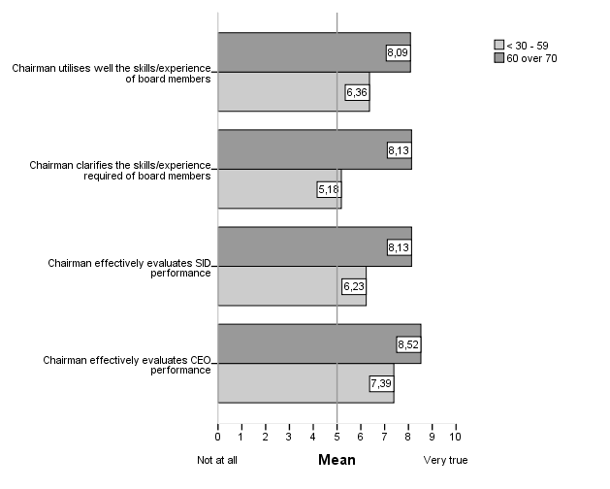The level of education and the views on the chairman performance are negatively correlated which may indicate that the higher the level of education the more demanding are the views related to the way the chairman evaluates the board, encourages feed-back on his own performance and clarifies the skills and experience of board members, as shown in table 12.

**Table 12 Correlations between level of education and Board views**

|  |  |  |
| --- | --- | --- |
|  | Spearman's rho | Highest level of education |
| Chairman effectively evaluates board members performance | Correlation Coefficient | -,562* |
|  | N | 109 |
| Chairman encourages feed-back on his performance | Correlation Coefficient | -,549* |
|  | N | 109 |
| Chairman clarifies the skills/experience required of board members | Correlation Coefficient | -,543* |
|  | N | 109 |
| *. Correlation is significant at the 0.01 level (2-tailed).  Note: presented only the variables with correlation > 0.5 |  |  |

The referred findings can be observed in graph 2 where respondents having the higher level of education score systematically lower in all the shown statements related to chair performance with the exception of the respondents belonging to School/College Certificate group when presenting their perception on the way the chair clarifies the skills/experience of board members.

**Graph 2** **Views by level of education**

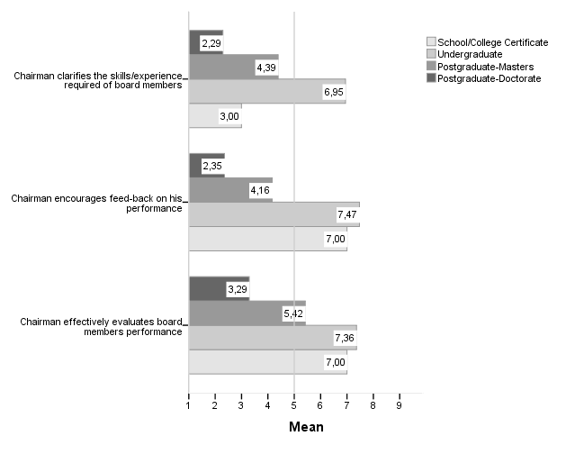

Notwithstanding the most relevant differences and the most statistically significant impact appear when crossing the position held by the directors and the views on the Chairman, Board, SID and CEO. Before engaging on a detailed description on the board members views’ of the Chairman, Board, SID and CEO graph 3 shows how perceptions vary according to the position held by board members, by dimension. Generally views are positive in the sense they are located in the right side of the graph (above the middle of the scale). However chairmen, consistently score themselves higher on their own performance, compared to the views of other Board members and CEO/GM. Moreover chief officers seem to be less positive with respect to the chairman performance but in the chair Qualities dimension. This finding shows a potential tension point between these two positions and their interrelation.

**Graph 3** **Mean’s comparison per dimension according to Chairmen, CEO/GM and other directors**

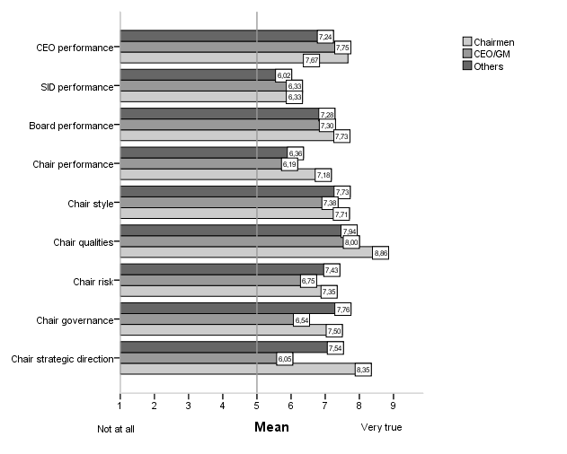

* + 1. **Views on the Chairman**

In respect to the chairman, generally speaking, the results are fairly positive, despite the differences observed among the various dimensions (table 10).

Exploring in more depth the perceptions on the chairman’s role, the table presented in annex C shows the scores received by the chairman. The items where chairmen got the highest rates, all measuring the qualities and style dimensions, were related to chairman displaying integrity (mean=8.46), being trustworthy (mean=8.39), encouraging consensus (mean=8.33), acting as a role model for others (mean=8.29) and being disciplined and encouraging challenge both with mean=8.25. The chairmen were rated lower in what concerns their performance when displaying concern for stakeholders (mean=6.01), displaying concern for shareholders (mean=5.86), discussing sensitive issues with the SID (5.82), encouraging feed-back in their own performance (mean=5.71), searching for CEO replacement (mean=5.59), clarifying the skills/experience required for board members (mean=5.28) and determining board agenda with the SID (mean=4.45). These results show that, apparently the chair cares more about the stakeholders than the shareholders. Additionally the chair got lower rates when measured about driving through management of risk protocols (mean=5.89) and the level of operational involvement (mean=4.52). At this stage the question to ask is whether the chairman accepts that this is part of their role, or it is because they are not effective in performing those tasks.

As already seen the results of the survey show that depending on the position held the views on the chairman differ. Graph 4 shows that the chairman does not get high scores in what his strategic decisions role concerns by both the executive directors and non-executive directors. This result apparently shows that the chairman is not perceived as being closely involved with the strategic decisions of the company as per the scores got in the item chairman determines organization strategy (mean=6.63 for the non-executive directors and mean=6.46 for the executive counterparts). In spite of not particularly relevant the differences between both categories of directors in the case of the chairman strategic decisions role the Non-executive directors rate highly the chairman rather the executive but in what concerns driving the vision. The major difference between the two groups is related to the way the chair person deals with the management team – it seems the relation is not as close as the executive directors would like it to be.

**Graph 4 Views on Chairman Strategic decisions according Executive and Non-executive directors**

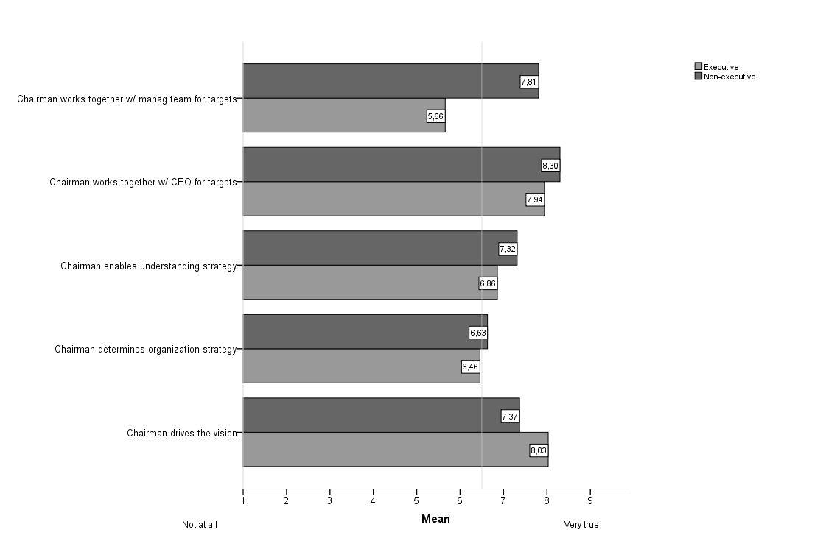The graph 5 shows that chairmen rate themselves close to the non-executive directors though higher than the scores given by the insiders being particularly large the difference in what concerns working together with the management team. This result shows that the role of the chairman is far from being sufficiently involved in the strategic decision making of the companies.

**Graph 5** **Views on Chair Strategic decisions according the Chairman Executive and Non-executive directors**

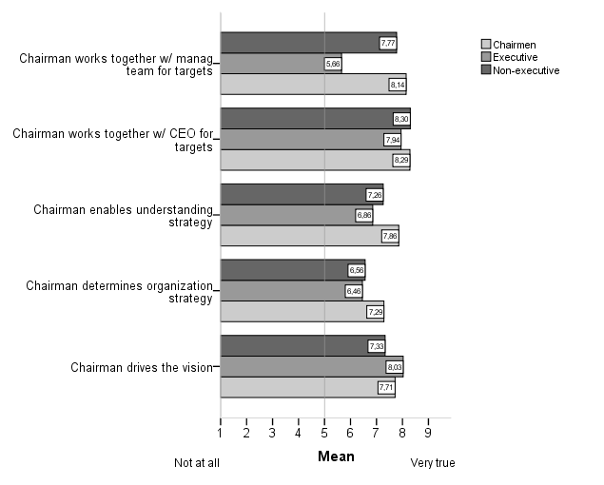Related to the risk dimension there are also some differences between the two mentioned different groups (executive and non-executive directors), as per the graph 6.

**Graph 6 Views on Chairman on Risk according to Executive and Non-executive directors**

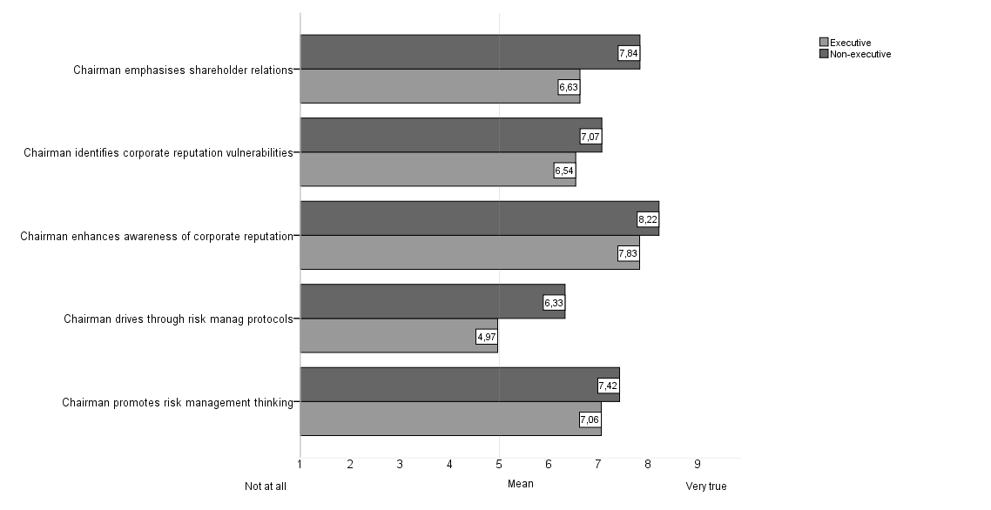

With respect to risk all the non-executive directors rate highly the chairman when compared with their counterparts, the executive directors. The major differences are related to the emphasis given by the chair person to the shareholders and the way of managing the firm’s risk. Apparently the executive directors feel that the chairman is not as assertive towards risk as he could be. Again the chairmen rate themselves closer to the outside Directors in what regards their perception towards risk (Graph 7) but, surprisingly, lower than both executive and non-executive directors concerning emphasising shareholder relations and enhancing awareness of corporate reputation. These findings might induce doubts about these tasks being perceived as making part of their role.

**Graph 7 Views on Chairman on Risk according to Chairman, Executive and Non-executive directors**

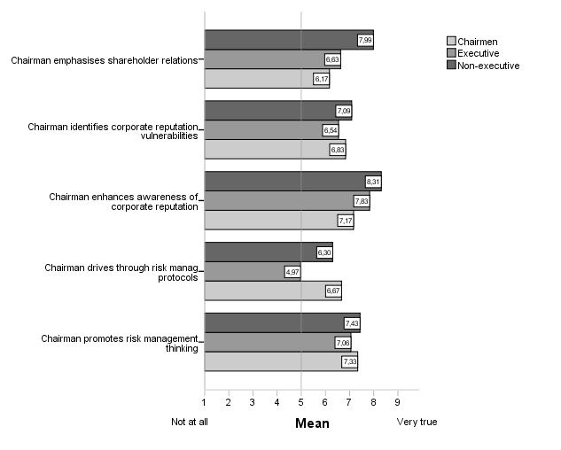The most significant divergence in opinion between the executive and non-executive directors related to governance issues is the way the chairman delineates his role from the CEO. Although both groups rate the chairman moderately high, for the executive directors it seems it is not as clear as for the non-executive directors, as per the graph 8.

**Graph 8 Views on Chairman Governance according to Executive and Non-executive directors**

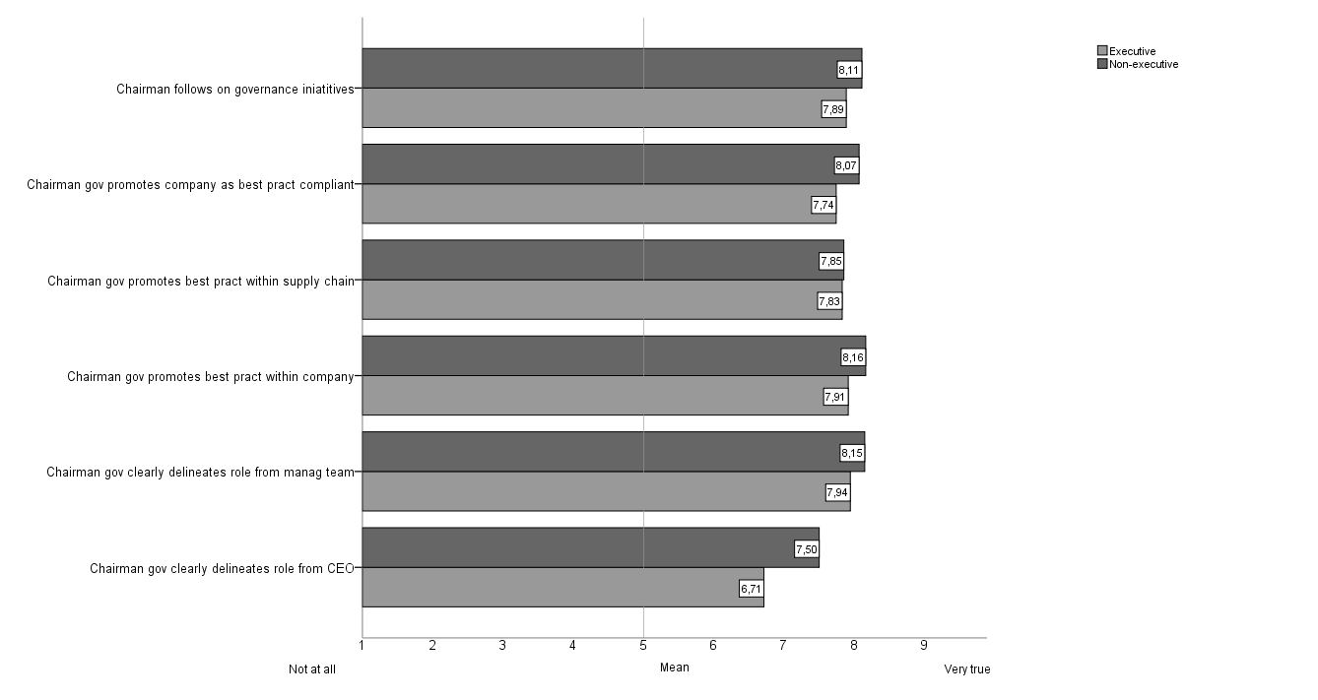

Surprisingly, in this particular case, the chairmen rate themselves lower than the executive directors but in the way they differentiate their role from the one of the CEO (graph 9). However their score is lower than the one given by the non-executive directors. Again these results seemed to show there is a grey zone between the roles of the chairmen and the CEO so that there might be a potential tension point and if so an area that requires attention and further development.

**Graph 9 Views on Chairman Governance according to the Chairman, Executive and Non-executive directors**

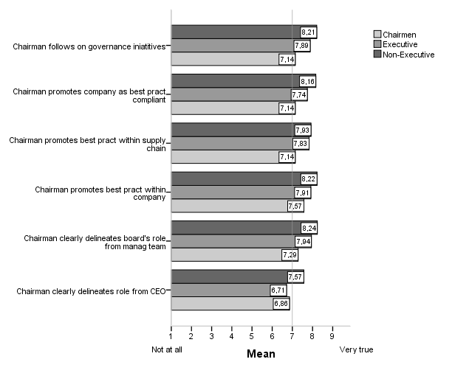

Views on the chair style show (graph 10), generally high scores and no major differences according to the position held, along all the statements with the exception, already reported, in what respects the chair involvement in the firm’s operations. Indeed it seems that everyone perceives a somehow too much involvement, even the chairs themselves (mean=5.44, mean=5.43, mean=6.00, others, CEO/GM and chairmen, respectively). These results may induce an overlapping of the chair and CEO functions and activities’ thus creating tension between these two positions, which ultimately would be negatively reflected in the boardroom climate and performance.

**Graph 10 Views on Chairman Style according to the Chair, the CEO/GM and Others**

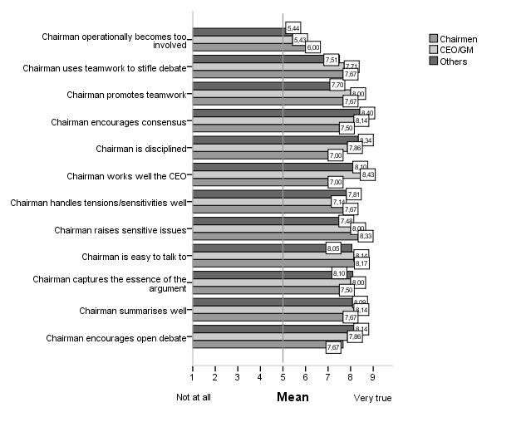

As already commented the qualities of the chairman are a relevant part of the role, and chairs within the survey score well, especially in terms of displaying integrity and being trustworthy. There are no relevant differences in the views reported amongst the positions held within the organisation in what respects the chairman qualities (graph 11).

**Graph 11 Views on Chairman Qualities according to the Chair, the CEO/GM and Others**

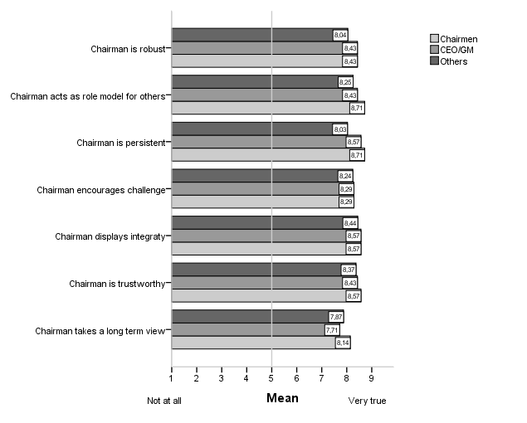As already stated the most relevant differences and the lowest scores got by the chair are related to their performance, as shown in graph 12.

**Graph 12 Views on Chairman Performance according to Executive and Non-executive directors**

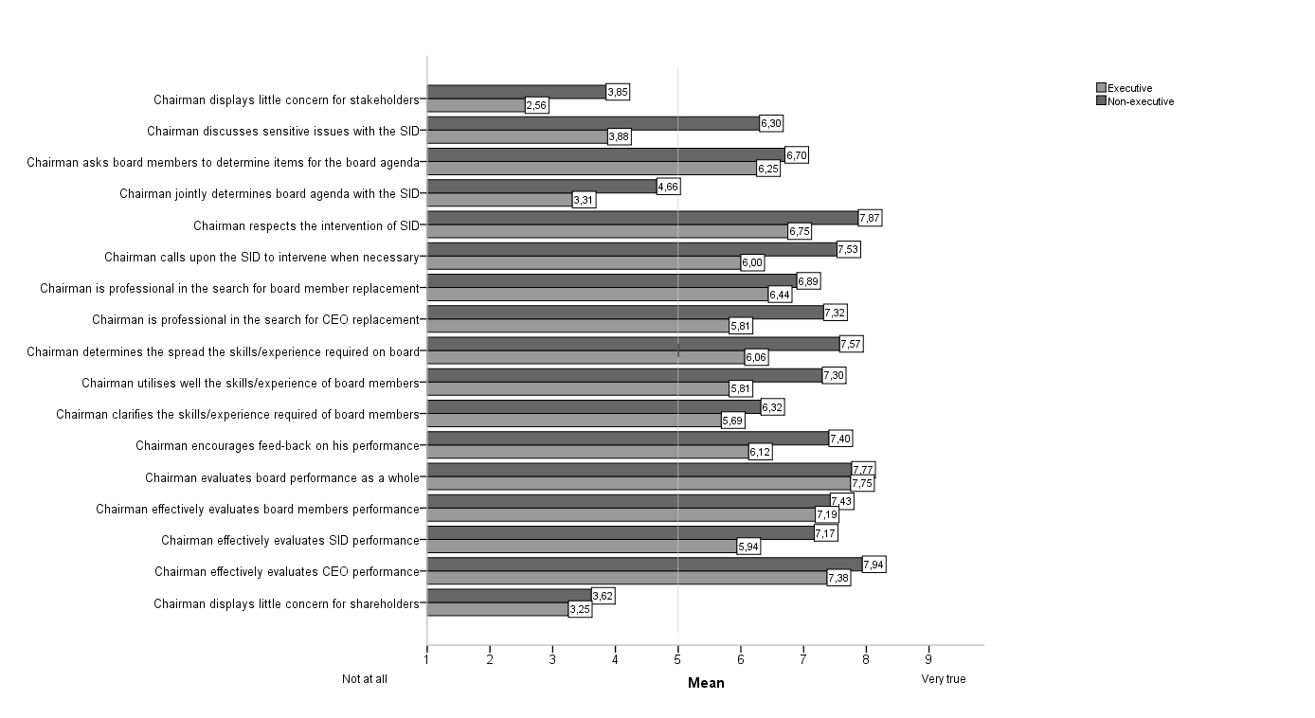

The executive directors – who are the least positive in their perception of chairmen - and the non-executive directors perceive differently the chairman’s performance, mainly in encouraging feedback on the chairman’s performance (mean=6.12 versus mean=7.40), in utilising the skills/experience of board members (mean=5.81 versus mean=7.30), indetermining the spread of skills/experience required on the Board (mean=6.06 versus mean=7.57) and inbeing professional in the search for CEO replacement (mean=5.81 versus mean=7.32).

In fact, the greatest discrepancy of view exists between chairmen and all the other board positions held together (graph 13). This discrepancy of view focuses in particular when related to the discussion of sensitive issues with the senior independent director[7] (mean=7.00 versus mean=5.59), the jointly determination of board agenda with the senior independent director (mean=8.25 versus 4.05),the call upon the senior independent director to intervene (mean=8.75 versus 7.03), the search for board member replacement (mean=9.00 versus 6.63), the search for CEO replacement (mean=8.50 versus 6.83), the use the skills/experience of board members (mean=8.25 versus 6.83) and the clarification ofthe skills/experience required of each Board member (mean=8.25 versus 6.02). And again chairmen significantly rate themselves higher when compared with the other directors. Again it is worth asking whether this result is the consequence of a poorer performance than expected or consequence of an absent shared clear perception about the chairman’s role. Based on these findings it would be difficult to name the chairman as the *‘boss of the board’* whose role is to ‘*induct, include and train to competence each director and the board as a collective whole’* (Garratt, 1999:199).

**Graph 13 Views on Chairman Performance according to the Chairmen and the other Directors**

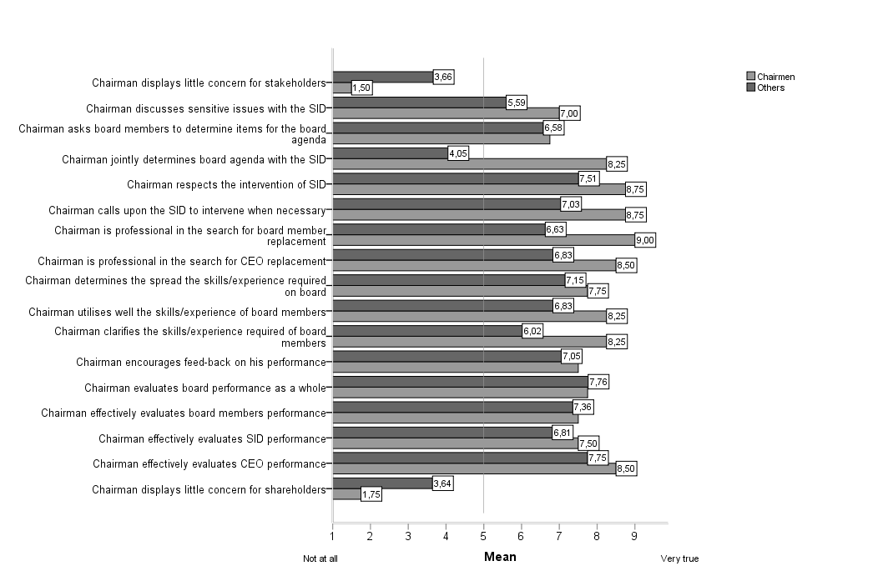

* + 1. **Views on the Board**

Generally the respondents rate the Board highly, namely in two key areas (table 13) that is its attentiveness to corporate reputation (mean=8.59) and its benefits from the chairman contribution (mean=8.53). In five items (out of eleven) range=8 but concerning board’s cohesion range=7, attentiveness to risk management, board’s balance in terms its members’ skill/experience and boards’ benefit from chairman’ contribution range=5, with range=4 the board’s diligence in governance application and board’s attentiveness to corporate reputation range=3.

**Table 13 Board scores**

|  |  |  |  |  |  |
| --- | --- | --- | --- | --- | --- |
| Items | Minimum | Maximum | Mean | Std. Deviation |  |
| Board is attentive to corporate reputation | 6 | 9 | 8.59 | 0.641 |  |
| Board benefits from Chairman contribution | 4 | 9 | 8.53 | 0.877 |  |
| Board is diligent in governance application | 5 | 9 | 7.89 | 1.165 |  |
| Board is well balanced in terms of member skill/experience | 4 | 9 | 7.87 | 0.954 |  |
| Board is attentive to risk management | 4 | 9 | 7.83 | 1.110 |  |
| Board performs effectively | 1 | 9 | 7.55 | 1.285 |  |
| Board is divided | 1 | 8 | 7.53 | 1.237 | a) |
| Board benefits from SID contribution | 1 | 9 | 6.88 | 2.099 |  |
| Board challenges Chairman when necessary | 1 | 9 | 6.50 | 1.698 |  |
| Board emphasises enhancing shareholder relations | 1 | 9 | 5.90 | 2.524 |  |
| Board has clear criteria for board member replacement | 1 | 9 | 3.89 | 2.807 |  |
| a) the original scale was reversed |  |  |  |  |  |
| For the questions related to SID there were only 68 cases |  |  |  |  |  |

However it is clear that there is still room for improvement regarding criteria for board’s member replacement.

The graph 14 shows that there are two areas where differences arise across the three positions held by respondents in respect to the board’s performance – criteria for board member replacement and challenging the chair where the chief officers rate the board slightly lower than the others. In fact the views of board members are, generally speaking, close to the views of the chairman. This finding may suggest that chief officers are not aligned with the board as expected and suspecting they are not of a ‘like mind’ with the chair, as shown later.

**Graph 14 Views on Board Performance according to the Chairmen, the CEO/GM and the other Directors**

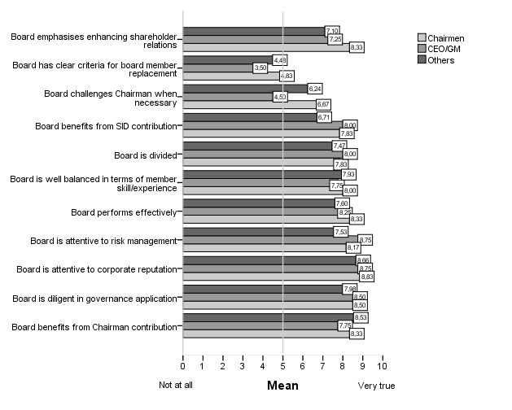

* + 1. **Views on the SID**

Although there were only 62.0% respondents to the section of the senior independent director (where the role existed), as shown in table 14, their role is seen to be potentially an important one in that they have the confidence of the board (mean=8.29), are attentive to shareholders (mean=7.96) andwork well with the chairman (mean=7.76) nevertheless their primordial role being of supervising. In what regards data variability, nine (out of twelve) items range=8. Concerning the way SID works with the chairman range=4 and relating his/her attentiveness to shareholders and having the confidence of the board range=3.

**Table 14 The Senior Independent Director scores**

|  |  |  |  |  |
| --- | --- | --- | --- | --- |
| Items | Minimum | Maximum | Mean | Std. Deviation |
| SID has the confidence of the Board | 6 | 9 | 8.29 | 0.865 |
| SID is attentive to shareholders | 6 | 9 | 7.96 | 0.888 |
| SID works well with the Chairman | 5 | 9 | 7.76 | 1.108 |
| SID is clear about his/her role | 1 | 9 | 6.87 | 2.753 |
| SID has clearly identified the tasks & responsibilities in his/her role | 1 | 9 | 6.72 | 2.796 |
| SID promotes improving shareholder relations | 1 | 9 | 6.53 | 1.896 |
| SID is the person to approach when difficulties arise | 1 | 9 | 6.43 | 2.934 |
| SID is the person shareholders approach when difficulties arise | 1 | 9 | 5.18 | 2.828 |
| SID offers feed-back to the Board | 1 | 9 | 5.01 | 2.883 |
| SID act as the "link" between Board & Chairman | 1 | 9 | 4.55 | 3.221 |
| SID holds separate meetings with the Board members | 1 | 9 | 4.41 | 3.270 |
| SID leads the search process for a new Chairman | 1 | 9 | 3.06 | 2.511 |

However it seems (graph 15) a great deal of role ambiguity still exists in the sense that between executive and non-executive directors there is no consistent understanding of the role and contribution of this particular function in what respects to promoting improvement in shareholder relations (mean=5.75 versus mean=6.78) and being the person to approach when difficulties arise (mean=5.88 versus mean=6.63), including the shareholders (mean=4.25 versus mean=5.45). In fact it looks like the board (both outside and inside directors) is not taking full advantage of this position especially as offering feed-back to the chairman (mean=4.84 versus 5.38), acting as a “link” between board and chairman (mean=4.55 versus 4.44), holding separate meetings with board members (mean=4.41 versus 4.31) and being the person shareholders approach when difficulties arise (mean=5.45 versus 4.25).

**Graph 15 Views on SID Performance according to Executive and Non-executive directors**

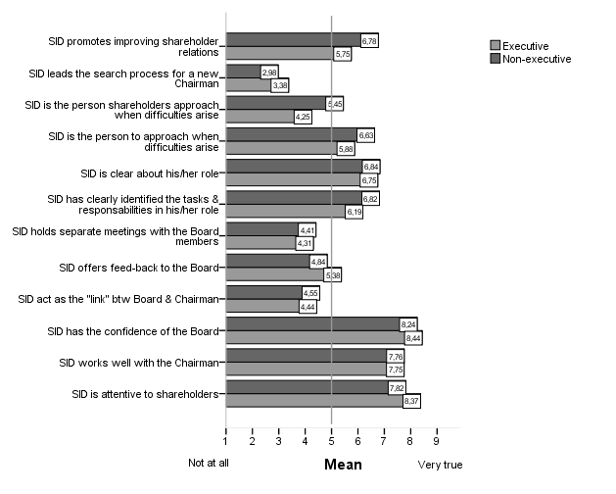

When comparing their own views with the other members of the board (graph 16) the discrepancy realised before appears to increase. While SIDs believe they are clear about their role (mean=7.40 versus 6.77) and clearly identified the tasks and responsibilities in their role (mean=7.40 versus 6.60) and that they indeed act like channels the other board members disagree (mean=6.80 versus 4.33). Yet the highest differences are related to the chairman’ search process (mean=6.80 versus 2.77) and being the person shareholders approach when difficulties arise (mean=6.80 versus 5.02). Their role may need to be re-evaluated and re-defined. The respondents also show disparate views on the way the SID communicates with the board – while the SID views himself as offering feed-back to the board (mean=6.80) the other board members’ do not fully agree (mean=4.82). Looking at the item “holding separate meetings with the Board members” the difference is even higher (mean=7.40 versus 4.13). Notwithstanding, with slight differences and, curiously, with higher scores from the other members of the Board than the SID himself, this position has the board confidence (mean=7.40 versus 8.37), works well with the chairman (mean=7.40 versus 7.78) and is attentive to shareholders (mean=7.40 versus 7.78) so that it seems that this position is perceived as adding value to the board and ultimately to the organization. Maybe this positive perception might be related to the need for challenge within the boardroom.

**Graph 16 Views on SID Performance according to the SID and the others Directors**

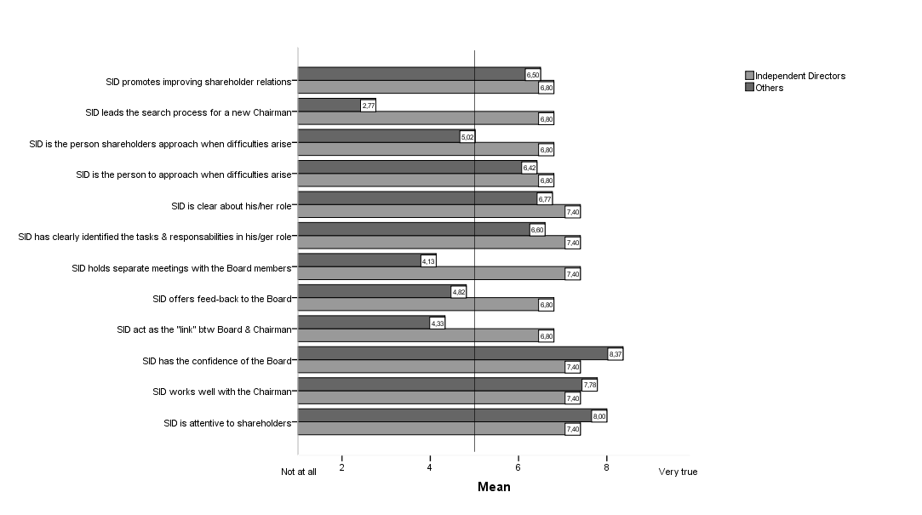

Looking at the SID performance through the eyes of both the chair and chief officers (graph 17), despite the importance both positions attribute to SID’s role, namely his/her attentiveness to the shareholders (mean=8.00), the support he/she gives to the chairman (mean=7.83 versus mean=7.25) and the confidence of the board (mean=8.67 versus mean=8.50), clearly different perceptions and above all lower scores appear in respect to their operational activities shown, for instance in leading the search process for a new chairman (mean=1.33 versus mean=3.00) and holding separate meetings with board members (4.83 versus mean=3.00). These findings show that there is a lot of ambiguity related to the tasks and responsibilities of this position and consequently to the role it plays within the boardroom.

**Graph 17 Views on SID Performance according to the Chairmen, CEO/GM and Others** 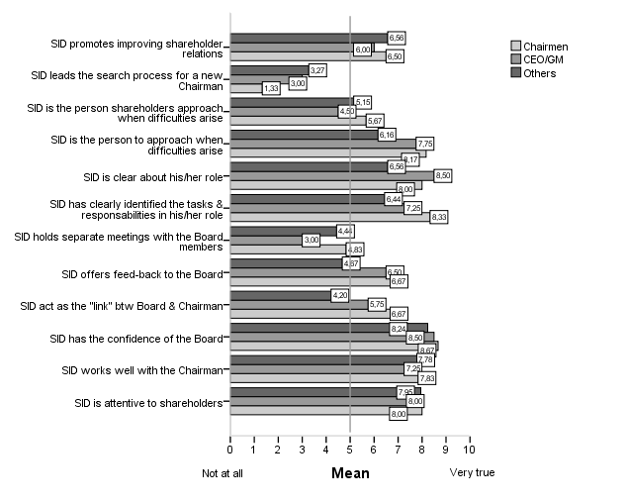

* + 1. **Views on the CEO**

In general the CEOs are rated positively across a number of strategic, operational and communications issues (table 15). The lowest scores are related with:

* Being of a like mind with the chairman (mean=6.06)
* Is undermined by the chairman (mean=5.79)
* Adoption of a different style to the board compared to the management team (mean=5.76)

With respect to the data variability seven (out of twelve) items got range=8, the question regarding CEO displaying attention to shareholders range=7, the two questions related to strategy and if CEO is undermined by the chairman got range=6 and the way the CEO communicates with the board had range=4.

**Table 15 The CEO scores**

|  |  |  |  |  |  |
| --- | --- | --- | --- | --- | --- |
| Items | Minimum | Maximum | Mean | Std. Deviation |  |
| CEO respects the Chairman | 1 | 9 | 8.71 | 0.981 |  |
| CEO has an open relationship with the Chairman | 1 | 9 | 8.58 | 1.082 |  |
| CEO visibly benefits from the relationship with the Chairman | 1 | 9 | 8.06 | 1.331 |  |
| CEO communicates well with the Board | 5 | 9 | 7.95 | 1.128 |  |
| CEO delineates duties from that of the Chairman | 1 | 9 | 7.86 | 2.489 |  |
| CEO determines the strategy | 3 | 9 | 7.60 | 1.711 |  |
| CEO drives the vision | 3 | 9 | 7.60 | 1.770 |  |
| CEO interacts well with the SID | 1 | 9 | 7.46 | 1.749 |  |
| CEO displays little concern for shareholders | 1 | 8 | 6.25 | 2.476 | a) |
| CEO and the Chairman are of a like mind? | 1 | 9 | 6.06 | 2.579 |  |
| CEO is undermined by the Chairman | 1 | 7 | 5.79 | 0.783 | a) |
| CEO adopts a different style to the Board compared to the management team | 1 | 9 | 5.76 | 2.868 |  |
| a) the original scale was reversed |  |  |  |  |  |
| The n=68 for the questions related to SID |  |  |  |  |  |

The relation with the chairman raises no different views among the CEOs and the other members of the board (graph 18). However chief officers rate themselves higher than others in terms of theirinteraction with the SID (mean=8.75 versus mean=7.35), the adoptionof adifferent style to the board compared to the management team (mean=7.75 versus 6.19), his communication with the Board (mean=8.75 versus 7.84), being the vision driver (mean=9.00 versus 7.32) and the one who determines the strategy (mean=8.75 versus 7.55).

**Graph 18 Views on CEO Performance according to the CEO and the other Directors**

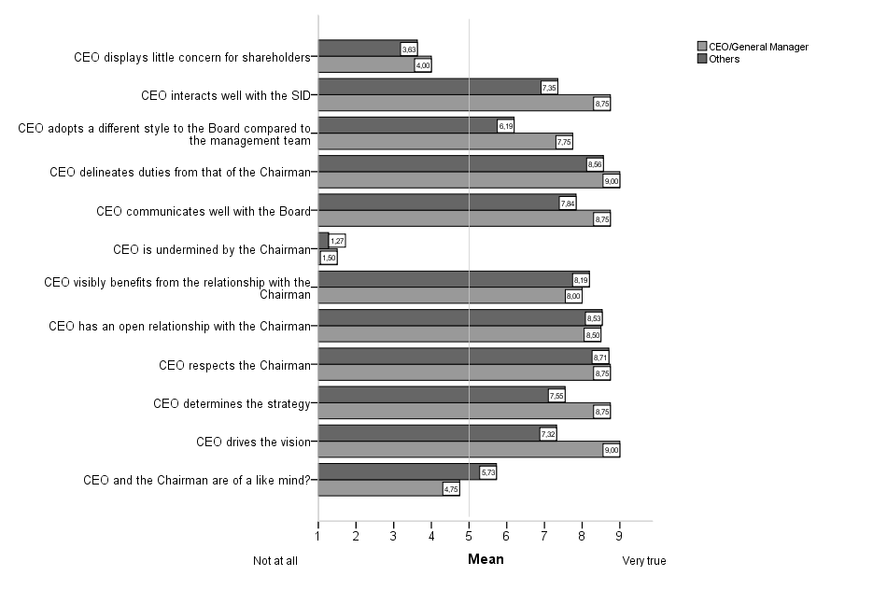

In spite of the relation between CEO and chairman being strong at a personal level since all respondents agree they have an open relationship (mean=8.50 versus 8.53) and a high degree of respect for each other (mean=8.75 versus 8.71) both, CEOs and others board members, believe CEOs and chairman are far from being of a like mind (mean=4.75 versus 5.73).

With respect to the strategic role it is clear that there is still room for improvement since results show that there is a lack of clarity in the roles performed both by the CEO and the chairman. The overall rates are not strong in what concerns to their respective roles towards the organizational strategy. Indeed both, chief officers and chairmen, rate themselves and between them, below the other Board members in what concerns the way both positions delineate their duties from each other. Considering the chief officers way of delineating their duties from that of the chairman the rates vary as follows (mean=7.98 versus 6.71 versus 7.33) for cthers, CEOs and chair, respectively whilst the scores for the chair delineates duties from CEO/GM are (mean=7.37 versus 6.00 versus 6.83) for cthers, CEOs and chair, respectively. Moreover CEOs are less positive towards the chair rather than the other way around (mean=6.00 versus mean=7.33) (graph 19).

**Graph 19 CEO and Chairman Relationship according to the Chairmen, CEO/GM and the other Directors**

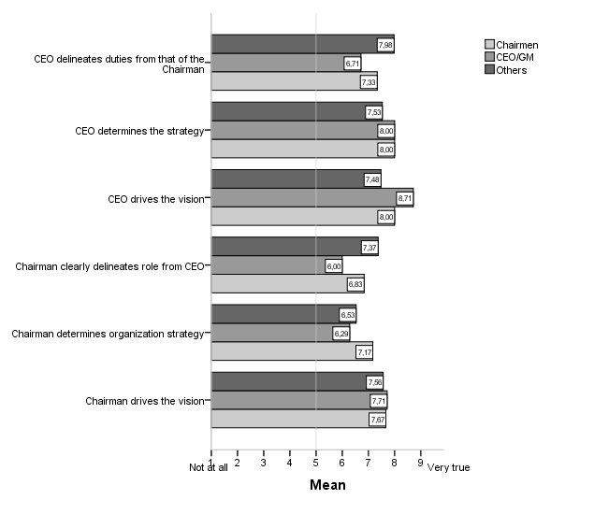

Going further in the analysis of the personal relationship between the CEO and chairman results, shown in the graph 20 below, suggest that CEOs feel more comfortable in their relationship with the chairman rather than the opposite (mean=8.43 versus 7.50) for the item “CEO visibly benefits from the relationship with the chairman”, (mean=8.71 versus 7.50) for the item “CEO has an open relationship with the chairman” and (mean=8.86 versus 7.50).

**Graph 20 CEO and Chairman personal relation according to the Chairmen, CEO/GM and the other Directors**

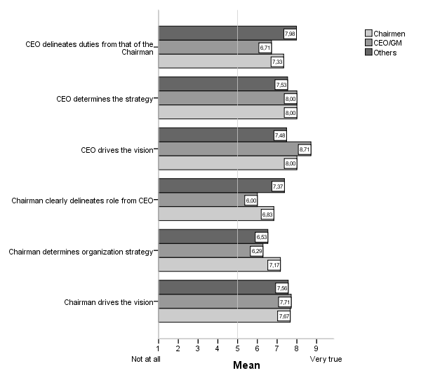

* 1. **Typology of Board members**

The findings presented so far seemed to show an overlapping of the chair and CEO functions and activities’ so that there might be a potential tension point and, if so an area that requires attention and further development. In order to fully assess and explore this apparent grey zone it was decided to cluster board members in what respects their perceptions concerning the chairman and CEO relation and the roles they perform. This ‘*magical relationship*’ (Kakabadse et al., 2006) has been consistently found determinant for board effectiveness by scholarship (Westphal 1999, Roberts and Stiles, 1999; Barratt et al., 2003; Gabrielsson et al., 2007; Kakabadse and Kakabadse, 2008; 2010; O’Higgins, 2009). Moreover the role boundary between chairman and CEO was found to be pivotal to governance application in terms of task accountabilities, vision ownership and recruitment of top talent (Kakabadse and Kakabadse, 2008). Therefore it seemed appropriate to look for patterns among the board members based on their perceptions of the chairman and CEO relation and role boundaries.

The clustering variables were the following statements[8]:

* Chairman clearly delineates role from CEO
* CEO delineates duties from that of the chairman
* Chairman effectively evaluates CEO performance
* CEO and the chairman are of a like mind?
* CEO is undermined by the chairman
* Chairman drives the vision
* CEO determines the strategy
* Chairman works together with CEO for targets
* Chairman works together with management team for targets
* Chairman operationally becomes too involved
* Chairman works well with the CEO
* CEO adopts a different style to the Board compared to the management team
* CEO communicates well with the board
* CEO has an open relationship with the chairman
* CEO visibly benefits from the relationship with the chairman.

Initially four additional variables were considered - chairman clearly delineates the role of Board from that of management team; chairman determines organization strategy; CEO drives the vision; CEO respects the chairman. Although they were discharged consequence of their high level of collinearity, which could provoke a strong impact and affect results (Hair and Black, 2000).

A hierarchical agglomerative clustering approach was chosen utilising the Squared Euclidean distance as the similarity index (Hair and Black, 2000) and the Ward’s method for cluster agglomeration, which maximize the internal cohesion of the clusters (Sinclair et al., 2005). The number of clusters was determined by the analysis of the fusion coefficients (Annex D). To eliminate bias caused by extreme cases it was decided to perform an analysis to track possible outliers. As a consequence one case was excluded. The fusion plot[9] suggested that the optimal cluster solution lay on three clusters with the following distribution (table 16).

**Table 16 Number of cases in each Cluster**

|  |  |  |
| --- | --- | --- |
| Cluster | n | % |
| 1 | 54 | 51.4 |
| 2 | 41 | 39.0 |
| 3 | 10 | 9.5 |
| Total | 105 | 100.0 |

* + 1. **Clusters’ profile**

A full description of each cluster, based on input variables’ means, is going to be provided in an attempt to show how the three different types of board members ideate the chairman/CEO relationship. Graph 21 and Annex E show the means split by cluster.

**Graph 21 Cluster means**

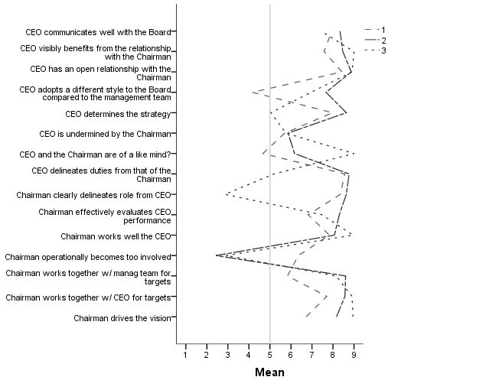

Cluster 1 – the Challengers - is the biggest cluster representing 51.4% of respondents. Both chairman and chief officer are perceived as clearly delineating their roles from each other (mean=8.35, mean=8.56, respectively). However, not in what respects strategic involvement. Indeed chairman is not clearly viewed as the vision driver (mean=6.72) and CEO is, to some extent, the one that determines the strategy (mean=7.98). The chairman is perceived as only, to some extent, working together with the CEO (mean=7.70) and even less as working together with the management team for targets (mean=5.83). The chairman is also not viewed as being overtly effective in evaluating CEO performance (mean=6.81) and is perceived as getting operationally more involved than desirable (mean=6.35). In spite of being seen as working well with the chief officers (mean=7.83) there is still room for improvement and maybe because chairman and CEOs are not perceived as of a ‘like mind’ (mean=4.67). Notwithstanding having an open relationship with the chairman (mean=8.43), to some extent benefiting from the referred relation (mean=7.57) and communicating well with the board (mean=7.94), chief officers are perceived to be, somehow, undermined by the chair (mean=5.70). Finally CEOs are viewed as adopting a different style to the Board compared to the management team (mean=4.17).

Cluster 2 – the Believers - is the second biggest group, with 39% of board members from the sample. Both chairman and chief officer are perceived as clearly delineating their roles from each other (mean=8.63, mean=8.77, respectively) even when considering strategic decisions. Chairmen are viewed as the vision drivers (mean=8.17) and chief officers as determining the strategy (mean=8.63). The chair is perceived to work together for targets both with the management team (mean=8.60) and with the CEO (mean=8.57). He is also viewed as being effective when evaluates CEO performance (mean=8.30) and as not getting operationally too involved (mean=2.43) as also as work well with the CEO (mean=8.07). Chief officers are viewed as adopting a different style to the board compared to the management team (mean=7.67), communicating well with the board (mean=8.33), as having an open relationship with the chairman (mean=8.87) and benefiting from it (mean=8.47). However they are perceived to be, to some extent, undermined by the chairman (mean=5.87) and also to, only to some extent, being of a ‘like mind’ with the chairman (mean=6.17).

Cluster 3 - the Resilients- is the smallest group with 9.5% of the respondents. The chairman does not clearly delineates his/her role from the CEO (mean=2.86) concomitantly with the CEO, but in a small extent (mean=5.19). The chair is clearly perceived as being the vision driver (mean=8.95) and maybe he/she is the one that determines the strategy since CEO is not plainly perceived as the one that does it (mean=5.05). In spite of role boundary issues, namely in what respects strategic decisions, the chairman is viewed as working together for targets both with the CEO (mean=8.90) and the management team, but in a less extent (mean=8.14). The chairman is perceived to effectively evaluate CEO performance although with still the need for amendment (mean=7.48). He is being seen as working well with the CEO (mean=8.95) and as not getting operationally too involved (mean=2.90). On the other side chief officers are perceived to somehow use different styles when approaching the board compared with the management team (mean=6.95), as communicating relatively well with the board (mean=7.43), as maintaining an open relationship with the chairman (mean=8.90) and visible benefiting from it (mean=9.00). Despite being perceived as, to some extent, being undermined by the chairman (mean=5.76), chief officers and chairman are a perfect match (mean=9.00).

* + 1. **Clusters’ (dis)similarity**

Based on the input variables presented in the graph 16 (shown above) and Annex E, whilst in respect to some views the three cluster scores present similar figures, others show disparate values among groups. This is quite noticeable in what regards role boundary between chairman and CEO, vision and strategy ownership, the way the chairman works with the management team, the operational involvement of the chairman, the different style adopted by the CEO towards both the Board and the management team and the CEO and the chairman being of a ‘like mind’. On the contrary two views got almost the same scores along the three clusters: the type of relation the CEO entails with the chairman and if he/she is undermined by the chairman.

Role boundary is clearly perceived as not existing within cluster 3 (Annex E and graph 16). In fact both the chair and the CEO are perceived as not clearly delineating their role (mean=2.86 and mean=5.19, respectively). On the contrary board members of both cluster 1 and 2 perceived chairman (mean=8.35, mean=8.63, respectively) and CEO (mean=8.56, mean=8.77, respectively) as clearly delineating their roles. However CEO is seen as being more noteworthy than the chairman. As seen in cluster 3 the CEO is performing better than the chairman, that is, he/she is perceived to stand out from chairman in what respects to their tasks and activities. This finding may be related to CEOs executive, and thus more visual, tasks’ and therefore inducing a higher level of indefiniteness of the chairman’ role or at least perceived as such. However it worth mention that this lack of clearance between chief officers and chairman roles was already noticed in the 2009 Heidrick & Struggles report (as previously mentioned) and ultimately may be related to the governance recommendations in force. As described, for the one-single tier boards, the Governance Code generally recommends the delegation of executive management powers. Yet it was also posited that the powers’ delegation does not hinder the board’s capacity to act upon the same matters which might lead to task’s overlapping.

In what respects to determining strategy cluster 3 visibly differentiates from the other two. In cluster 3 the CEO is not clearly perceived as determining the strategy (mean=5.05), so that this might be a chair task or a task performed by both the chair and the CEO. Within the cluster 2 the CEO is perceived as determining the firm’s strategy (mean=8.63) and to some extent also in cluster 1 (mean=7.98) but not as clearly as in cluster 2. In cluster 3 the chairman is clearly viewed as being the vision driver (mean=8.95) and, as already pertained, the one that might also determine the strategy. On contrary in cluster 1 the chair is not expressly viewed as driving the vision (mean=6.72). Board members of cluster 2 view the chairman as the vision driver (mean=8.17) however not as clearly as in cluster 3. These results are consistent with the statement of the way the chairman works both with the CEO and with the management team. Indeed in both clusters, 2 and 3 the Chair is perceived to work together with the CEO (mean=8.57, mean=8.90, respectively) and the management for targets (mean=8.60, mean=8.14, respectively) while within cluster 1 the chair got lower scores both for working with the CEO (mean=7.70) and even lower in what regards the management team (mean=5.83), thus denoting a somehow lack of togetherness. However it seems difficult to perceive togetherness when board meetings occur once a month or once every quarter (on 55.6% of cases board meetings are held on a monthly basis on 37.0% of cases on a quarterly basis) and for a short elapse of time (78.0% meetings usually last for up to half a day and 22.0% for a full day). Moreover it seems improbable to develop togetherness considering the number of boards the sample directors sit. In fact almost one third of directors sit on six or more boards. Analogously, the Heidrick and Struggles 2011 report on European corporate Governance practices rank Portuguese board members amongst the least available chairmen and directors. Availability is calculated using the total number of executive and non-executive positions that directors and chairmen hold in public companies. Empirical research, as shown in the literature chapter, stresses the increasing importance of the board’s role in strategic management draw on the perception that they are ultimately responsible for effective organizational functioning (Blair and Stout 2001, Johnson et al. 1996, Pearce and Zahra 1991). Yet these results confirm Roberts and Stiles (1999) findings, who report that there are no clear lines separating the roles and responsibilities of board members and maybe it translates the conflicting requirements boards of directors face in fulfilling the monitoring role (independence) and the strategy role (involvement) (Mueller et al, 2003). In the Portuguese case this situation may be even worsened by the fact that some strategic matters which have a major impact on the companies’ strategic setting and direction, are taken at the shareholders meeting, thus creating a grey zone on the strategic role boundary played by the board of directors.

Being of a like mind is one of the views that most differentiates the three clusters. Whilst within cluster 3 the chair and the chief officer are perceived to be the perfect match getting the highest possible score (mean=9.00), within cluster 2 they are not perceived as being close aligned (mean=6.17) being even far within cluster 1 (mean=4.67).

In what regards the operational involvement of the chairman again we face disparate results. Whilst within clusters 2 and 3 the views held that chair does not get too involved (mean=2.43, mean=2.90, respectively) board members from cluster 1 perceived chair more involved than desired (mean=6.35). Again these findings show that further clarity is needed in what respects role definition of the chairman.

There are also quite different views among the clusters concerning the style chief officers adopt towards the Board compared to the one assumed with the management team. While board members from cluster 2 and 3 perceived chief officers to have a different style to the board compared to the management team (mean=7.67, mean=6.95, respectively), within cluster 3 board members view CEO as not changing too much their style when facing both teams (mean=4.17). Interestingly, when crossing these results with the scores translating the way chief officers communicate with the board in the case of cluster 3 maybe the different style adoption leads to a communication process not perceived as good as it could be (mean=7.43) while within cluster 2 an adoption of a different style is perceived as being desirable since communication is perceived as being highly effective (mean=8.33). The same analysis done for cluster 1 shows more consistency since the same style apparently contributes to good communication level (mean=7.94).

Despite disparate views there are also similarities common to all clusters. In fact looking at, whether chief officers are undermined or have an open relationship with the chairman, the three types of board members have close (inter-group comparison) and, apparently contradictory views (intra-group comparison). Inasmuch all clusters seemed to perceive (with slight differences) the existence of an open relationship between the two leaders (mean=8.43, mean=8.87, mean=8.90 for cluster 1, 2 and 3) simultaneously all view CEOs being, somehow, undermined by the chair (mean=5.70, mean=5.87, mean=5.76 for cluster 1, 2 and 3).Crossing these findings with the views on CEO and chairmen being of a ‘like mind’ only cluster 3 presents coherent results. As shown, CEO and chairman are perceived as soul mates by cluster 3 (mean=9.00) which is congruent with the high score in the open relation (mean=8.90), the CEO visibly benefiting from the relationship with the Chairman (mean=9.00), the chairman working well with the CEO (mean=8.95) and the chairman working together with CEO for targets (mean=8.90). Consequently the apparent incongruous cluster 3’ result of chief officer being, somehow (mean=5.76), perceived as undermined by the chairman, despite their effective and close relation, may be related to the grey zone of their role boundaries.Considering clusters 1 and 2 this tentative explanation between the role boundaries and the CEO being undermined by the chairman cannot be established since for board members of both clusters their roles are perceived to be clearly delineated.

* + 1. **Cluster’s demographics**

In order to characterize the clusters it was decided to observe the clusters’ demographics such as age, level of education and position held in the board[10]. Although these do not have a direct impact on board performance, they could help to identify clues on the answers given and, areas for further research. Table 17 displays the results.

**Table 17 Clusters’ demographics**

|  |  |  |  |  |  |  |  |
| --- | --- | --- | --- | --- | --- | --- | --- |
|  | | Clusters | | | | | |
| 1 | | 2 | | 3 | |
| N | % | N | % | N | % |
| Age | < 30 - 49 | 4 | 7.4 | 2 | 6.7 | 0 | 0.0 |
| 50 - 59 | 44 | 81.5 | 12 | 40.0 | 13 | 61.9 |
| 60 over 70 | 6 | 11.1 | 16 | 53.3 | 8 | 38.1 |
| Total | 54 | 100.0 | 30 | 100.0 | 21 | 100.0 |
| Level of education | School/College Certificate | 6 | 11.1 | 0 | 0.0 | 0 | 0.0 |
| Undergraduate | 10 | 18.5 | 20 | 66.7 | 21 | 100.0 |
| Postgraduate-Masters | 22 | 40.7 | 9 | 30.0 | 0 | 0.0 |
| Postgraduate-Doctorate | 16 | 29.6 | 1 | 3.3 | 0 | 0.0 |
| Total | 54 | 100.0 | 30 | 100.0 | 21 | 100.0 |
| Board position | Chairmen | 4 | 7.4 | 1 | 3.3 | 0 | 0.0 |
| CEO/GM | 4 | 7.4 | 1 | 3.3 | 2 | 9.5 |
| Executive directors | 17 | 31.5 | 3 | 10.0 | 8 | 38.1 |
| Non-executive directors | 29 | 53.7 | 25 | 83.3 | 11 | 52.4 |
| Total | 54 | 100.0 | 30 | 100.0 | 21 | 100.0 |
| Board position (Executive & Non executive) | Executive | 21 | 38.9 | 4 | 13.3 | 10 | 47.6 |
| Non-executive | 33 | 61.1 | 26 | 86.7 | 11 | 52.4 |
| Total | 54 | 100.0 | 30 | 100.0 | 21 | 100.0 |

Cluster 1 is mostly composed (81.5%) by board members aged between fifty to fifty nine years old and 70% belong to the two highest levels of education. In terms of position held it has exactly the same weight of chairmen and chief officers (7.4%) and more than half (61.1%) held a non-executive position.

In cluster 2 the majority (53.3%) of the board members are aged 60+, 66.7% are undergraduate and more than three quarters (83.3%) are non-executive directors. From the clusters’ results presented cluster 2 seems to show a more balanced perception of the chairman/CEO relationship and consequently how it affects board effectiveness. Pye and Pettigrew (2005:S35) posit that *‘Regardless of contingency factors and context, the enduring qualities of NEDs include that they are: articulate/able to communicate effectively; adept/capable; and most importantly of all, have a conceptual awareness which enables them to see a much wider horizon with an ability to conceptualize what is happening and act in a conceptually appropriate manner*’. Drawing on these conclusions about the non-executive directors there might be a relation between a more balanced position demonstrated by cluster 2 board members and the fact that it is mostly composed by non-executive directors.

All board members from cluster 3 hold an undergraduate degree, 61.9% are aged between fifty to fifty nine years old and 52.4% are non-executive directors. In terms of executive (47.6%) versus non-executive directors (52.4%) this cluster is the most balanced. Board task expectations vary across different functions among the board (Huse, 2007) so this balanced distribution between executives and non-executive directors may explain their more consistent perceptions about the tensions in what respects board role boundaries, despite chairman and CEO mind alignment. These findings confirm the pivotal relevance of chairman/CEO role boundary definition for board effectiveness revealed by Kakabadse and Kakabadse (2008).

* 1. **Chapter summary**

The discussion presented in this chapter, revealed many inconsistencies of the study participants’ perceptions within the boardroom, namely related to the board role boundaries between the chairman and the CEO and their strategic involvement. It was also shown that a higher level of role indefiniteness was perceived within the chairman’ role when compared with the chief officers. However the most impressive finding is that, somehow, chief officers are undermined by the chairman, which translates tensions at board level that ultimately could affect the organization performance. Moreover results show that despite the senior independent director being perceived as a relevant position to be kept in the board, there is also a lot of ambiguity related to the tasks and responsibilities of this position and consequently to the role it plays within the boardroom.

The next chapter provides the conclusions of the research, its main contributions, its limitations and areas for further investigation.

**CHAPTER 5 - CONCLUSION**

1. **Conclusion**

*Não há soluções, há caminhos.*[11]

Padre Vasco Magalhães (2003)

This concluding chapter will examine the findings as they relate specifically to the research question. Following the review of the key research findings the chapter will discuss the main implications. This chapter discusses the originality and contribution of this study to both the academic and management communities. The thesis ends with a short reflection on the limitations of the research and suggestions for areas of further investigation.

**5.1. Revisiting the research question and survey's conclusions**

This project aimed to explore the dynamics and performance at the boardroom in a non-Anglo-American context in order to understand the contribution and the role that boards play. The literature review (see Chapter 2) identified a gap between firms’ expectations from the boards’ tasks (boards’ role) and their contribution (what the boards actually do). Scholars previously had not thoroughly researched this area (Mace, 1972; Stiles, 2001; Leblanc and Gillies, 2005; Huse, 2009). Therefore, the purpose of this survey was to try to fill this void as much as possible by bridging the gap between board role expectations and actual board role reality and shed light on boards’ *real* contribution and ultimately their effectiveness.

As a result of the literature review, the author framed the following research question to address the gap in the empirical research: What is the perceived role and contribution of the boards of directors? Consequently, the author designed the research project to understand and explore Portuguese listed companies’ boards of directors as an appropriate exploration of the perceived boards’ role and descriptive research design for the perceived boards’ contribution. Despite the attractiveness of using a survey that describes *how* directors do or enact their role, the author decided to check and explore the things that directors actually perceive that they do. This decision was then reinforced by the opportunity to replicate the Kakabadse and Kakabadse (2007) survey in the Portuguese environment. Thus, this work intended to generate '*what is'* knowledge to stimulate and facilitate future research of '*how to'* knowledge generated through process studies. The author based the empirical study on the quantitative survey which was administered to the board members of the Portuguese listed companies at Euronext Lisbon, in 2011. Therefore, this survey explored a set of quantitative data from a sample of directors who express their views on the Chairman, the Board, the Senior Independent Director and the CEO performance, based on their own (board) experience. From the onset, the author assumed that not considering the board of directors as context driven might lead to the gap widening between board role expectations and actual board role reality. Regardless the hegemonic role played by the universalistic attempts to reform corporate governance around the world, mainly among the listed companies, this research intended to show and, has shown the relevance of the particular context where firms act and its influence. In fact being corporate boards social constructs (Aguilera and Jackson, 2003; Johnson et al., 1996) its functioning is indelibly connected with the specific institutional environments in which they operate.

The overall findings raised three major issues related to 1) role boundary between chairman and chief officers and indefiniteness of both the chairman and the SID roles; 2) lack of clarity regarding the board’s strategic involvement and, 3) the relation between board members, namely executive and non-executive.

Scholars have found the role boundary between chairman and CEO as pivotal to governance application (Kakabadse and Kakabadse, 2008) and have consistently found it a determining factor in board effectiveness (Westphal 1999, Roberts and Stiles, 1999; Barratt et al., 2003; Gabrielsson et al., 2007; Kakabadse and Kakabadse, 2008; 2010; O’Higgins, 2009). Kakabadse and Kakabadse (2009), referring to the '*system’s'* pressure to 'deliver the numbers', contend that '*the system',* whilst disabling corporate responsibility and governance, heap significant legal and administrative demands on corporate boards to uphold the highest standards of governance obligations. The question is whether this paradox affects board effectiveness. The empirical evidence shows that the lack of clearance between chief officers and chairman roles may be related to the governance recommendations in force. In reality, the Governance Code, whilst recommending boards to delegate the executive management powers simultaneously, posits that the powers’ delegation does not hinder the board’s capacity to act upon the same matters which might lead to overlapping tasks. In addition to the role boundary issues that board members perceived, they perceived a slightly higher level of role indefiniteness regarding the chairman’ role. Specifically, executive directors feel that the chairman is not as assertive towards risk as one should expect him or her to be. Perhaps more impressive are the disparate results regarding the chairman’s operational involvement. These results show an overlapping of the chair (too involved) and CEO functions and activities, thus creating tension between these two positions, which ultimately is reflected negatively in the boardroom climate and with the board’s performance. The study results also revealed a great deal of role ambiguity about the independent directors’ role and contribution and consequently, to the role they play within the boardroom. Board independence has been the cornerstone of the governance debate for long, although considerable divergent views exist on the right proportion of independent directors and their definition (Dalton et al. 1999). Despite board members perceiving this position as offering a valuable contribution to board dynamics, findings showed that the board members need to re-evaluate and re-define the SIDs’ role needs.

This research evidences that a lack of clarity exists regarding the board’s strategic involvement. Findings show that there is lack of clarity in the roles which both the CEO and the chairman perform as the overall rates are not strong in what concerns their roles towards the organisational strategy. Despite the increasing importance of the board’s role in strategic management, according to empirical research (Blair and Stout 2001, Johnson et al. 1996, Pearce and Zahra 1991), the findings identified that this area requires further attention and improvement. As Mueller et al. (2003) suggest, it might translate the conflicting requirements and constant tension that boards of directors face into fulfilling the monitoring role (independence) and the strategy role (involvement). In the Portuguese case this situation might be worse due to some strategic matters that have a major impact on the companies’ strategic setting and direction and which are ruled at the shareholders’ meeting. This could lead to a grey zone on the strategic role boundary on which the board of directors play.

Concerns subsist around the chairman and CEO relationship and its impact upon the board environment and ultimately its effect in board effectiveness. Findings indicate that there is tension between these two positions. The tension is perceived both ways - when participants rate directly the chairman/CEO relation (level of openness, working together for targets, mutual benefits from the relationship, for instance), clearly demonstrating both are far from being of a ‘like mind’ and CEO being, to some extent, undermined by the chairman, but above all when looking at the disparate views between the two teams (executive and non-executive) when grading both positions. For example, survey results showed that the executive directors are least positive in their perception of the chairmen, showing distance between the chairman and the executive team. Furthermore, survey results showed that chief officers are not closely aligned with the board, whilst executive directors do not see the chairmen as having a close relation with them as they would like. Moreover, the Chapter 4 discussion revealed many inconsistencies of study participants’ perceptions precisely when rating the relationship between the two leaders. At this stage, we require further investigation to understand the nature of this tension. Nevertheless, those findings confirm Kakabadse and Kakabadse (2006:30) conclusions that '*no amount of attention to governance controls and procedures is perceived as compensatory for an effective working relationship between the Chairman and the CEO'*. In fact, regardless of whether Portuguese legal corporate governance is highly developed (OECD, 2011), '*effective governance application is dependent on the Chairman and CEO nurturing a supportive and transparent relationship and manner of interaction.'* (Kakabadse and Kakabadse, 2006:31).

* 1. **Implications of the research**

With the purpose of exploring the role and contribution of boards of directors, this survey draws three key conclusions: first, there are, generally, many inconsistencies around the board role boundaries between the chairman and the CEO and, particularly, around their strategic involvement. Second, tensions arise from the way that this relationship evolves and affects both teams (the executive and non-executive directors) and third an absence of a clear picture of the board’s role regarding its strategic involvement. In so doing, there is the need to improve the chairman/CEO role boundaries and also clarify the board’s role, as a whole, regarding its strategic involvement. Indeed, the grey zone created by the fact that some strategic matters which have a major impact on the companies’ strategic setting and direction, are taken at the shareholders meeting may lead to a lax corporate directorship on a day-to-day activities so ultimately affecting not only board effectiveness but above all the overall organization performance. Additionally, further investigation is required to analyse the extent to which the national corporate governance legal framework and other relevant contextual variables are potentially affecting boards’ dynamics and, as a consequence, the firm’s performance. Lastly, particular attention needs to be paid to the impact created by the deployment of the '*magical relationship'*. Recall from our discussion in Chapter 2 (literature review) that despite national contexts, nationally determined practices, role delineation (or not) and sound governance application (or not), the qualities and behaviour of the leaders emerge as the pivotal key to determine a firm’s success (Kakabadse and Kakabadse, 2007a).

Finally, results suggest that there is not a shared and clear perception of the chairman’s role among survey participants. However, findings confirm the role of chairman as influential and powerful in shaping the board through, for instance, generation of consensus and acting as a role model for others. Concomitantly the chairpersons rate, systematically, themselves higher than other directors and do not strongly encourage others to give feedback on his/her performance. Adding up all these findings, it seems that despite the chairperson’s paramount relevance to contribute to board effectiveness, board functioning issues surrounding his/her role are affecting the chairmanship. The chairman, as the apex of corporate leadership in the organisation, is a critical factor in determining a firm’s success. So that further improvements are required to guarantee the full exercise of chairmanship and therefore the long term value creation to all stakeholders.

**5.3 Contributions of the research**

*Theoretical contribution*

This survey makes at least four contributions to the corporate governance literature. The first contribution stems from the study of boards of directors in a non-Anglo-American context using an alternative research method. In an article with the objective to present an overview of empirical research on boards and governance in leading international academic journals, Gabrielsson and Huse (2004) contend that no articles employed cluster analysis. In that sense this study’s approach is novel. Moreover, it enlarges and enriches the still scarce but growing non-mainstream literature on boards of directors (Huse, 2005; Levrau and Van den Berghe, 2009). Second, this survey provides directions to open the '*black-box'* of board dynamics and it has contributed to 'dismantling the fortress' in studies of boards of directors (Daily et al., 2003) whilst exploring and understanding directors and their interactions inside the boardroom. This inquiry does not intend to generate universal theory about boards, rather, it tests the theories surrounding the role and contribution of boards of directors producing locally relevant knowledge. As such it contributes to opening the '*black-box'* that characterises the actual scholarship knowledge. Third, this study also stresses the relevance of considering the human side of governance. It shows one of the major flaws of the corporate governance reforms whilst attempting to uniformly create governance mechanisms and practices with the purpose of enhancing board effectiveness. To forget the human and social side of the board of directors, the bilateral influence between people and the organisational structures, somehow denies the complex and richness of the social nature. Maybe this is one of the root causes of the mentioned gap between the board of directors’ role and the correspondent practice, on which this survey sheds light. As Van der Berghe and Levrau (2004:467) put it, '*Structures are no guarantee for an effective board working: they are only a facilitator. Structures* *are 'brought alive' by people*.' Much of board research is data based, examining boardroom dynamics from a distance (Dalton and Dalton, 2011). In contrast, this survey contributes to a relatively small, but growing stream of research which draws on the growing recognition that the board is a living social system that operates as a 'team' and having a human dimension, whose behavioural aspects have a deep impact on board contribution to the firm’s performance. Finally, this research contributes to theory by demonstrating the particular context where firms act and its influence in the board dynamics. As such, asserting that boardroom behaviour is context-driven.

*Managerial contribution*

Wong (2012:11) argues that for board members to reach their potential they should '*1) think like an owner; 2) know their companies; 3) be prepared to “roll up their sleeves'; 4) take charge of their priorities; 5) hire a collaborative CEO; and 6) protect their authority and independence.”* Above all, this survey contributes to management practice by exploring the actual role and contribution of the boards of directors. In particular, the study provides guidance to those board members who wish to improve their own performance at boardroom level, by highlighting the current issues that board members experience in trying to perform their role. To perform Wong’s targets (2012), board members first need to have a clear perception of the board’s role expectations and how actual board performance meets board role expectations.

Whilst entailing '*what is'* knowledge about the role and contribution of the corporate apex decision-making group, it leads to the overarching and painful (but absolutely needed) reflection about the pivotal boards’ role as shapers of the ever changing business society relationship. It is the duty of management scholars in an age of an ever-expanding influence of companies, to raise society’s awareness of corporate responsibility.

**5.4. Limitations of the research**

This study’s contribution to existing knowledge has its own limitations. Without considering the limitations, contributions may be biased or, at least, not deeply understood by all. This study would have benefited further from using a qualitative approach. In fact, the use of a mixed method approach would allow a greater understanding of the mechanisms underlying the quantitative results and a richer knowledge about the role and contribution of boards through board members’ voices.

**5.5 Areas of further investigation**

As already mentioned, the author structured this survey to generate '*what is'* knowledge with the aim to stimulate and facilitate future research of '*how to'* knowledge generated through process studies. Therefore, qualitative research is now necessary to explore in greater depth and detail the role and contribution of boards, but above all, to understand the nature of the tension and the '*why'* of the disparate views between the executive and non-executive board members.

This research has proven the existence of many inconsistencies of study participants’ perceptions related to the role boundaries between the chairman and the CEO and their strategic involvement. Following Stiles’ research design (2001), it would be interesting to survey company secretaries on the role of the board to foil answers’ biases since this group '*may be thought to respond in a less self-serving fashion'* (Stiles, 2001:633).

Despite the findings’ confirmation of how the chairman’s role is influential and powerful in shaping the board, the study has not given enough attention to the role of the chairman. Further research into his/her critical influence in determining the nature of boardroom relationship dynamics and how he/she shapes board effectiveness would be of capital relevance.

**5.6 Chapter summary**

This chapter closes the thesis. Aiming to present the survey conclusions, it has identified the implications and the contributions to knowledge that this research has made, has acknowledged its limitations and suggested potential avenues for further investigation.

**BIBLIOGRAPHY**

Abbuhl, R. (2012), Why, when, and how to Replicate Research, inMackey, A., Gass, S.M. (Eds), *Research Methods in Second Language Acquisition: A Practical Guide,* Wiley-Blackwell Publishing, Ltd., Oxford, 296-311.

Aguilera, R. (2005), Corporate Governance and Director Accountability: An Institutional Comparative Perspective, *British Journal of Management,* 16, 1-15.

Aguilera, R.V. and Jackson, G. (2003), The cross-national diversity of corporate governance: dimensions and determinants, *Academy of Management Review*, 28 (3):447-465.

Alchian, A.D.H. (1972), Production, information costs and economic organization,*The American economic review*, 62, 777-795.

Aldrich, H.H.D. (1977), Boundary Spanning roles and Organization Structure., *Academy of Management Review*, 2, 217-230.

Ali, S. (1998), Research methodology: Back to basics, *Unpublished manuscript*, <http://www.journal.au.edu/abac_journal/jan98/article5.html>.

Allen, F., Gale, D. (1998), Corporate governance and competition, in Vives, X. (Ed), *Corporate Governance: Theoretical and Empirical Perspectives*, Cambridge University Press, 23-94.

Allen, W.T. (1992), Our Schizophrenic Conception of the Business Corporation, *Cardozo Law Review,* 14, 261-281.

Andrews, K.R. (1982), Rigid rules will not make good boards, *Harvard Business Review*, 35.

Ayuso, S., Argandona, A. (2007), Responsible Corporate governance: towards a stakeholder board of directors?, *Working paper number 701,* IESE Business School, University of Navarra.

Bainbridge, S. (2008), *The new corporate governance in theory and practice*, New York:Oxford University Press.

Barratt, R. (2005), *The role and contribution of the Non-Executive Director: Implications for Corporate Social Responsibility in the Boardroom*. Ph.D. Thesis, School of Management, Cranfield University.

Barratt, R., Kakabadse, N., Barratt, M. (2003), Corporate Social Responsibility in the Board Room: The Need for a Coherent Business Case, *European Academy of Business in Society (EABiS) Conference,* 2003.

Barrocas, M.P. (2009), *Portuguese Company Law*, Lisboa, Barrocas Sarmento Neves.

Baysinger B., B.H. (1985), Corporate governance and the board of directors: Performance effects of changes in board composition, *Journal of Law, Economics, & Organization*, 1, 101-124.

Bazeley, P. (2004), Issues in mixing qualitative and quantitative approaches to research, in R. Buber, J. Gadner, & L. Richards (eds), *Applying qualitative methods to marketing management research,* Basingstoke, UK: Palgrave Macmillan, 141-156.

Bechhofer, F. (1974), Current approaches to empirical research: some central idea*, in Rex, J. (ed.) Approaches to sociology,* Routledge, London.

Becker-Blease, J. (2009), Corporate Social responsibility in Finance, in: Smith, C. and Lenssen, G. (Eds.) *Mainstreaming Corporate Responsibility. Cases and Text for Integrating Corporate Responsibility across the Business School Curriculum.* London: John Wiley.

Berle, A.,Means, G. (1932), *The Modern Corporation and Private Property*, New Jersey, New York: Transaction Publishers.

Bhagat, S., Black, B. (2002), The Non-Correlation Between Board Indpendence and Long-Term Firm Performance, *Journal of Corporation Law*, 27 (2).

Biglan, A, (1973), The characteristics of subject matter in different academic areas, *Journal of Applied Psychology*, 57, 195-203.

Blaikie, N, (1993), "Retroductive and reductive strategies", in: Blaikie and Norman, (Eds.), *Approaches to Social Enquiry*, United Kingdom: Polity Press.

Blair, M. (1995), *Ownership and Control: Rethinking Corporate Governance for the Twenty-First Century*, Washington DC, Brookings Institution Press.

Blair, M.M., Stout, A.L.(2001), Director Accountability and the Mediating Role of the Corporate Board, *Washington University Law Quarterly*, 79.

Blair, M.M., Stout, A.L. (1999), A team production theory of corporate law, *Virginia Law Review,* 85, 248-328.

Bonnafous-Boucher, M., Porcher, S. (2010), Towards a stakeholder society: Stakeholder theory vs theory of civil society, *European Management Review*, 7 (4), 205-216.

Boyd, B.K. (1995), CEO duality and firm performance: a contingency model, *Strategic Management Journal*, 16 (4), 301-312.

Brealey, R.A., Meyers, S.C. (1988), *Principles of Corporate Finance*, Singapore, McGraw-Hill, Inc..

Bruch, H., Ghoshal, S. (2004), Management is the Art of Doing and Getting Done, *Business Strategy Review* ,15, 4-13.

Bryman, A., Bell, E. (2007), *Business research methods*, New York, Oxford University Press.

Burton, P. (2000), Antecedents and Consequences of Corporate Governance Structures, *Corporate Governance: An International Review*, 8 (3).

Cadbury, A. (1992), Report of the Committee on the Financial aspects of Corporate Governance, London, GEE & Co..

Carpenter, M.A., Westphal, J., James, D. (2001), The strategic context of external network ties: examining the impact of director appointments on board involvement in strategic decision making. *Academy of Management Journal*, 44, 639-660.

Carroll, A. (1989), *Business Society: Ethics Stakeholder Management*, Cincinnati, South Western Publishing Company.

Carroll, A.B. (1991), The Pyramid of Corporate Social Responsibility: Toward the Moral Management of Organizational Stakeholders, *Business Horizons.*

Centro de Estudos Aplicados – CATÓLICA–LISBON SCHOOL OF BUSINESS & ECONOMICS (2011), Relatório sobre o grau de acolhimento de recomendações. Índice e rating de governo societário, AEM, <https://docs.google.com/viewer?url=http%3A%2F%2Fwww.emitentes.pt%2Fimages%2Fmedia%2Fdocs%2F172_logos_552111219_AEM_CatolicaLisbon_Relatorio.pdf>

Charan, R. (1998), *Boards at work. How corporate boards create competitive advantage,* San Francisco JosseyBass, a Wiley Company, CA..

Clancy, J.J. (1989), *The Invisible Power: The language of Business*, Lexington, Ky:Lexington Books.

Clarke, T., Chanlat, J. (2009), 'Introduction: A New World Disorder? The Recurring Crises in Anglo-American Corporate Governance and the Increasing Impact on European Economies and Institutions"', in Clarke, Thomas and Chanlat, Jean-Francois (eds)*, European Corporate Governance,* Routledge, London, UK, 1-42.

Clarkson, M.E. (1995), A stakeholder framework for analysing and evaluating corporate social performance, *Academy Of Management Review*, 20, 92-117.

CMVM (2007), Corporate Governance Code, <http://www.cmvm.pt/EN/Legislacao_Regulamentos/Regulamentos%20Da%20Cmvm/2007/Pages/Regulation%201_2007.aspx>.

CMVM (2012), Annual Report on the Corporate Governance of Listed Companies in Portugal, 2011,<https://docs.google.com/viewer?url=http%3A%2F%2Fwww.cmvm.pt%2FEN%2FEstudos%2FDocuments%2FFinal.Corporate.Governance.Report.2011.pdf>.

Coase, R.H. (1960), The problem of Social Cost, *Journal of Law and Economics*, 3, 1-44.

Creswell, J. (2003), *Research design: Qualitative, quantitative and mixed methods approaches,* Thousand Oaks, CA, SAGE Publications.

Cunha, P. (2009), Corporate Governance in Portugal: What lies ahead?, *International Corporate Governance Digital Guide.*

Daily C, Dalton, D., Cannella Jr.A. (2003), Corporate governance: decades of dialogue and data, *Academy Of Management Review*, 28, 371-382.

Dalton, D., Daily C., Ellstrand,A., Johnson, J. (1998), Meta-analytic reviews of board composition, leadership structure, and financial performance, *Strategic Management Journal,* 19 (3).

Dalton, Daily C., Ellstrand, A., Johnson, J.. (1999) Number of Directors and Financial Performance: a Meta-Analysis. *Academy of Management Journal*, 42, 674-686.

Dalton, D.R., Daily, C.M., Covin, J.G. (2004), Meta-analysis of post-acquisition performance: indications of unidentified moderators. *Strategic Management Journal*, 25, 187-200.

Dalton, D.R., Dalton, C.M. (2011), The integration of Micro and Macro-Studies in Corporate Governance Research: CEO Duality, Board Composition, and Financial Performance, *Organizational Research Methods,* 37,2,401-411.

Davis, I. (2005), The biggest contract, *The economist,* May.

Davis, J.H., Schoorman, F.D, Donaldson, L. (1997), Toward a stewardship theory of management,. *Academy of Management Review*, 22 ( 1), 20-47.

Denzin, N.K. (1989),*The research act (3rd ed.)*, New York: McGraw-Hill.

Denzin, N.K., Lincoln, Y.S. (1994), *Handbook of qualitative research*, Thousand Oaks, CA: Sage Publications.

Donaldson, L., Davis, J.H. (1991), Stewardship Theory or Agency Theory: CEO Governance and Shareholder Returns. *Australian Journal of management*, 16, 17.

Donaldson, L., Davis, J.H. (1994), Boards and Company Performance - Research Challenges the Conventional Wisdom, *Corporate Governance: An International Review*, 2, 151–160

Donaldson, T., Preston, L.E. (1995),The stakeholder theory of the corporation: concepts, evidence, and implications. *Academy of Management Review*, 20 (1), 65-91.

EABIS’ Position Paper and Response to the European Commission’s Green Paper on the EU Framework for Corporate Governance, July 2011,

<http://ec.europa.eu/internal_market/consultations/2011/corporate-governance-framework/individual-replies/eabis_en.pdf>

Easterby-Smith, M., Thorpe, R., Jackson, P.R. (2008), *Management Research*, London: Sage Publications, Ltd..

ECGI, European Commission Green Papers on Corporate Governance and the ECGI research agenda, September 2011, <https://docs.google.com/viewer?url=http%3A%2F%2Fwww.ecgi.org%2Fconferences%2Fgreen_papers2011%2Ffinal_report.pdf>

ecoDa’s response to the EU Green Paper on CG for listed companies, June 2011,

<http://www.ecoda.org/ecoDa%27sresponsetoEUgreenpaperonCGforlistedcompanies.pdf>

European Commission, Green Paper, Corporate governance in financial institutions and remuneration policies, June 2010, <http://ec.europa.eu/internal_market/company/docs/modern/com2010_284_en.pdf>.

European Commission, Towards a Single Market Act, November 2010, <http://eur-lex.europa.eu/LexUriServ/LexUriServ.do?uri=COM:2010:0608:FIN:en:PDF>.

European Commission, Green Paper, The EU corporate governance framework, April 2011, <http://eur-lex.europa.eu/LexUriServ/LexUriServ.do?uri=COM:2011:0164:FIN:EN:PDF>.

Esperança, J.P., Sousa, A., Soares, E., Pereira, I. (2011), *Corporate Governance no espaço lusófono,* Lisboa, Texto Editores.

Fama, E.F., Jensen, M.C. (1983), Separation of ownership and control, *Journal of Law and Economics*, 26, 301-325.

Finkelstein, S., D’Aveni, R.A. (1994), CEO duality as a double-edged sword: How boards of directors balance entrenchment avoidance and unity of command, *Academy of Management Journal*, 37, 1079-1108.

Finkelstein S, Money, A. (2003), Not the usual suspects: How to use board process to make boards better. *Academy Of Management Executive*, 17, 101-113.

Forbes D, Milliken, F. (1999), Cognition and corporate governance: understanding boards of directors as strategic decision-making groups, *Academy of Management Review*, 24, 489-505.

Foss, N.L.H.T.S. (1999) The theory of the firm. *Working paper 5610*, Department of industrial economics and Strategy Copenhagen Business School.

Fowler, F.J. (2002), *Survey Research Methods*, Thousand Oaks: Sage Publications, Inc; .

Freeman E. (1984), *Strategic management: A stakeholder approach,* Pitman.

Freeman, E., Liedtka, J. (1991), Corporate Social Responsibility: A Critical Approach. *Business Horizons*, 34, 92-98.

Freeman, R.E., Wicks, A.C., Parmar, B. (2004), Stakeholder Theory and "The Corporate Objective Revisited ", *Organization Science*, 15, 364-369.

Friedman, M. (1970), The social responsibility of business is to increase its profits, *The New York Times Magazine,* September*.*

Fuller, B.R. (1970), *Utopia or oblivion: the prospects for humanity?*, Bantam Books.

Gabrielsson, J., Huse, M., Minichilli, A. (2007), Understanding The Leadership Role Of The Board Chairperson Through A Team Production Approach, *International Journal of Leadership Studies*, 3, 21-39.

Gabrielsson, J., Huse, M. (2004), Context, Behaviour, and Evolution. *International Studies of Management & Organization*, 34 (2):11-36.

Garratt, B. (1999), Developing effective directors and building dynamic boards, *Long range planning*, 32, 28-35.

Gliem, J.A., Gliem, R.R. (2003), Calculating, Interpreting, and Reporting Cronbach's Alpha Coefficient for Likert-Type Scales, *refereed paper for Midwest Research to Practice Conference in Adult, Continuing, and Community Education*

Greene, J.C. (2007), Employing mixed methods in evaluation. *Centers for disease control - American evaluation association, Summer evaluation Institute*.

Greene, J.C., Caracelli, V.J. (1997), Defining and describing the paradigm issue in mixed-method evaluation, *New directions for evaluation*, 74.

Grossman, S.J., Hart, O.D. (1986), The Costs and Benefits of Ownership: A Theory of Vertical and Lateral Integration, *Journal of Political Economy*, 94 (4):691-719.

Guba, E., Lincoln, Y. (1994), Competing paradigms in qualitative research in N.K. Denzin and Y.S. Lincon (eds), *Handbook of Qualitative Research*, London:Sage Publications, Ltd..

Hambrick, D.C., Ming-Jer, C. (2008), New academic fields as admittance-seeking social movements: the case of strategic management, *Academy of Management Review*, 33, 32-54.

Hannah, L. (2006), *The rise of the Corporate Economy*, Taylor & Francis.

Hart, O., Moore, J. (1990), Property rights and the nature of the firm. *Journal of Political Economy*, 98 (6).

Heidrick & Struggles (2011), Challenging board performance: European Corporate Governance Report.

Herzberg, F. (1968), *Work and the nature of man*, London:Staples Press.

Hill, C.&.J.T. (1992), Stakeholder-agency theory. *Journal Of Management Studies*, 29, 131-154.

Hillman, A.J., Keim, G.D., Luce, R.A. (2001), Board composition and stakeholder performance: Do stakholder directors make a difference?, *Business and Society*, 40, 295-314.

Hillman, A.J., Dalziel, T. (2003), Boards of directors and firm performance: integrating agency and resource dependence perspectives, *Academy of Management Rev;* 28, 383-396.

Hubbard, R., Vetter, D.E. (1996) An Empirical Comparison of Published Replication Research in Accounting, Economics, Finance, Management, and Marketing. *Journal of Business Research*, 35, 153-164.

Hunt, B.C. (1936), *The development of the business corporation in England, 1800-1867*, Harvard: Harvard University Press.

Huse, M. (1993), Relational norms as a supplement to neo-classical understandings of directorates. *Journal of Socio-Economics*, 22, 219-240.

Huse, M. (1998), Researching the dynamics of the board-stakeholder relationships, *Long range planning* 31, 218-226.

Huse, M. (2003), Renewing Management and Governance: New Paradigms of Governance?, *Journal of Management & Governance*, 7, 211-221.

Huse, M. (2005) Accountability and creating accountability: A framework for exploring behavioural perspectives of corporate governance. *British Journal of Management*, 16, 65-80.

Huse, M. (2007), *Boards, Governance, and value creation*, New York: Cambridge University Press.

Huse, M. (2009), Building blocks in understanding behavioural perspectives of boards: Developing   
a research stream, in Huse, M. (Ed.), *The Value Creating Board: Corporate governance and organizational behaviour,* London, England: Rutledge, *57-69.*

Huse, M., Minichilli, A., Schoning, M. (2005), Corporate boards as assets for operating in the new Europe, The value of process-oriented boardroom dynamics, *Organizational Dynamics*, 34, 285-297.

Ibrahim, N.A., Angelidis, J.P. (1995), The Corporate Social Responsiveness Orientation of Board Members: Are there Differences between Inside and Outside Directors?, *Journal of Business Ethics*, 14, 405-410.

Ibrahim, N.A., Howard, D.P., Angelidis, J.P. (2003), Board Members in the Service Industry: An Empirical Examination of the Relationship Between Corporate Social Responsibility Orientation and Directorial Type, *Journal of business ethics,* 47, 393-401.

Jensen, M.C., Meckling, W.H. (1976), Theory of the Firm: Managerial Behaviour, Agency Costs and Ownership Structure, *Journal of Financial Economics*, 3.

Jensen, M.C. (2002), Value maximization, stakeholder theory, and the corporate objective function. *Business Ethics Quarterly,* 12, 235-256.

John, K., Senbet, L.W. (1998), Corporate governance and board effectiveness, *Journal of Banking & Finance*, 22 (4), 371-403.

Johnson, J.L., Ellstrand, A.E.,Daily, C.M. (1996 Special Issue), Boards of Directors: A Review and Research Agenda. *Journal of Management;* 22, 409-440.

Johnson, P., Clark, M. (2006) Mapping the terrain:an overview of business and management research methodologies in Johnson, P., Clark, M. (eds)*, Business and Management Research Methodologies*, London: Sage Publications, Ltd..

Johnson, R.A., Greening, D.W. (1999), The effects of corporate governance and institutional ownership types on corporate social performance. *Academy of Management Journal*, 42, 564-576.

Jordi, C.L. (2010), Rethinking the firm's mission and purpose. *European Management Review*, 7 (4), 195-204.

Judge, W. and Dobbins, G. (1995), Antecedents and Effects of Outside Director's Awareness of CEO Decision Style, *Journal of Management*, 21, 43-64.

Kakabadse, A., Kakabadse, N. (2001),*The geopolitics of governance: The impact of contrasting philosophies*, Palgrave, Hampshire.

Kakabadse, A. and Kakabadse, N. (2007), The return of the chairman, *Business Strategy Review*, 18 (4):62-65.

Kakabadse, A., Kakabadse, N. (2008), *Leading the Board: The Six Disciplines of World-Class Chairman*, Palgrave, London.

Kakabadse, A., Kakabadse, N. (2009), *Global boards: One desire, Many realities*, London: Palgrave.

Kakabadse, A., Bank, J., Vinnicombe, S. (2004), *Working in Organisations, 2nd edition*, Aldershot: Gower Publishing Ltd.

Kakabadse, A., Kakabadse, N., Barratt, R. (2006), Chairman and chief executive officer (CEO): that sacred and secret relationship, *Journal of Management Development,* 25, 2.

Kakabadse, A., Kakabadse, N., Knyght, R. (2010), The chemistry factor in the Chairman/CEO relationship: New Leadership Themes, *European Management Journal*, 28, 285-296.

Kakabadse, A., Keith, W., Kakabadse, N., Bowman, C. (2001), Role and Contribution of Non-Executive Directors, *Corporate Governance*, 1, 4.

Kakabadse, A., Myers, A. (1996), Boardroom skills for Europe, *European Management Journal*, 14.

Kakabadse, N, Kakabadse, A (2001), Board governance and company performance: any correlations? *Corporate Governance*, 1, 24-30.

Kakabadse, N., Kakabadse, A. (2004), Editors' notes. Mapping the corporate governance landscape, *Corporate Governance*, 4, 3-6.

Kakabadse, N., Kakabadse, A. (2007a), Chairman of the board: demographics effects on role pursuit, *Journal of Management Development*, 26,169-192.

Kakabadse, N., Kakabadse, A. (2007b), CSR in the boardroom: myth or mindfulness, in: Kakabadse, N., Kakabadse, A. (eds.) *CSR in Practice: Delving Deep,* London: Palgrave MacMillan,180-205.

Kakabadse, N., Kakabadse, A., Cheng, Y. (2009), The Chinese boardroom: roles, dynamics and relationships, in Kakabadse, A. and Kakabadse, N. (eds.), *Global Boards: One Desire, Many Realities,* Basingstoke: Palgrave Macmillan Ltd., 85-106.

Kakabadse, N., Lee-Davis, L., Kakabadse, A. (2009), CSR leaders road-map, *Corporate Governance*, 9, 50-57.

Kakabadse, N., Rozuel, C., Lee-Davis, L. (2005), CSR and stakeholder approach: a conceptual review, *International Journal of Business Governance and Ethics*, 1, 277-302.

Kakabadse, N., Knyght, R., Kakabadse, A. (2012), Aligning the Board: The Chairman’s Secret, forthcoming.

Knyght, R., Kakabadse, A. (2012), The Chairman: Linchpin Board .Effectiveness, forthcoming.

Katz, D. and Kahn, R. (1978),*The social Psychology of Organizations*, ed. New Jersey: John Wiley & Sons.

Kaufman, Englander, E. (2005), A team production model of Corporate Governance, *The academy of Management executive*, 19, 9-22.

Kemper, A., Martin, R.L. (2010), After the fall: The global financial crisis as a test of corporate social responsibility theories, *European Management Review*, 7 (4):229-239.

Kochan, T.A., Rubinstein, S.A. (2000), Toward a Stakeholder Theory of the Firm: The Saturn Partnership, *Organization Science*, 11, 367-386.

Kulka, R.A. (1982), Idiosincrasy and circumstance: choice and constraints in the research process, in McGrath, M., Kulka, R.A. (eds), *Judgement calls in research,* Sage, London.

La Porta, R., Lopez-de-Silanes, F. and Shleifer, A. (1999), Corporate Ownership Around the World, *Journal of Finance*, 54, 471-517.

Laplume, A., Sonpar, K., Çitaz, R. (2008) Stakeholder theory: Reviewing a theory that moves us. *Journal of Management* 24, 1152-1189.

Lessen, G., Perrini, F., Tencati, A., Lacy, P. (2007), Corporate responsibility, strategic management and the stakeholder view of the firm (Guest editorial), *Corporate Governance*, 7, 344-354.

Letza, S., Sun, X., Kirkbride, J. (2004), Shareholding versus stakeholding: a critical review of corporate governance. *Corporate Governance*,12.

Levrau, A., Van Den Berghe, L.A.A. (2009), Identifying Key Determinants of Effective Boards of Directors. in Kakabadse, A. and Kakabadse, N. (eds.), *Global Boards: One desire, Many realities,* Basingstoke: Palgrave Macmillan Ltd.

Luoma, P., Goodstein, J. (1999), Research notes. stakeholders and corporate boards: institutional influences on board composition and structure. *Academy of Management Journal*, 42, 553-563.

Mace, M.L. (1972), The President and the board of directors. *Harvard Business Review.* March-April.

Margolis, J.D., Walsh, J.P. (2003), Misery Loves Companies: Rethinking Social Initiatives by Business, *Administrative Science Quarterly*, 48, 268-305.

Marnet, O. (2004) Behavioural aspects of corporate governance, *Corporate Governance Advances in Financial Economics* 9, 265-285.

Maroco, J. (2010), *Análise estatística com o PASW Statistics (ex-SPSS)*. Pero Pinheiro.

Masadeh, M.A. (2012), Linking philosophy, methodology, and methods: toward mixed model design in the hospitality industry. *European Journal of Social Sciences*, 28, 128-137.

Mclleland, D.C. (1962), *The achieving society*, New York: Van Nostrand.

McNulty, T., Pettigrew, A. (1999), Strategists on the Board, *Organization Studies*, 20, 47-74.

Miles, M.B., Huberman, A.M. (1984), *Qualitative data analysis: A sourcebook of new methods*, Beverly Hills, CA: Sage.

Mintzberg, H. (1994), *The rise and fall of strategic planning*, Hertfordshire: Prentice Hall Europe.

Monks, R.A.G., Minow, N. (1996), *Watching the Watchers: Corporate Governance for the 21st Century*, Cambridge: Basil: Blackwell Publishers.

Morrison, R., Matuszek, T., Self, D. (2010), Preparing a Replication or Update Study in the Business Disciplines. *European Journal of Scientific Research*, 47, 278-287.

Mostovicz, I., Kakabadse, N., Kakabadse, A. (2009), CSR: the role of leadership in driving ethical outcomes. *Corporate Governance,* 9, 448-460.

Mota, B.A. and Montez, M.V. (2012), Portugal, chapter 19. *Corporate Governance Review,* 2nd edition.

Mueller, F., Sillince, J.Harvey, C., Howorth, C. (2003), A Rounded Picture is What We Need: Rhetorical Strategies, Arguments, and the Negotiation of Change in a UK Hospital Trust, *Organization Studies*, 25, 75-93.

Nesbitt, S. (1994), Long-term rewards from shareholder activism: a study of the “cALpers effect”. *Applied Corporate Finance*, 6, 75-80.

Nestor, S., Thompson, J.K. (2000), Corporate Governance: patterns in OECD Economies: Is Convergence Under Way? *Discussion paper,* Paris: OECD

New York Stock Exchange Corporate Accountability and Listing Standards (2002)

New York Stock Exchange Commission on Corporate Governance, Report (2010)

Newman, I., Benz, C.R.(1998), *Qualitative-Quantitative Research Methodology: Exploring the Interactive Continuum*, Carbondale, IL: Southern Illinois University Press.

Nicholson, G.J., Kiel, G.C. (2004a), A Framework for Diagnosing Board Effectiveness. *Corporate Governance: An International Review*, 12 (4):442-460.

Nicholson, G.J., Kiel, G.C. (2004b), Breakthrough board performance: How to harness your board's intellectual capital. *Corporate Governance*, 4, 5-23.

O'Higgins, E.R.E. (2009), The chairman of the board of directors: Role and contribution, in Kakabadse, A. and Kakabadse, N. (eds.), *Global Boards: One desire, Many realities,* Basingstoke: Palgrave Macmillan Ltd.

OECD Principles of Corporate Governance (1999), <http://www.oecd.org/corporate/corporateaffairs/corporategovernanceprinciples/oecdprinciplesofcorporategovernance.htm>

OECD Report Board Practices: incentives and governing risks (2011), <https://docs.google.com/viewer?url=http%3A%2F%2Fwww.oecd.org%2Fdaf%2Fcorporateaffairs%2Fcorporategovernanceprinciples%2F49081438.pdf>.

O´Sullivan, M. (2000), *Contests for Corporate Control: Corporate Governance and Economic Performance in the United States and Germany*, USA: Oxford University Press.

Padilla, J. (2000), Comments on Allen and Gale "Corporate governance and competition", Vives, X. (ed.), *Corporate Governance: Theoretical and Empirical Perspectives,* Cambridge, University Press

Patton, M.Q. (2002), *Qualitative Research and Evaluation Methods*, Thousand Oaks: Sage Publications, Inc..

Pava, M.L., Krausz, J. (1997), Criteria for Evaluating the Legitimacy of Corporate Social Responsibility. *Journal of Business Ethics*, 16, 337-347.

Pearce II J, Zahra. S.(1991), The relative power of ceoS and boards of directors: associations with corporate performance. *Strategic Management Journal*, 12, 135-153.

Pearce II J, Zahra, S.( 1992), Board composition from a strategic contingency perspective. *Journal of Management Studies;* 29, 411-438.

Petrovic, J., Kakabadse, N., Kakabadse, A. (2009), How do International Joint Venture (IJV) Directors contribute to board effectiveness evidence from practice, in Kakabadse, A. and Kakabadse, N. (eds.), *Global Boards: One desire, Many realities,* Basingstoke: Palgrave Macmillan Ltd.

Pettigrew A. (1992), On studying managerial elites. *Strategic Management Journal,* 13, Winter92 Special, 163-182.

Pettigrew, A. (1997), What is a processual analysis? *Scandinavian Management Journal*, 13, 337-348.

Pettigrew, A. (2009), Corporate responsibility in strategy, in Smith, C., Lenssen, G. (Eds.) *Mainstreaming Corporate Responsibility. Cases and Text for Integrating Corporate Responsibility across the Business School Curriculum,* London: John Wiley.

Pettigrew, A., McNulty, T. (1995), Power and influence in and around the boardroom. *Human Relations* 48, 845-873.

Pettigrew, A., McNulty, T. (1998), Sources and Uses of Power in the Boardroom. *European Journal of Work and Organizational Psychology*, 7, 197-214.

Pfeffer, J. (1972), Size and composition of corporate board of directors: the organization and its Environment, A*dministrative science quarterly*, 17, 218-229.

Porter, M.E. (1990), *The Competitive Advantage of Nations*, New York: Free Press.

Porter, M.E., Kramer, M.R. (2006), Strategy & Society: The Link Between Competitive Advantage and Corporate Social Responsibility. *Harvard Business Review*, 84 (12):78-92.

Post, J.E., Preston, L.E., Sachs, S. (2002), Managing the Extended Enterprise: the new stakeholder view. *California Management Review*, 45 (1):6-28.

Pye, A. (2000), Changing Scenes in, from and Outside the Board Room: UK Corporate Governance in Practice, from 1989 to 1999. *Corporate Governance: An International Review*, 8.

Pye, A. (2004), The Importance of Context and Time for Understanding Board Behaviour. *International Studies of Management & Organization*, 34 (2):63-89.

Pye, A., Pettigrew, A. (2005), Studying Board Context, Process and Dynamics: Some Challenges for the Future. *British Journal of Management*, 16, S27–S38.

Ragin, C.C. (1989), *The comparative method: moving beyond qualitative and quantitative strategies*, Berkeley: University of California Press.

Rajan, R.G., Zingales, L. (1998), Power In A Theory Of The Firm. *The Quarterly Journal of Economics*, 113, 387-432.

Ricart, J.E., Alvarez, J.L., Gallo, M.A. (1998), Governance mechanisms for effective leadership: The case of Spain. *Research Paper 371*. Universidad de Navarra.

Ricart, J.E., Rodriguez, M.A., Sanchez, P. (2004), sustainability in the boardroom:an empirical examination of dow jones. *Working Paper 577.* Universidad de Navarra.

Roberts, J., McNulty, T., Stiles, P. (2005), Beyond Agency Conceptions of the Work of the Non-Executive Director: Creating Accountability in the Boardroom, *British Journal of Management*, 16, S5–S26.

Roberts, J., Stiles, P. (1999), The Relationship between Chairmen and Chief Executives: Competitive or Complementary Roles?, *Long Range Planning*, 32, 36–48.

Robson, C. (2002), *Real World Research: A Resource for Social Scientists and Practitioner-Researchers (Regional Surveys of the World)*, 2nd. Oxford: Blackwell Publishing Limited.

Rocco, T.S., Bliss, L.A., Gallagher, S., Pérez-Prado, A. (2003), Taking the Next Step: Mixed Methods Research in Organizational Systems. *Information Technology, Learning, and Performance Journal*, 21.

Roe, M. (1994), *Strong managers, weak owners: The political roots of Corporate Finance*, Princeton University Press in Princeton, N.J.

Salomon, G. (1991), Transcending the qualitative-quantitative debate: the analytic and systemic approaches to educational research. *Educational researcher*, 20, 10-18.

Santos, S., Gai, E., Barbosa, P. (2010), Sustainability and Corporate Governance – comparing Portuguese companies with International best practices, *Presentation in Gira Conference,* September 2010*.*

Sarbanes-Oxley Act of 2002, Public Law 107-204.

Saunders, M., Lewis, P., Thornhill, A. (2009), *Research methods for business students*, Harlow, England: Pearson Education Limited.

Schimdt, S. (2009), Shall we really do it again? The powerful Concept of Replication is neglected in the Social Sciences, *Review of General Psychology*, 13, 90-100.

Schwandt, T. (1994), "Constructivist, interpretativist approaches to human enquiry"*,* in: Denzin, N.K., Lincoln, Y.S., (Eds.), *Handbook of Qualitative Research*, California: Sage.

Sellevoll, T., Huse, M., Hansen, C. (2007), The Value Creating Board. Results from the "Follow-Up Surveys" 2005/2006 in Norwegian firms. *BI Norwegian School of Management*

Shleifer, A., Vishny, R.W. (1997), A Survey of Corporate Governance, *Journal of Finance*, 52 (2):737-783.

Sinclair,R.R., Tucker,J.S., Jullen,J.C., Wright,C. (2005), Performance Differences Among Four Organizational Commitment Profiles, *Journal of Applied Psychology*, 90 (6), 1280-1287.

Singh,K., Ang,S.H., Leong,S.M. (2003), Increasing Replication for Knowledge Accumulation in Strategy Research, *Journal of Management*, 29, 533-549.

Sonnenfeld, J.A. (2002), What Makes Great Boards Great, *Harvard Business Review*, 80, 106-113.

Stiles, P. (2001), The impact of the board on strategy: an empirical examination, *Journal of Management Studies*, 38, 627-650.

Sundaram, A. K., Inkpen, A. C. (2004), Stakeholder Theory and "The Corporate Objective Revisited ": A Reply, *Organization Science*, 15, 370-371.

Sundaramurthy, C., Lewis, M. (2003), Control and collaboration: paradoxes of governance. *Academy of Management Review*, 28, 397-415.

Tashakkori, A.T.C. (1998), *Mixed Methodology: Combining Qualitative and Quantitative Approaches*, Thousand Oaks, CA: Sage publication Inc..Taylor, B. (2001), From corporate governance to corporate entrepreneurship, *Journal of change management*, 2, 128-147.

Thomsen, S. (2006), Corporate values and corporate governance, *Corporate Governance*, 4, 29-46.

Tranfield, D., Starkey, K. (1998), The nature, Social Organization and Promotion of Management: towards policy Research, *British Journal of management*, 9, 341-353.

UK Revised Combined Code, 2003, <https://docs.google.com/viewer?url=http%3A%2F%2Fwww.ecgi.org%2Fcodes%2Fdocuments%2Fcombined_code_final.pdf>.

UK Company Law Reform White Paper, 2005, <https://docs.google.com/viewer?url=http%3A%2F%2Fwww.bis.gov.uk%2Ffiles%2Ffile13958.pdf>.

Usunier, J-C. (1998), *International and cross-cultural management research*, SAGE (London and Thousand Oaks, California).

Van den Berghe, L.A.A., Levrau, A. (2004), Evaluating Boards of Directors: what constitutes a good corporate board? *Corporate Governance: An International Review*, 12 (4):461-478.

Van der Walt, N., Ingley, C. (2001), Evaluating board effectiveness: The changing context of strategic governance, *Journal of Change Management*, 1 (4).

Wang, J., Dewhirst, H. D. (1992), Boards of Directors and Stakeholder Orientation, *Journal of Business Ethics*, 11, 115-123.

Webb, E. (2004), An Examination of Socially Responsible Firms' Board Structure, *Journal of management and governance,* 8, 255-277.

Westphal, J.D. (1999), Collaboration in the boardroom: behavioural and performance consequences of CEO-board social ties, *Academy of Management Journal*, 42, 7-24.

Wong, S.C.Y. ( 2012), Elevating Board Performance: The Significance of Director Mindset, Operating Context, and Other Behavioural and Functional Considerations, *World Financial Review* 11.

Wood, D.J. (1994*), Business and Society*, HarperCollins College Publishers, New York.

Zahra, S.A., Pierce J.A. (1989), Boards of directors and corporate financial performance: a review and integrative model, *Journal of Management*, 15, 291-334.

Zahra, S.A. (1990), Increasing the board's involvement in strategy, *Long Range Planning*, 23, 109-117.

Zingales, L. (1998), Corporate Governance. *The New Palgrave Dictionary of Economics and the Law*

Zollo, M., Freeman, E. (2010), Re-thinking the firm in a post-crisis world. *European Management Review* 7 (4):191-194.

**ANNEXES**

**ANNEX A**













**ANNEX B**



### 











**ANNEX C**



**ANNEX D**



**ANNEX E**



1. SID – Senior Independent Director
2. Non-executives directors are persons who do not form part of the executive committee and do not have delegated management powers.
3. Directors are considered independent when they are not associated with any specific group of interests or affected by any circumstances that could collide with the neutrality of their decisions, like holding or acting on behalf of shareholders representing at least 2 per cent of the firm’s share capital, or by having been re-elected for more than two terms of office, either consecutively or not.
4. The Latin corporate governance model is composed by the board of directors and an audit board.
5. SID – Senior independent director
6. 5 All the statements of each dimension entered to compute a new variable using their arithmetic mean so that each dimension got its own scale. Reversing scales have been done where appropriate.
7. In the questions related to SID, the level of non-response was considerable (n=67) so results should be interpreted with some caution.
8. Answers were given on a nine-point rating-scale (1=Not at all true to 9=Very true)
9. Two clustering hierarchical algorithms were computed - the complete-linkage method (also known as the farthest neighbour) and the Ward’s method – to check for the stability of the cluster solution. Both procedures suggested a three clusters solution.
10. The analysis draws on the variables that show statistical significance when crossed with the Board members’ views.
11. *There are no solutions, there are pathways.* Priest Vasco Magalhães. Translation provided by the author.